**02/28/2012**

# Table of Contents­­­­

1 Table of Contents 2

2 Change procedure and history 4

2.1 Change procedure 4

2.2 change history 4

3 purpose 5

3.1 Reference Documents 5

4 Common System Functions 7

4.1 System Architecture 7

4.2 Graphical User Interface (GUI) 20

4.3 System Security 32

4.4 Data Historian 35

4.5 Trending 40

4.6 Archival Functionality 42

4.7 Alarms & Messages 43

4.8 Time Synchronization 46

4.9 System Shutdown 48

5 Research Electrical Distribution Bus (REDB) 49

5.1 System Architecture 49

5.2 REDB System Controls (non-safety Functions) 51

5.3 REDB System Controls (Safety InstrUmented Functions) 55

5.4 Compact Rio Functionality 56

5.5 Fixed Equipment Interface 73

5.6 Graphical User Interface (GUI) 73

6 Process Control System (PCS) 86

6.1 Common Components 86

6.2 Common Unit Graphics 91

6.3 Research Fuel Lines (RFL) 103

6.4 Hydrogen (H2) (Future) 103

6.5 Research Heating and Cooling (RHC) 104

6.6 Master Safety System 120

7 Building Automation System (BAS) 123

7.1 Overview 123

7.2 System I/O interfaced to SCADA/PLC 123

7.3 Graphical User Interface (GUI) 126

8 Fire & Security System 127

8.1 Overview 127

8.2 Graphical User Interface (GUI) 127

9 Laboratories 128

9.1 Overview 128

9.2 Graphical User Interface (GUI) 128

9.3 Laboratory Details 129

10 Experiments 147

10.1 Experiment Configurations 147

10.2 Creating ExperimentS 150

10.3 Experiment Validation 157

10.4 Experiment ACtivation (loading) 157

10.5 Equipment Control and Monitoring 158

10.6 Experiment Deactivation 158

10.7 Experiment Data 158

10.8 Experiment Screens 162

11 Attachments 163

11.1 Attachmen t A – Requirement Traceability Matrix 163

11.2 Attachmen t B – Master Safety I/O Listing 163

# Change procedure and history

## Change procedure

### request for change

A notification of request for change must be submitted to the Project Manager. The request for change must include the original items to be revised and the revised verbiage.

### review and approval

### document issue

The document is re-issued with a new revision number, an explanation of the nature of the change and revision bars to delineate the revised sections.

## change history

|  |  |  |  |  |
| --- | --- | --- | --- | --- |
| Revision | Date | Pages Affected | Author | Description |
| 0.6 | 02/28/2012 | N/A | GGS | Initial FRS for submission |
|  |  |  |  |  |
|  |  |  |  |  |
|  |  |  |  |  |

# purpose

The purpose of the Functional Requirement Specification (FRS) is to define the functional and non-functional system requirements. Primary project requirements are established in reference documents provided to Glenmount Global Solutions (GGS).

## Reference Documents

### Specifications and Reference dOcuments

|  |  |  |  |
| --- | --- | --- | --- |
| Version | Date | Source | Description |
| 101118 | 11/18/2010 | AUS007716Q GGS Encore NREL SCADA Project_101118 | GGS Proposal |
| 101201 | 12/01/2010 | AUS007716QA1 GGS Encore NREL SCADA Project_REDB Programming_101201 | GGS Proposal |
| N/A | 05/27/2009 | ESIF Request for Proposals RFJ-9-88648 | Project RFP |
| N/A | 11/2010 | Specification Section 25 0168 Instrument Index A | AEI Specifications |
| N/A | 11/2010 | Specification Section 25 0901 Process Control System Integration | AEI Specifications |
| N/A | 11/2010 | Specification Section 25 1316 Control Panels | AEI Specifications |
| N/A | 11/2010 | Specification Section 25 1514 Process Control Application Software Design | AEI Specifications |
| N/A | 11/2010 | Specification Section 25 1524 Graphical User Interface Application Design | AEI Specifications |
| DP3 (60%) | 11/2010 | ESIF01, 60% Preliminary Design Drawings | AEI Design Drawings |
| DP6 (100%) | 02/2012 | ESIF01, 100% Preliminary Design Drawings (proposal based on 60% Preliminary Design Drawings) | AEI Design Drawings |
| N/A | 07/2011 | CHS10357E Submittal 001 – REDB PLC Hardware and Profibus Interface | GGS Submittal |
| N/A | 07/15/2011 | Change Notice #2 – REDB PLC Hardware | Add REDB AC/DC Master PLCs |
| N/A | 09/01/2011 | Change Notice #3 – cRIO Programming (Phase 1) | Add cRIO metering code |
| N/A | 10/12/2011 | Change Notice #4 – Neutral Sensing/Single Phase | Add cRIO neutral sensing & single phase code |
| N/A | 10/11/2011 | Change Notice #5 – Modbus Topology | Add Modbus topology hardware |
| N/A | 02/15/2012 | Change Notice #6 – REDB PLC Topology | Modify/Add REDB PLC topology |

### Requirement Traceability Matrix

Included as Attachment A.

### software Development Environment

The FRS will define the development environment(s) utilized for project-specific development.

#### Windows Environment

|  |  |  |
| --- | --- | --- |
| MFG | Description | Version |
| Microsoft | Operating System | Windows 7 Professional |
| Microsoft | Operating System | Windows Server 2008 |

#### Programmable Logic Controller

Programmable Logic Controller (PLC) development environments provide the Integrated Development Environment (IDE) for PLC and Input/Output (I/O) configuration and logic programming. The following development environment(s) will be used:

|  |  |  |  |
| --- | --- | --- | --- |
| MFG | Description | Version | Operating System |
| Siemens | Simantic Step-7 | 5.5 | Windows XP, Windows 7, Windows Server 2008 |
| Siemens | S7 Distributed Safety | V5.4 + SP4 | Windows XP, Windows 7, Windows Server 2008 |
| Siemens | Primary Setup Tool | V4.0 | Windows XP, Windows 7, Windows Server 2008 |

#### SCADA software

Supervisory, Control, and Data Acquisition (SCADA) development environments provide the Integrated Development Environment (IDE) for SCADA configuration and programming. The following development environment(s) will be used:

|  |  |  |  |
| --- | --- | --- | --- |
| MFG | Description | Version | Operating System |
| Wonderware | System Platform | 3.1 Service Pack 1 | Windows XP, Windows 7, Windows Server 2008 |
| Wonderware | Information Server | 4.0 | Windows XP, Windows 7, Windows Server 2008 |
| Wonderware | InTouch | 10.1.3 | Windows XP, Windows 7, Windows Server 2008 |
| Wonderware | Historian/Hist Client | 10 | Windows XP, Windows 7, Windows Server 2008 |

# Common System Functions

## System Architecture

The SCADA system architecture includes:

1. A pair of redundant Application Object Servers (***AOS*)** used to host application objects and interfaces for communications and data acquisition.
2. A dedicated Database Server (***Historian***) where data is collected, organized and stored.*
3. An Integrated Development Environment Server (***IDE***) which, in addition to a development and deployment environment, provides a web-base reporting portal (***Reporting Services & Information Server***) and file storage*.
4. Access, via Remote Desktop, to Fixed Equipment Remote Operating/Interface Systems.
5. SCADA PC Workstations located throughout the facility.

\**Prior to archiving*

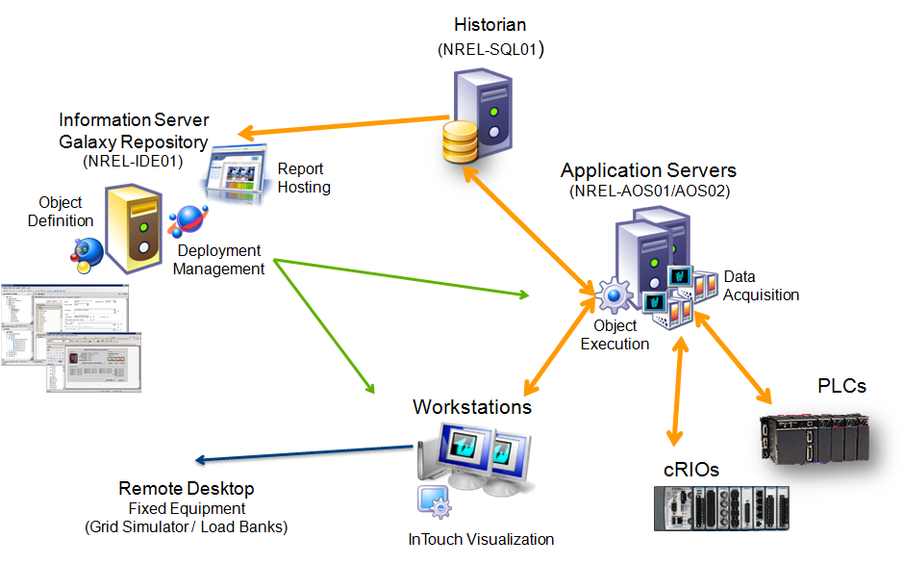

Figure 1: SCADA Components Overview

### Architecture Drawing



SCADA Workstation locations are noted in drawings DP-601 through DP-621. For additional details regarding the SCADA System Network:

|  |  |
| --- | --- |
| Drawing Number | Description |
| ESIF-001-DP-599 | SUPERVISORY CONTROL AND DATA ACQUISITION (SCADA) SYSTEM ARCHITECTURE OVERVIEW |
| ESIF-001-DP-600 | SUPERVISORY CONTROL AND DATA ACQUISITION (SCADA) SYSTEM ARCHITECTURE |
| ESIF-001-DP-630 | CONTROL NETWORK ARCHITECTURE |

Table 1: DP5 SCADA Architecture Drawings

### Bill of Materials

#### Server Hardware

|  |  |  |  |  |
| --- | --- | --- | --- | --- |
| **Name:** | NREL-IDE01 | NREL-SQL01 | NREL-AOS01 | NREL-AOS02 |
| Server Role: | Information Server / Web Server (IIS)  Integrated Development (IDE)  Galaxy Repository (GR) | Historian  (Database Server) | Application Object Server | Application Object Server |
| IP Address: | DHCP or Static | DHCP or Static | Static | Static |
| Software Installations**:** | Microsoft Windows Server 2008 Standard R1 Service Pack 2 | | | |
| Internet Information Services (IIS) 7 | | | |
| .NET Framework 3.5 | | | |
| Wonderware Application Server 3.1 SP3 (IDE/GR) | Wonderware Application Server 3.1 SP3 System Platform | | |
|  | Historian 10.1 | DA Server | |
| SQL Server 2008 Standard SP1 32 Bit | |  | |
| Information Server 4.0 |  |  |  |
| InTouch 10.1 SP3 |  | InTouch 10.1 SP3 | InTouch 10.1 SP3 |
| Model: | Dell PowerEdge R310 | Dell PowerEdge R410 | Dell PowerEdge R310 | Dell PowerEdge R310 |

Model Descriptions & Details

|  |  |  |
| --- | --- | --- |
| **Model** | Dell PowerEdge R310 | Dell PowerEdge R410 |
| Chassis: | R310C | R410 |
| Processor: | Intel Xeon X3470, 2.93 GHz, 8M Cache, Turbo | Intel Xeon E5620 2.4 GHz, 12M Cache, Turbo, HT, 1066MHz Max Memory |
| Memory: | 16GB (4x4GB), 133 MHz, Dual Ranked RDIMM | 32GB Memory (8x4GB), 1333MHz Dual Ranked LV RDIMMs for 2 Processors, Optimized |
| Operating System: | Windows Server 2008 R2 SP1, Standard Edition, Including 5 CALs | Windows Server 2008 R2 SP1, Standard Edition, Including 5 CALs |
| Hard Drive Configuration: | RAID 1 – SAS6iR/H200/H700 (SAS/SATA Controller), 2 HDD | RAID 10 for PERC S300 Controller, 4 HDD |
| Internal Controller: | SAS 6iR SAS Internal RAID adapter, PCI-Express | PERC 300 3 Gb/s SAS/SATA Internal Software RAID Adapter, Cabled Configuration |
| Power Supply: | Redundant, 400W | Redundant, 300W |
| Network Adapter: | On-Board Dual Gigabit Network Adapter | Broadcom NetExtreme II 5709 Gigabit NIC w/TOE & iSOE, Quad Port, Copper, PCIe-4 |
| Internal Optical Drive: | DVD-RW Drive, SATA | DVD-RW Drive, SATA |
| Primary Drive: | HF Multi-Select |  |

#### Workstation Hardware

|  |  |  |  |
| --- | --- | --- | --- |
| **Qty** | Item | Description | **Mfg** |
| 6 | SCADA  Multi-monitor Workstation | **Workstation:** Precision T1600 Fixed Workstation Operating System: Windows 7, 64-bit; Processor: Dual Core 3.30 GHz; Memory: 4GB, DDR3 Non-EC SDRAM, 1333 MHZ, 2X2GB; Hard Drive: 3.5” SATA, No RAID, 500 GB, 7200 rpm; 512MB NVIDIA Quadro NVS 420, Quad Monitor, 4DP; 16X DVD-ROM SATA; Integrated PCIE 10/100/1000 Network Adapter; Mouse; Keyboard | DELL |
| **Display: Four (4) Screen, Multi-Monitor Display (TBD)** |
| 14 | SCADA  Standard Workstation | **Workstation:** Precision T1600 Fixed Workstation; Operating System: Windows 7, 64-bit; Processor: Dual Core 3.30 GHz; Memory: 4GB, DDR3 Non-EC SDRAM, 1333 MHZ, 2X2GB; Hard Drive: 3.5” SATA, No RAID, 500 GB, 7200 rpm; Intel HD Graphics 2000 / P3000; 16X DVD-ROM SATA; Integrated PCIE 10/100/1000 Network Adapter; Mouse; Keyboard | DELL |
| **Display:** Single 23” widescreen Monitor (max resolution of 1920x1080 / 60 Hz), keyboard and mouse | DELL |
| **Enclosure**: 57” x 26” roll-around PC enclosure | NTRON  (or equivalent) |
| 3 | SCADA Outdoor Workstation | 17” Series C Touch Panel Computer; 1280x1024 32 bit color TFT-LCD, Resistive Touch Screen Display; Dual 10/100 NIC Ports; Intel Core Duo 1.7 GHz Processor; 2 GB RAM; 80GB HDD; External Interfaces: 4-USB, 2-RS232, 1-RS422/485, 1-DVI | Wonderware |

#### Networking Hardware

|  |  |  |
| --- | --- | --- |
| **Qty** | **Description** | **Manufacturer** |
| 1 | Managed switch w/fiber connection; Model (TBD), Per DWG ESIF-001-DP630 | Cisco |
|  | Modbus TCP to Profibus Gateway; P/N 5205-MNET-PDPS | Prosoft Technology |
|  |  |  |
|  |  |  |
|  |  |  |

#### Software

##### Wonderware ArchestrA

|  |  |  |
| --- | --- | --- |
| **Qty** | **Part Number** | **Description** |
| **1** | SP-4540A | System Platform 25K 1O/25K History v4.0 |
| **1** | 19-0062 | Application Server 25K IO v3.1 SP2* |
| **1** | 17-0507 | Historian Server 25K Tag Enterprise Edition V10.0 |
| **1** | 09-0145 | Information Server Portal V4.0* |
| **1** | 19-0068 | Application Server Platform |
| **1** | Apr-67 | Device Integration Server V10.1 |
| **1** | Jun-08 | Wonderware System Platform 4.0 Media |
| **1** | SO-D1101 | Device Integration Servers v10.1A |
| **1** | 97-1221 | Development Studio Unlimited v10.1A |
| **1** | 06-7009A | Wonderware Development Studio v10.1A Media |
| **20** | Jan-19 | InTouch for System Platform w/o History Client v10.1A |
| **1** | 17-1131 | Historian Client Per Server Concurrent 5 User v10.9 |
| **1** | 09-0180 | Information Server Standard Client Concurrent 20 Pack v4.0 |
| **1** | 17-0240 | WW Basic CAL with MS CAL 20 Pack |
| **1** | Oct-01 | Wonderware Customer First Stand + Level (Software support agreement) |

*Includes Microsoft SQL Server 2008

### System Communications

The SCADA System is designed to integrate with systems and equipment throughout the facility. The diagram provides a high level overview of these systems and equipment with which the SCADA system is integrated. Additional details regarding each system, or type of equipment interface, can be found in the sub-sections or drawings referenced below:

|  |  |
| --- | --- |
| Reference | Description |
| ESIF-001-DP-599 | SUPERVISORY CONTROL AND DATA ACQUISITION (SCADA) SYSTEM ARCHITECTURE OVERVIEW |
| ESIF-001-DP-600 | SUPERVISORY CONTROL AND DATA ACQUISITION (SCADA) SYSTEM ARCHITECTURE |
| ESIF-001-DP-630 | CONTROL NETWORK ARCHITECTURE |
| Typical Lab | Overview of Typical Lab communications with SCADA |
| Typical Fixed Equipment | Overview of Typical Fixed Equipment communications with SCADA |
| **Error! Reference source not found.** Building Automation System | Overview of communications with Building Automation System, Facility Security, and Fire Alarm |

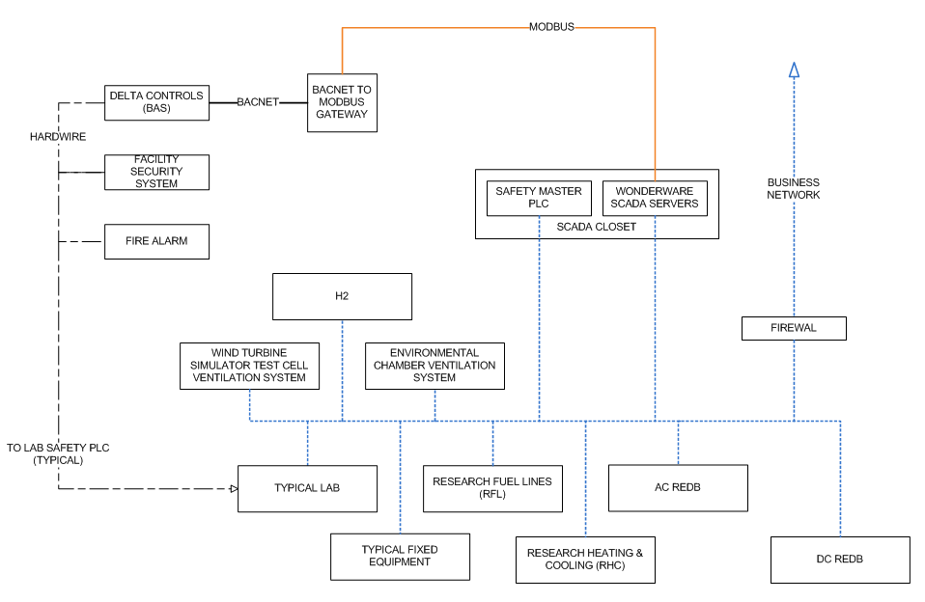

Figure 2: Communication Connections Diagram

### Lab Communications (Typical)

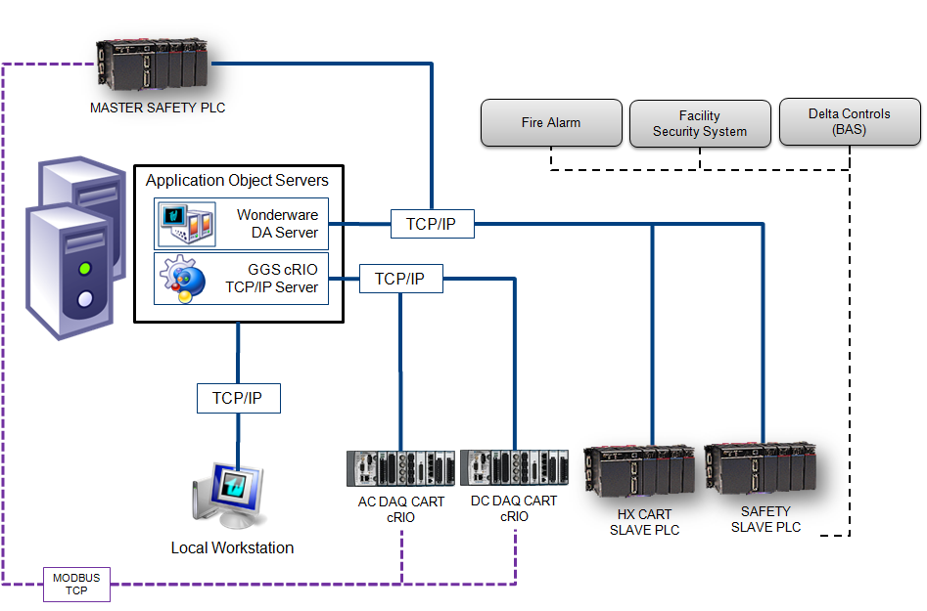

### Fixed Equipment Communications (Typical)

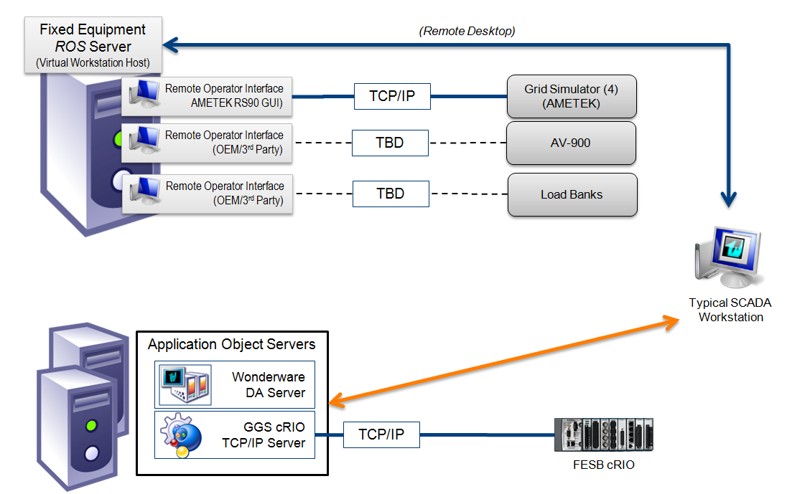

### Building AutomaTION sYSTEM

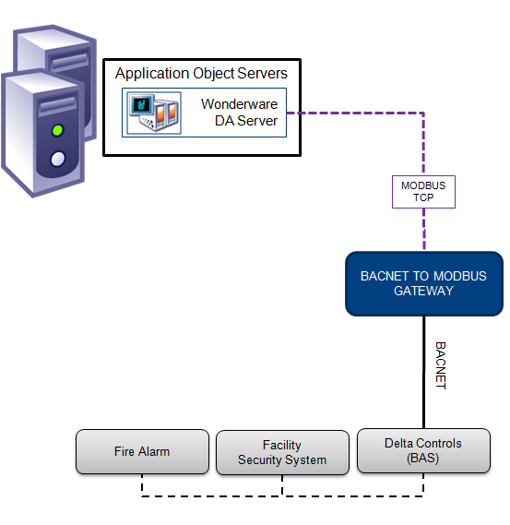

### System Startup & Shutdown

The SCADA System application and architecture is designed so as to not affect the state of connected systems or equipment during startup or shutdown; being managed or unmanaged (*result of power loss or equipment failure*).

#### System Startup

The sequence of SCADA Server start-up does not have an influence on the state of connected systems or equipment. “Best Practice” information with details and instructions on SCADA system startup is included with the system documentation.

#### sHUTDOWN

Due to the redundant Application Object Server (AOS) architecture, data store forward methods utilized, and the overall system design, certain application modules and/or servers can be powered down or taken off line without losing system functionality*



\**Depending on the particular application module or server that is taken out of service, and the duration of the outage, degradation in performance could be appreciated. In addition, there is a limited amount of temporary data storage that can be maintained in the event of a SQL Server (Historian) outage.*

#### Managed Shutdown

The possibility exists for the need carry out a managed shutdown of a SCADA server, group of servers, or of all servers within this system. This need could arise for a variety of reasons such as maintenance, planned power outages, equipment moves, or system updates/modifications. The sequence of SCADA Server shut-down has no influence on the state of connected systems or equipment. However, to avoid data-loss or to shut down only a portion of the system, certain procedures should be followed. “Best Practice” information with details and instructions on SCADA system shut-down is part of the documentation provided with the system.

### Power Loss Functions

In the event of an unexpected power loss to the system servers, assuming the PLCs and other local controllers and network devices are still operational and unaffected, the equipment and process control systems will continue to function. Experiment or test data is not retained at the controller (PLC/cRIO) level and therefore will be lost.

Once power is return the servers may be restarted.

### System Changes

Certain changes, additions, or modifications to the SCADA system may be made without bringing the system down and without causing any major impact to performance or usability. However it should be understood that there is always an inherent risk when modifying a production or running system. Changes or updates should only be performed by qualified individuals and any newly developed content should be created in a development environment and deployed to the running system only after successful testing. The table below provides general information on the impact of certain system changes to a running system.

|  |  |  |  |
| --- | --- | --- | --- |
| **Addition or Modification** | | **Impact** | **Details** |
| General Software updates/patches | | Depending on nature | Certain software updates or patches require that a particular service or process be restarted or even a server reboot. Would not require entire SCADA system outage but could impact performance depending on duration |
| Screens | | Minimal to none | Requires redeployment of HMI; Done on a station by station basis not requiring outage |
| Tag Database | HMI Level Tags | Minimal to none | Requires redeployment of HMI; Done on a station by station basis not requiring outage |
| Object Attributes | Minimal to none | Does not require outage; however changes to object require deployment which will not cause a state change but could cause minor interruption to certain functions. |
| Alarm Database | | Minimal to none | Included within Object Attributes; User may define at HMI (tag database) as well. |

Table 2: System Changes

### Audio/Visual Integration

#### Scope Provision

The GGS Scope, in regards to integration of the SCADA System, is as follows:

* Provision of six (6) SCADA PC Workstations, (*to be located in the Power Systems Control Room*), which will have the hardware connections (DVI) available to connect to and display SCADA Images on the A/V Screen.
* The development of a fixed number of A/V System use specific (“large-scale”) screens (described below).
* On-site time (prior to startup) for the purpose of SCADA configuration on the “Large-Desktop” workstation.

#### Architecture Overview

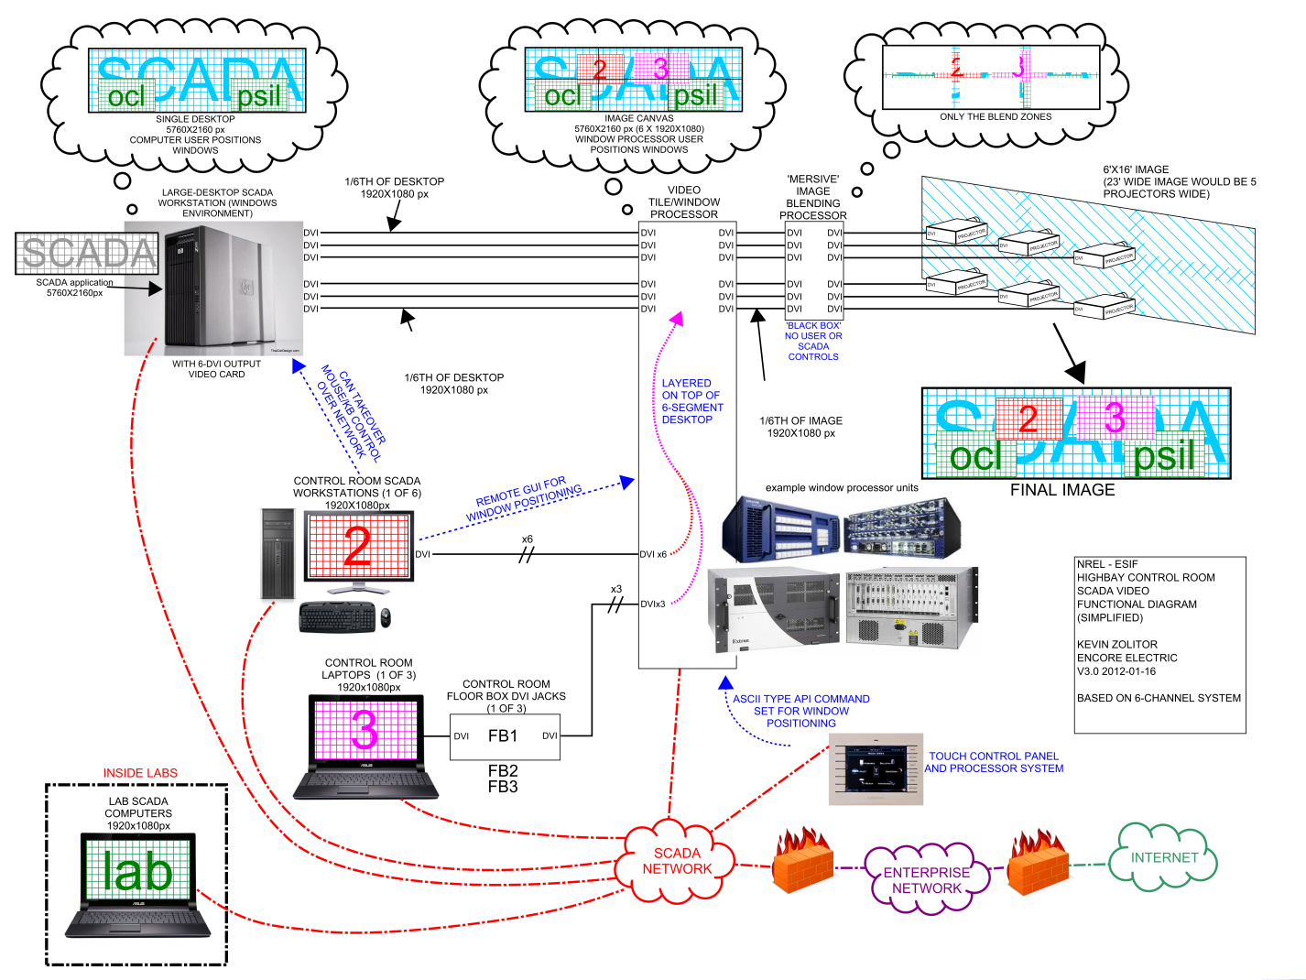

Figure 3: A/V Integration Overview (supplied by others)

#### a/v cONNECTION bY OTHERS

* (1) DVI connection for each of the Six (6) Power Systems Control Room SCADA PC Workstations.
* The “Large-Desktop” SCADA PC (by others) will be connected to the A/V System video processor by (6) DVI connections. It is understood that these individual DVI connections will be appear seamless to the PC/Server operating system and therefore the ArchestrA applications; resulting in the equivalent of one (1) large desktop.

#### scada a/v sCREEN lAYOUT

The “Large-Desktop” results in an available image space of 5760 x 2160 pixels. GGS understands that the video processor of the A/V system has the ability to “blow-up” or scale-up images from SCADA to accommodate the large resolution screen. In addition, a fixed number of A/V System use specific (“large-scale”) screens will be developed that at a resolution that can be displayed natively.

The standard SCADA screens were developed at a resolution of 1920 x 1080 (16:9 aspect ratio). These screens are largely based in ArchestrA Graphic Symbols, which are vector based and scale very well. However, they are design to “best fit” with the 16:9 aspect ratio of the screens. Therefore, in order to maintain this aspect ratio, the SCADA display for the A/V system will be broken up into two (2) separate regions, as shown below.



Views, as described in the following section, will be displayed in a 3844 x 2160 area of the screen. In the remaining area of 1916 x 2160, a Control Panel area is provided to allow for view configuration and to display other configurable items such as metering points, alarm/status displays.

As the end user will have access to the development environment, the freedom will exist to create screens and graphics at the full resolution available. The toolbox of graphics as well as graphics from deployed object instances will be available for use in developing user screens.

#### lARGE sCALE sCREENS

|  |  |
| --- | --- |
| View | Description |
| REDB Racetrack Views | Views of selected REDB Racetrack (D21/D22/D16/D2/A21/A22/A16/A25), (6) configurable metering points, alarm overview/status, EPO status, and navigation links to Lateral, Test, and Room Views. |
| Lateral View | Macro view of lateral connections, alarm overview/status, EPO status and navigation links to REDB, Room, and Test Views |
| Test View | Details of DAQ Cart, (4) configurable metering points, alarm overview/status, EPO status, and navigation links to REDB, Lateral, and Room Views |
| Room View | (4) Configurable REDB Views (small overview), Fixed Equipment list and status, BMS Related Data, alarm overview/status, EPO status, and navigation links to REDB, Lateral, and Test Views |
| View Control Panel | Control Panel type screen to allow for configuration of views and containing certain configurable items such as metering points and data views. |

## Graphical User Interface (GUI)

The Graphical User Interface of the Energy System Integration Facility (ESIF) SCADA System will, in general, provide the following functionality:

* Graphical representation of the processes, equipment, and instrumentation as denoted by the preliminary design documentation.
* Provide appropriate process data (flow rates, status, process variables, etc.), REDB Status (i.e., breaker status, metering values)
* Display alarms
* No commands will be implemented if operator presses touch screen area while screen saver is implemented.
* Operator interaction with the system will be straightforward and quick.
* Main Menu should be the first displayed graphic on system startup.
* Provide historical data logging and trending.
* Interface with other systems and equipment as defined herein.
* Monitoring functions shall include the following:
  + Status of control elements
  + Process parameters for each field instrument
  + Current process step
  + Interlock status and description(s)
  + Access to specific control and monitoring sub-graphics from unit graphics

SCADA will present on the necessary information for control and monitoring of the facility systems, system components and sub-components as described with the sections of this document.

### Text and Font Sizing

Text within system navigation, menus, and graphics will follow a consistent pattern of size, type, and usage as described in the table below. The font color and animation is described in sections of the FRS where the related feature or function is described.

|  |  |  |  |
| --- | --- | --- | --- |
| **Type** | **Name** | **Size** | **Example Usage** |
| Extra-Large | Tahoma | 14 | Main graphics that are sized to full screen size, such as Area Overview screens; and in certain cases unit graphics. |
| Large | Tahoma | 12 | Unit and sub-unit screen titles, where applicable; other labels or informational displays where required to give proper emphasis or scale. |
| Medium | Tahoma | 10 | Equipment labels and general informational displays |
| Small | Tahoma | 8 | Detail items on sub-unit graphics such as numeric scales and other labels. |

Table 3: Font Type & Size

This does not include fonts within third party programs or systems that are accessed via SCADA through remote desktop sessions or embedded web browsers.

### System Navigation

#### Main Entry Screen

|  |  |  |  |  |  |  |  |  |  |  |  |  |  |  |  |  |  |  |  |  |  |  |  |  |  |  |  |  |  |  |  |  |  |  |  |  |  |  |  |  |  |  |  |  |  |  |  |  |  |  |  |  |  |  |  |  |  |  |  |  |  |  |  |  |  |  |  |  |  |  |  |  |  |  |  |  |  |  |  |  |  |  |  |  |  |  |  |  |  |  |  |  |  |  |  |  |  |  |  |  |  |  |  |  |  |  |  |  |  |  |  |  |  |  |  |  |  |  |  |  |  |  |  |  |  |  |  |  |  |  |  |  |  |  |  |  |  |  |  |  |  |  |  |  |  |  |  |  |  |  |  |  |  |  |  |  |  |  |  |  |  |  |  |  |  |  |  |  |
| --- | --- | --- | --- | --- | --- | --- | --- | --- | --- | --- | --- | --- | --- | --- | --- | --- | --- | --- | --- | --- | --- | --- | --- | --- | --- | --- | --- | --- | --- | --- | --- | --- | --- | --- | --- | --- | --- | --- | --- | --- | --- | --- | --- | --- | --- | --- | --- | --- | --- | --- | --- | --- | --- | --- | --- | --- | --- | --- | --- | --- | --- | --- | --- | --- | --- | --- | --- | --- | --- | --- | --- | --- | --- | --- | --- | --- | --- | --- | --- | --- | --- | --- | --- | --- | --- | --- | --- | --- | --- | --- | --- | --- | --- | --- | --- | --- | --- | --- | --- | --- | --- | --- | --- | --- | --- | --- | --- | --- | --- | --- | --- | --- | --- | --- | --- | --- | --- | --- | --- | --- | --- | --- | --- | --- | --- | --- | --- | --- | --- | --- | --- | --- | --- | --- | --- | --- | --- | --- | --- | --- | --- | --- | --- | --- | --- | --- | --- | --- | --- | --- | --- | --- | --- | --- | --- | --- | --- | --- | --- | --- | --- | --- | --- | --- | --- | --- | --- | --- |
| 4.2.2.1.1 Building Overview Screen  The Building Overview is the main, or start-up screen. It consists of a single screen (developed from DP 3 Architectural drawings) outlining the overall building layout. Areas A, B, C, and D are segregated by colors. Each Area representation has a general indication (flashing button) to indicate if there are any active, SCADA-monitored alarms within any levels of the area. Clicking on the Area’s text box (containing the Area’s name) navigates to the Area’s main screen. An example of the overview screen is below:  C:\Documents and Settings\lwilson\Local Settings\Temporary Internet Files\Content.Outlook\FDSUGYX9\Building Overview.png  The Building Overview graphic includes time information (MM/DD/YYYY hh:mm:ss), alarm summary navigation, a QuickLink toolbar, and a navigation explorer menu that allows a User to quickly navigate to other available SCADA-resident screens.  4.2.2.1.2     BAS/Fire/Security/Safety Monitoring  The Building Overview graphics do not directly display information from the BAS system. Alarms or trouble messages communicated through the BAS system are indicated by a flashing red button on the Area representation in which the alarm/warning originates. By navigating to the Area Overview, and then selecting the particular flashing button of interest, the Operator can navigate directly to the specific room which generated the alarm. Alarms, whether from BAS, Fire, or Security systems, can always be viewed and acknowledged from the alarm summary screen, which is available on every screen from the header toolbar. SCADA-monitored instrumentation and devices communicate alarm or trouble status to the BAS, Fire, and Security systems by means of a single dry contact connected to the respective system. For example, in the Power Systems Integration laboratory (PSIL), the O2, CO, and NO2 detectors individually or in any combination will initiate dry contact closure (through SCADA) to the BAS system when SCADA receives an ‘alarm’ indication from those devices. In this example, contact closure is also initiated when a ‘warning’ alarm is generated for any of these three gasses. The BAS system, from the closure of a single contact, is not able to discern which of the devices triggered the alarm state (because any of the three are capable of generating an alarm), but is aware that an alarm or warning condition exists. Similarly, in the PSIL, the single contact connection to the Fire system is actuated from the “alarm” state of either of these three gas monitors, but is not actuated upon a ‘warning’ alarm. The single contact to the security system is activated by the ‘alarm’ level of these three gas detectors as well. The Security contact is also activated in the event of an Emergency Stop (EPO) action. Life safety and critical process alarms for each Area are displayed as a general alarm on the Area graphics – a User would need to navigate to the particular laboratory/room screen or the alarm summary screen to examine the particulars of the alarm. Fire and Security alarms are monitored by on-site security personnel. SCADA provides a separate browser window for those personnel to quickly navigate to and identify the source and location of any Security/Fire related alarm. The ‘Safety System I/O’ document provides a matrixed view of the inputs to the SCADA system and the outputs generated by the SCADA/PLC control. The PSIL example (from above) is shown below:   |  |  |  |  |  |  |  |  |  |  |  |  |  |  | | --- | --- | --- | --- | --- | --- | --- | --- | --- | --- | --- | --- | --- | --- | | **PSIL** | **OUTPUTS** |  | PSIL Alarm Light Red | PSIL Alarm Light Yellow | PSIL Alarm Light Blue | PSIL Alarm Horn | PSIL NG Shutoff Valve | PSIL Soft Stop Active Relay | PSIL Security Dry Contact | PSIL BAS Dry Contact | PSIL Fire Dry Contact | PSIL EPO Active Relay | REDB EPO | | **INPUTS** | PSIL O2 Detector Warning Alarm | AI |  | X |  |  |  |  |  | X |  |  |  | |  | PSIL CO Detector Warning Alarm | AI |  | X |  |  |  |  |  | X |  |  |  | |  | PSIL NO2 Detector Warning Alarm | AI |  | X |  |  |  |  |  | X |  |  |  | |  | PSIL CO Detector Alarm | DI | X |  | X | X | X |  | X | X | X | X | X | |  | PSIL O2 Detector Alarm | DI | X |  | X | X | X |  | X | X | X | X | X | |  | PSIL CO/O2 Detector Trouble | DI |  | X |  |  |  |  |  |  |  |  |  | |  | PSIL NO2 Detector Alarm | DI | X |  | X | X | X |  | X | X | X | X | X | |  | PSIL NO2 Detector Trouble | DI |  | X |  |  |  |  |  |  |  |  |  | |  | PSIL SG3 Gas Manifold Alarm | DI |  | X |  |  |  |  |  |  |  |  |  | |  | PSIL Soft Stop | DI |  |  |  |  |  |  |  |  |  | X |  | |  | PSIL EPO | DI | X |  |  | X | X |  | X |  |  | X | X |  Floor Navigation Each Area exists across several of five floors (Levels). The Building Overview screen gives the Operator the ability to drill down into an Area and select a Level to view. An Operator can navigate from any Level to any other Level from within the Area screens. Because the primary areas of interest in certain Areas lie within a particular Level, the Building Overview screen by default will navigate the Operator to the primary Level within each Area when the Area screen is selected from the Building Overview Screen. For example: In Area B, the Smart Power Lab, the Power Systems Integration lab, and the Optical Characterization lab reside on Level 2, extending upwards to Level 3; by default, selecting ‘Area B’ on the Building Overview screen navigates to ‘Area B, Level 2’. |
| Area A |
| The Area A graphic can be accessed from the Building Overview screen, from the explorer menu, or from the individual laboratory screens for laboratories which are contained within Area A. It provides the same basic displays as the Building Overview screen (time/date, a general alarm indication, navigation tree). The graphic is derived from the architectural drawing, and provides a textual reference to and visual demarcation of the individual laboratories housed within Area A.  A sample of the graphic for Area A Level 3 excised from the architectural drawings is illustrated below:  C:\Documents and Settings\lwilson\Local Settings\Temporary Internet Files\Content.Outlook\FDSUGYX9\Area A - Level 3.png  In this example, the corridors are indicated in orange, and the separate laboratories within Area A Level 3 are shaded in various transparent colors. This graphic will reside on a basic building template (see Building Overview screen above). Each of the laboratories has an ‘alarm indication’ overlay, which flashes if there is a recorded alarm within the specific lab. The individual labs are identified by a text overlay, which serves as the navigation pointer to the individual laboratory screens. Also on each lab section are displays of available information from the BAS system about the environmental conditions within the particular lab (temperature, humidity, and/or dew point). An Operator can set temperature and humidity setpoints for most of the lab areas from the lab screens; however, only one Operator may control the humidity, because there is only one humidifier in the system. The ground level for the Area A laboratories is Level 3: this will be the primary level (floor) to which the Area A overview graphic navigates. Area A Level 2 houses the Research Electrical Distribution Busses (REDB), which are covered by separate graphics. Although the Area A overview screen allows navigation to the REDB screens, they are most commonly accessed through the REDB shortcuts on the navigation header. Area A Level 4 screen exists as a placeholder since the Area A labs merely extend upwards from Level 3 to Level 4. There are no SCADA-monitored points in Area A Level 4 or 5. |
|  |
| Area B The Area B graphics are accessed from the Building Overview screen, from the navigation 'explorer' menu, or from the individual laboratory screens for laboratories which are contained within Area B, and provide the same basic displays as the Building Overview screen. The separate laboratories within Area B are colored to provide a quick visual reference. The Area B graphics reside on the basic building templates (see Building Overview screen above). Alarm indication is the same as in Area A screens. Each lab section displays available information from the BAS system about the environmental conditions within that particular lab. The monitored rooms in Area B cover two floors – Level 3 and Level 2; Level 4 and 5 screens exist as placeholders only, since no monitored devices currently exist on those levels. Level 3 is an extension of the labs grounded on Level 2. |
| 4.2.2.1.1.3 **Area C** |
| Like other Area screens, the Area C overview is accessed from the Building Overview screen or from the explorer menu. Area C has three Levels – 1, 2, & 3. Although the graphics exist for all three levels, generally Level 3 will be the only active display, with a link into the Insight Visualization Room. The Data Center is also on Level 3, but currently is without SCADA-linked instrumentation. BAS information is available to SCADA via the MODBUS/BacNET interface, and can be viewed on the Area C screen. Level 1 is Data Storage and Mechanical Room, and Level 2 is a large Conference Room and a Mechanical Room: only BAS-transmitted information is available to the screens for those levels.  **4.2.2.1.1.4** **Area D**  The Area D graphics can be accessed from the Building Overview screen and from the navigation explorer menu. Area D graphics cover Levels 1-4, and are placeholders, as there are no monitored points within this Area other than BAS-communicated information. The CERBS Electronic Visualization room, Mechanical Room, and Fire Alarm Panel Room on Level 1 are potentially future rooms to be included, but beyond the current scope of work. |

#### MENUS

|  |  |
| --- | --- |
| From the **Explorer** **Menu** the user may directly access, with proper credentials, any of the area overview or unit screens.  The **Header** **Menu** provides short-cuts to specific area and unit screens. Some shortcuts, such as to “My Experiments” are user specific. | Figure : Explorer Menu |
| Once in an Area Overview screen, the user may navigate to related area overview screens and unit screens using shortcuts and drill-down navigation (such as tab navigation) within the screens. |
| Figure : Tab Navigation |
| Figure : Header Menu | |

#### Quick Links

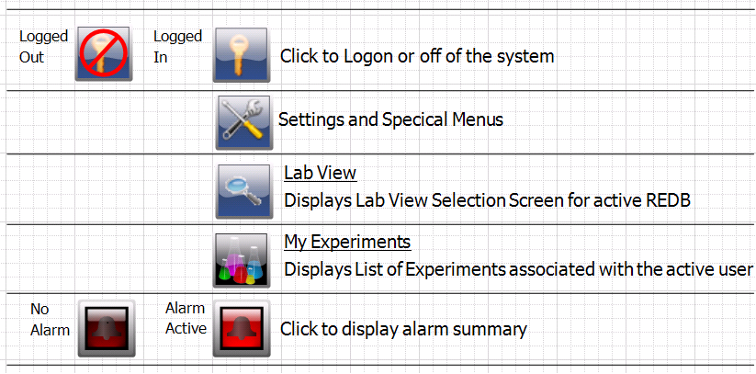

### Common SCADA Keystrokes

In addition to the on-screen commands, such as push buttons, many functions in the SCADA system may be executed by using a combination of keystrokes. These commands and keystrokes are described in the sections with the applicable functionality. Examples of these common keystrokes are as follows:

|  |  |  |
| --- | --- | --- |
| Keystrokes | Command | Description |
| F5 | Refresh | Refresh Data in a **Trend Chart** |
| DELETE | Delete | Delete a **Tag** from a **Trend Chart** |
| ALT-A | Alarm Acknowledgement | On Alarm Screens, **Acknowledge** selected alarm(s) |
| ALT-R | Alarm Reset | On Alarm Screens, **Reset** selected alarm(s) |
| ALT-E | Edit | Edit a field; where applicable |
| ALT-O | File Open | Open a file; for example a waveform XML file |
| SPACEBAR | (un)Select | Select or un-select a checkbox item (such as alarm enable) when item has focus |

### Area Graphics

* Overall display will be an overall view locating major process equipment units. Each process equipment unit, when selected, will take operator to corresponding Unit Graphic.
* Each Operation Graphic will be displayed as boxed target which, when selected, will take operator to corresponding graphic.
* Each graphic will have target on each side of graphic which takes user to next graphic horizontally in hierarchy; i.e., second Unit Graphic will have target on left that will take user to first Unit Graphic and target on right that will take user to third Unit Graphic.

### unit Graphics

Sub-Unit graphics will include alarm displays, details of monitoring and control, and trend groups associated only with that unit.

### Color Conventions

The color conventions listed in each of the following sub-sections are to be utilized on the graphic screens to represent the status of process piping, pumps, valves, and other equipment as described herein.

|  |  |  |
| --- | --- | --- |
| **Process (Gas or Liquid)** | **Flow Condition** | **No Flow Condition** |
| Nitrogen | White | Gradient Gray |
| Chilled Water | Dark Green | Gradient Gray |
| Deionized Water | Dark Green | Gradient Gray |
| Air | Dark Blue | Gradient Gray |
| Hydrogen | Yellow | Gradient Gray |
| Bio-Diesel/Diesel | Brown | Gradient Gray |
| Natural Gas | Yellow | Gradient Gray |

### Maintenance Screens

#### A2 platform & Application Engines status

|  |  |
| --- | --- |
| Status Screens show the status and health of the platforms, networks, and control devices in the system. | |
|  | **Application Engine(s) Overview Diagnostic** screen showing summary of conditions in each area and navigation to detail screen(s). |
|  | **SCADA System Platform diagnostics** showing, for each Application Server, SCADA Redundancy Status, run status and engine diagnostics such as CPU load and scan time. |
|  | **Application Object Status & Details** provides details regarding application object status, associated system I/O, and the values of field references and UDAs |

#### Tag Out & Tag Notes

An input to the PLC will indicated when certain breakers and devices are physically locked out. In these cases, the system will display the an icon (*described in switch details*) indicating this status.

A software function is provided per breaker (or device) that allows a user to indicate that it is tagged out in the field. This function is provided primarily as a means of providing visual indication of the LOTO status and contact information of the LOTO owner.

The addition and removal of a tag out will be recorded as an event. While the SCADA system will not attempt to operate a device with an active LOTO recorded this **function is not intended to be a system safeguard**. The software function is security controlled requiring the original user (or an administrator) to enter username and password.

|  |  |
| --- | --- |
|  | |
| C:\Projects\NREL\Design\SCADA\Misc Screen Shots\TagDetail.png | The **tag** **note** information includes the tagging out person’s name, contact method, and date of the tag out.  A tag note may also contain general information regarding the associated device, a request for maintenance or inspection, or information regarding maintenance.  A tagout must be entered by a user with a system account. Fields are provided in the details section to allow for the recording and tracking the lockouts of non-system users (i.e., outside contractors). |

#### Network Diagnostics

|  |  |
| --- | --- |
|  |  |
|  | Network Diagnostic screen provides overview of network status & indication of any network related alarms.  Provides drill down to specific device and applicable modules. |

## System Security

The ArchestrA security model is utilized in the SCADA application in conjunction with configuration tables in the system database.

* When the user logs on, security credentials are checked and access to areas and activities is granted.
* In addition to the standard ArchestrA security groups and roles, each User in the system will be maintained in a database table and will be assigned a unique system generated UserID. Verification of the user will take place via ArchestrA and not through SQL.
* A default user (wwuser) will be provided that will allow certain functions, such as alarm acknowledgement. The roles and associated privileges of this user, as well as all system users, will be configurable.

### Login/Logout

#### Login

|  |  |
| --- | --- |
| Upon startup of the SCADA GUI, a popup window will appear prompting the user to login to the system. |  |
| The user may also access this screen from the LOGIN/LOGOUT Shortcut button on the header menu: |  |

#### Logout

1. Manual
   1. The user may manually log out of the system at any time
2. Automatic
   1. **Inactivity Warning:** After a configurable period of inactivity (<*InactivityWarningPeriod*>), a warning will be displayed on the screen displaying a countdown timer until the user is automatically logged off.
   2. **Inactivity Auto Logoff:** After a configurable period of inactivity (<*InactivityLogoffPeriod*>), the user is automatically logged off.
   3. **Auto logoff will not cause a change in the ownership status of any system component, sub-**component, or other item checked-out to the user.

### Users, Groups, and Roles

Each user will be assigned to one or more roles which are mapped to one or more groups. For example, within the Admin group shown below there are three roles; Developer, Supervisor, and IT. The Security group, Researchers, contains the roles of Principle Investigator, Investigator, and Jr. Investigator.

|  |  |
| --- | --- |
|  |  |

#### Users

The First and last names of each user will be maintained and used, for example, to display the user’s real name where required (i.e., LOTO screens, Experiment Assignments, Reports, etc.) rather than using the system user name.

* Users are associated with specific roles.
* User roles are associated with specific administration, configuration and operational permissions, which map to security groups
* Security groups are associated with specific automation objects in the system.
* A single user may have multiple accounts. For example, a user may have a supervisory account and also an operational account.

#### Groups

* Each laboratory will be considered one (1) group.
* Utilities, maintenance, presenter and system administrator groups will be created. These groups will have access across multiple laboratories.
* The ability will be provided, for system administrators, to add and configure groups through a secured HMI screen.
* A user may have more than one account; allowing membership in more than one group.

#### Roles

* Read-Only will have basic screen navigation. Read-Only may monitor graphics including system status graphics. Read-Only may not enter any setpoint or change the state of any piece of equipment. Read-Only will also be blocked for screens defined as confidential data (see below section on Confidential Screens).
* Operator will have basic functionality. Operator may monitor graphics including system status graphics. Operator control is limited to switching device modes between AUTO, MANUAL, and REMOTE (if applicable), manually starting and stopping or opening and closing devices, manually changing valve positions, and adjusting setpoints within engineering defined ranges.
* Principle Investigator will have same capabilities as operator; with the ability to modify parameters, such as interlock setpoints, user saved recipes, and simple system functions such as data back-up. Principle Investigator will not have access to any software modification graphics including permanent recipe changes.
* Configurer will have complete access to system functions including software configuration screens. After executing proper change control procedures, Configurer will be able to make any application software revision.

### Permissions

Permissions determine what kind, if any, of access the user has for each attribute. There are four basic operational permissions:

* Acknowledge Alarms
* Change Configuration Values (*Alarm Enables, Setup Parameters, etc.,*)
* Change Operational Values (*Start/Stop, Setpoints, etc.,*)
* Change Tuning Parameters (*Loop Tuning*)

### Confidential Screens

In order to limit access to confidential data, each screen (*area, unit, and sub-Unit graphics*) will be provided with the ability to be marked confidential by a Principle Investigator (security *role*).

Exceptions would include:

* Any screen that does not contain data of a confidential nature; no system PLC or controller data; no calculated values, settings, or any information related to experiments.
* Navigation screens or menus
* Main system entry screens
* Current alarm screens
* Screens related to safety (EPO Actions )
* Maintenance screens (still requires high level access)

#### Ownership

In order to operate a breaker, regardless of breaker utilization (REDB, FESB, DAQ, etc.) It must be owned by a process. This process may be, for example an experiment or diagnostic/maintenance mode. In the case of a DAQ Cart or FESB breaker the ownership of the breaker will take place through ownership of the device to which it is related. (i.e., the FESB or DAQ Cart will be owned by the experiment and thus its breaker(s)).

The ownership of breakers, as well as other own-able objects, will be recorded in the database. A entry will be recorded, per object, for each valid and current ownership. When a valid ownership is recorded, the system will set the appropriate status in the PLC for that object. The system will indicate, to the PLC, the removal of object ownership when the entry in the database is removed. In the case of objects that can have more than one concurrent owner, such as an isolation breaker, this will not occur until all records have been

## Data Historian

The SCADA system will include a SQL Server and Wonderware ArchestrA based historian.

Thirty (30) days of historical data will be available through the SCADA System. Data older than thirty (30) days will be archived to the data center systems in a SQL backup format that will allow the data to be imported back into the system as needed, to the point that server disk space allows.

Due to the potentially large amounts of data that could be collected by the system, for efficient management and archival, the archival of SQL data will be carried out through integration services (of SQL) and will result in a backup file.

Data provided to the SCADA systems via the PLCs will be recorded at one (1) second intervals.

### Data Acquisition

The SCADA System will interface with High speed data acquisition equipment to capture electrical waveforms of device under test (DUT). This equipment will be part of the Data Acquisition Carts (DAQ) and as described further in this document.

The SCADA System will interface with fixed metering and data acquisition equipment to capture electrical waveforms for permanently installed equipment. The Fixed metering devices and locations are described further in this document.

Waveform captures will occur based on triggered events and capture a minimum of 128 samples per cycle at 0-400 Hz for five seconds. The data shall be stored to a SQL Server database as described within this document. Captures will be completed at the metering device and data retrieved by the SCADA system.

Waveforms shall have the capability to be viewed and compared across different collection equipment and to time align events in the system for analysis.

The system shall include a time synchronization clock to accurately time-stamp data for recording.

Through the use of DAQ Carts, the system to provide flexibility for acquiring data from various DUTs (Device Under Test) and portability throughout the laboratories.

### Alarm Historian

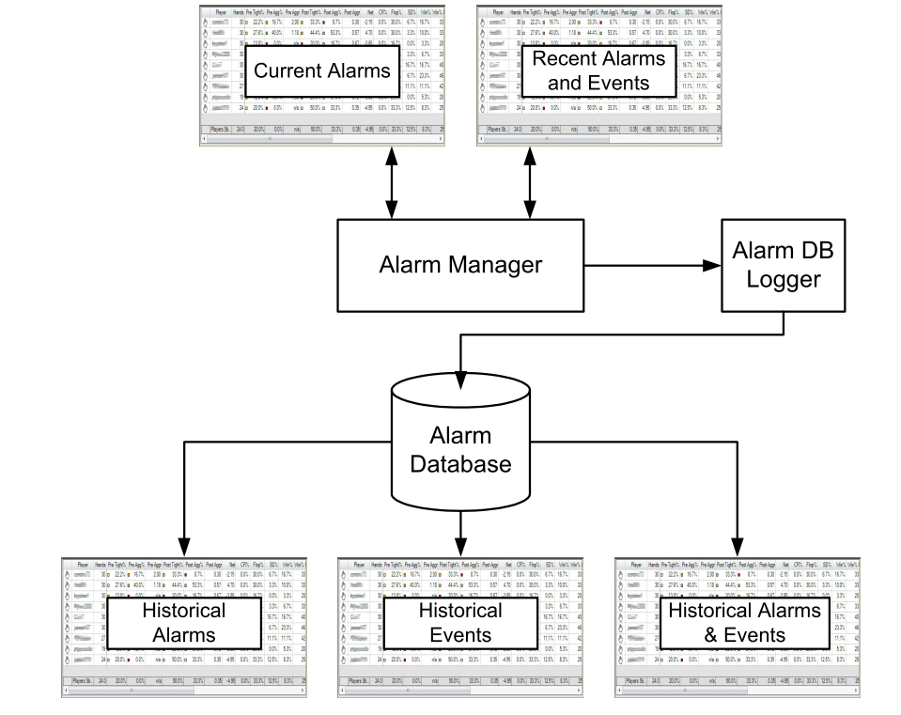

Alarm Manager

Manages currently active alarms (*summary alarms*) and recent alarms and events (*historical alarms and events*). The Alarm Control within the SCADA Application will provide the ability to view current and recent historical alarms and events. All alarm and event history will be able to be queried through the reporting system.

Alarm Database

Stores Historical Alarms & Events in a SQL Server Database (Historian).

### Reporting

#### Configured Reports

SQL Server Reporting Services based preconfigured reports have the following base functionality. Depending on the report selected from the launch pad, Information Server will present the user with report configuration options, as in the following Alarm History example. Any sorting, filtering, or display controls defined in the report are accessible here.

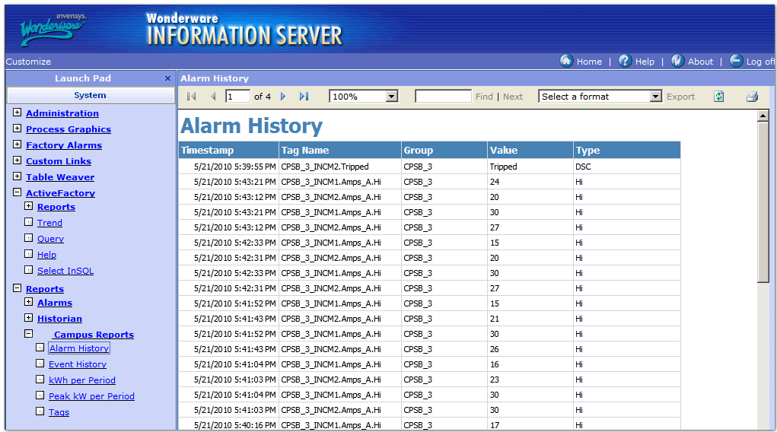

Figure : Alarm History Report Example

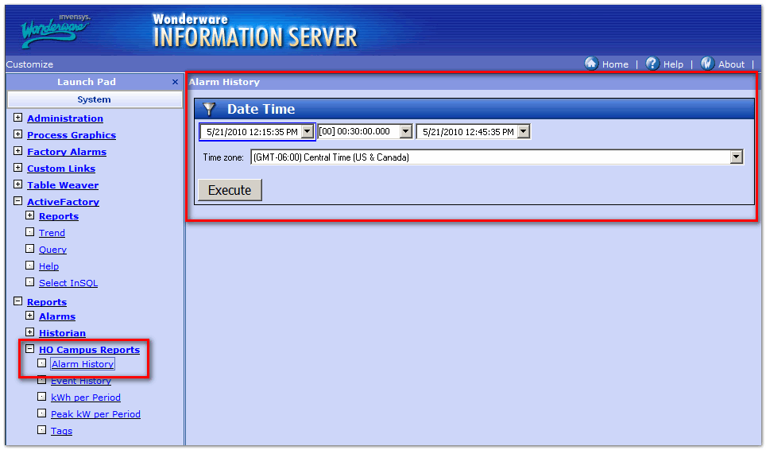

Figure : Event Time Filter Selection

Many predefined query types will be available, including aggregate values, alarm history, event history, and tag details. Each report will contain a report control menu which allows:

Page select

Zoom

Search

Data export to XML, CSV, PDF, and Excel file format.

Printing to any printer accessible by the client viewing the report.

#### User Defined Reports

*ActiveFactory* query and trend based, user defined, reports are also be made available from the SCADA system under the Reporting menu.

The interface for creating User Defined Reports will be provided with the following base functionality:

* Create new reports.
* Load existing reports
* Store reports such that they can be accessed from another workstation.
* Store reports locally, to a particular client, or to an experiment file repository (secured access).
* Export data to XML, CSV, PDF, or Excel file format. This ability will provide a method for further analysis.
* Tag selection layout using the Systems Galaxy’s Model, improving and providing clarity to the selection process.
* Several aggregate functions available for easy analysis of reported values.
* Report SQL syntax will be constructed automatically from the interface by selecting report type and any number of column options, but can be hand edited to create more complex and customized queries.
* Both historical and real-time data can be viewed from the same interface using date/time and player controls, unlimited as to interval and duration (provided data presence).

|  |  |
| --- | --- |
| Figure : Tag Picker | Figure : Editable Query Results |
| Figure : Column Selection & Configuration | |

## Trending

Trending of both historical and real time data is available from multiple places in the system, and all use the same ActiveFactory trending interface within the system.

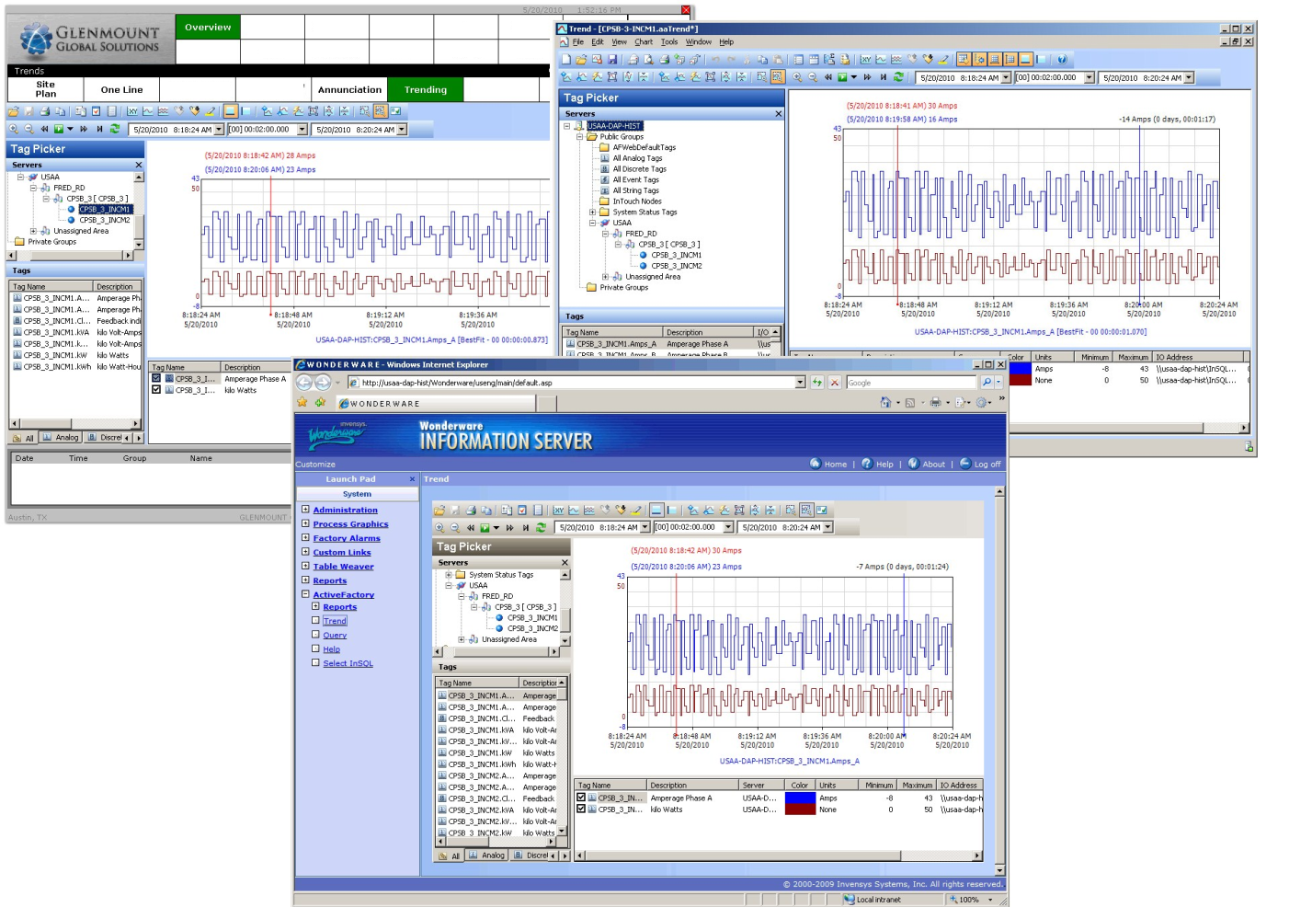

In the figure above, a common trend configuration and display is available from the HMI system, a stand-alone trend application available on the Information Server PC, and as a web page published by the Information Server.



Time axis cursors allow displaying values in time and also differences between points in time.

|  |  |
| --- | --- |
|  | |
| Trend data can be easily viewed in tabular form right from the trend. |  |
| Trend data can be easily exported as a CSV file for further analysis from any of the interface locations. |  |

## Archival Functionality

The frequency of data base archival and the size of the related files to be archive will be a function of system usage. There are a number of factors, such as the frequency and duration of experiments, the number of points/items logged per experiments, and how often the user chooses to archive their data rather than relying on local storage.

The SQL Server has 450GB of storage capacity and will host several databases that include system configuration and application data (will not grow frequently), typical historical data, and experiment specific data. It is the experiment data that will most often require archiving. Experiment data will be comprised of both database entries as well as files, such as waveform XML files, screen captures, and other documents (PDF, for example) that are saved with the experiments into file locations. As an example, the waveform XML files will be approximately 10 MB for a 5 second snapshot of a single channel.

SQL Backups:

The SQL Databases will be configured for daily backups of application databases and weekly backup of system databases. Transaction logs backups will occur every 15 minutes. The application and system backups should be archived; however it will not be necessary to archive the transaction logs.

The backups will be created locally and then copied to the archive location. The local copies of the backups will be deleted after a certain period (TBD) and confirmation of a successful archive copy. In order for SQL (or other services, as required) to create archive sub-directories and copy/move files, a service account, with read/write/create rights on the archival location, will be required.

The archive structure will be as follows:

<Archive Location>

\SQL Backups

\System Databases

Files: <*databaseName_DateTimeStamp*>

\Application Databases

Files: <*databaseName_DateTimeStamp*>

\User Archives

\<*User Specific Folder*>

\<*Experiment Specific Folder*>

Files:<user named file>

## Alarms & Messages

In addition to alarm pop-ups and alarm summary/history screens, graphic flags will be used to alert the operator that an alarm condition has occurred. Only necessary alarms will be presented to avoid having operator process any unnecessary information.

An alarm condition will exist when a configurable limit has been exceeded, a hard limit has been exceeded, or an alarm condition has been reported by an integrated system.

* Alarm switching will be executed in controller. Alarms will be latched within controller requiring operator acknowledgement and reset either though SCADA or panel mounted push-button.
* No alarm switching may be in SCADA only system. Alarm logging, annunciation, acknowledgement, and printing will be executed by SCADA only system alarm task manager.
* Field device generated alarms normally-closed, alarm on open.
* Software generated alarms to alarm on true.
* Control system will store alarms on fixed disk in First-In-First-Out stack

### Alarm Summary & History Screen

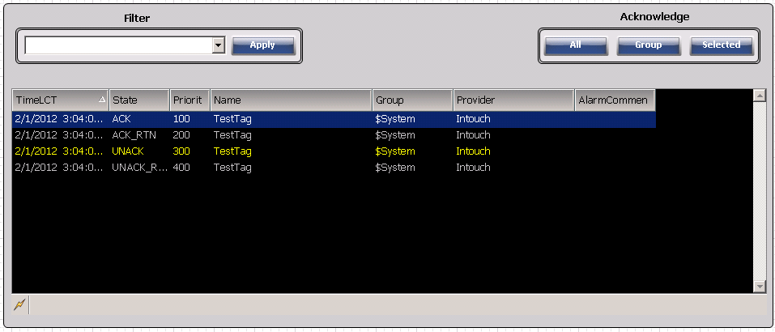

Figure 12: Alarm Popup

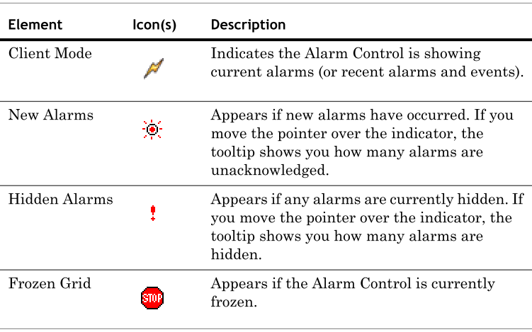

### Alarm acknowledgement

Alarm acknowledgement, by users, is based on their permission level and the current security configuration. Alarms (accessible to user) may be acknowledged by:

1. Select one or more alarms in alarm state.
2. Click the appropriate button (All / Group / Selected) or right-click the Alarm Control grid, point to **Ack** **Others**, and click one of the following:
   * **Ack All** to acknowledge all alarms in alarm state.
   * **Ack** **Visible** to acknowledge all visible alarms.
   * **Ack** **Selected** **Group** to acknowledge alarms with the same provider names and group names of one or more selected alarms in alarm state.
   * **Ack Selected Tag** to acknowledge alarms with the same provider names, group names, and tag names within the priority ranges of one or more selected alarms in alarm state.
   * **Ack Selected Priority** to acknowledge alarms with the same provider names, group names, and within the priority ranges of one or more selected alarms in alarm state.

### ALARM FILTERING

#### Adding a New Query Filter

At run time, you can create new query filters to limit the number of alarm records. The new query filters are not stored for future use and are only valid for the current session. If you want to store them for future use, you must also export the query filters to an XML file. For more information, see Exporting Query Filter Favorites.

To add a new query filter right-click the Alarm Control grid and click **Query** **Filters**. The Query Filters dialog box appears.

#### Modifying an ExistingQuery Filter

The modification of query filters is not saved for future use and is only valid for the current session. If you want to save the modifications, you must also export the query filters to an XML file. For more information, see Exporting Query Filter Favorites

#### Deleting a Query Filter

At run time, you can delete a query filter. After you delete a query filter at run time, it is only deleted for the current session. If you want to save the list of query filters without the deleted query filter, you must export the query filters to an XML file. For more information, see Exporting Query Filter Favorites.

#### Importing Query Filters

At run time, you can import the list of query filters from an XML.

##### Exporting Query Filter Favorites

At run time, you can export the list of query filters to an XML file for future use. After exporting, you can import the query filter from the XML into design time. Note that the default query filter favorite is not exported to the XML file.

### Alarm Classes

There are four (4) classes of alarms configured within the system. Each class of alarm, as described in below, has an associated priority code and color display schema.

1. Alarm Class Descriptions
   1. **Hardware Failure:** Control system hardware failure detected by system diagnostics. Example would be failure of analog card in a PLC (or similar device)
   2. **Process Critical:** An event that causes any environmental damage, personnel injury, major equipment damage, or significant production loss.
   3. **Process Advisory:** Alert operator that process is not functioning optimally or that a process critical alarm is pending unless appropriate operator action is taken. (Warning)
   4. **Operator Message:** Alerts operator that certain tasks are required or that process events have occurred. For instance, message for monthly data back-up would be operator message.

|  |  |  |  |  |  |
| --- | --- | --- | --- | --- | --- |
| **Alarm Class** | **Priority Code** | Color | | | |
| Unacknowledged | | Acknowledged | |
| Foreground | Background | Foreground | Background |
| Hardware Failure | 400 | Magenta | Black | Blue | Grey |
| Process Critical | 300 | Red | Black | Blue | Grey |
| Process Advisory | 200 | Yellow | Black | Grey | Black |
| Operator Message | 100 | Green | Black | Grey | Black |

## Time Synchronization

### Architecture Overview

The Master SCADA system is equipped with a system to synchronize data samples from disparate sources to a common clock. This is done so that data from different sources can be compared with the knowledge that the signals are correctly aligned in time. The master clock source is the GPS satellite system. All process data is time stamped as it is collected. Time stamp data is in Universal Time Coordinate (UTC) format. This avoids confusion caused by daylight savings time and time zone offsets. There are two distinct subsystems to the time synchronization system: the network time sync system and the cRIO time sync system.

### Communications Overview

#### Network Time Sync System

The network time sync system uses the Network Time Protocol (NTP) to synchronize the SCADA AOS server real-time clocks and S7 PLC real-time clocks. NTP is accurate within several milliseconds. Two Meinberg Lantime M200 LAN clocks operate in a redundant pair. The active unit responds to NTP client requests with a synchronization signal. If the active unit fails, the standby unit assumes the role of active unit. A pair of GPS antennae is dedicated to the LAN clocks.

#### Compact RIO Time Sync System

National Instruments Compact RIO (cRIO) programmable controllers are utilized to collect electrical waveforms and measurements as well as other experiment data. Because it is desired to be able to compare waveforms originating from different cRIOs, waveform data must be time stamped with high accuracy. NTP is only capable of synchronizing clocks to within several milliseconds, which is insufficient for this purpose.

To meet the synchronization needs for waveform capture, each cRIO is equipped with a GPS receiver. The GPS antenna distribution system provides each cRIO with a GPS signal, and each receiver determines the time from the GPS satellite signal. Data is time stamped locally at the cRIO using the GPS-based local clock signal. Time stamps originating at the cRIO are accurate to within several hundred nanoseconds.

In order to synchronize the cRIO clocks more accurately, the effective length of the antenna cable for each cRIO must be accounted for. This is accomplished with a propagation delay setting in the configuration file for each cRIO. The antenna outlets in the labs are marked with their propagation delay, so that DAQ cart cRIOs fan be easily configured when they are moved from one lab to another.

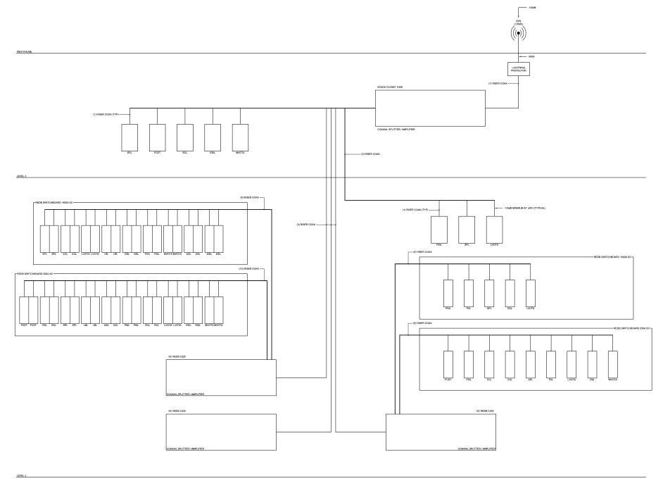

#### Siemens Equipment

Siemens S7 PLC’s are utilized in various roles as process controllers. The S7 PLC’s have an NTP client that synchronizes their local real-time clocks to the Meinberg units. Process data that are communicated from sources outside the S7 PLC are time stamped by the source. The S7 PLC’s check the incoming process data time stamp against their real-time clocks to insure that the incoming process data is recent enough to be used in the calculation of the S7’s process logic.

#### Master SCADA Clock

The Application Object redundant pair (AOS1 and AOS2) servers run an NTP client that requests time sync data from the Meinberg units and synchronizes their local real-time clocks. All process data that does not originate at a cRIO is time stamped at the AOS (Archestra) servers as it is collected. Note that since UTC format is being used, the Meinberg units are used only to synchronize the AOS servers. Workstations on the network shall be synchronized from another source so that their real time clocks read in local time. Note that when data is viewed and retrieved from the historical database the SCADA software automatically converts the time stamps to local time so that users do not have to mentally convert from UTC to local time.

### Alarms & Messages

Because time synchronization is essential for correct functioning of the PLC systems and experiment data collection, there are several alarms to indicate that the time sync system is not functioning properly.

#### Compact RIO GPS Lock Alarm

Each cRIO monitors the quality of the GPS signal. If the GPS module cannot determine the time from the GPS satellite system this alarm is set.

#### Compact RIO/Meinberg MismAtch Alarm

In addition to determining the time from the GPS signal, each cRIO also runs an NTP client that requests time sync data from the Meinberg units to synchronize the local real-time clock. The local cRIO real-time clock is not used to time stamp data. However, the real-time clock is compared to the GPS clock signal. If the GPS lock alarm is not active and the clocks differ by more than a preset amount, this alarm is set.

## System Shutdown

### Process Stop Buttons and Controlled Stop Alarms (C-Stop)

The controlled stop (C-stop) is an experiment-specific, collection of SCADA level 3 alarms that trigger a common reaction. During experiment configuration, the user must select which alarms are to be included in the collection. By default the lab stop button (yellow button) alarms for all labs included in the experiment are added to the collection, but they can be removed and any readable alarm can be added. The experiment’s single C-stop can be configured to open or close any rated switches that are owned by the experiment, but by default does nothing. If any of the selected alarms becomes active, the AOS commands the configured switches to open or close as configured. C-Stops must be manually reset via SCADA once the triggering alarms have been cleared. The C-stop is for equipment protection only. Note that the process stop buttons will not function if the redundant pair of AOS servers is not functioning.

### EPO Buttons and Software EPO Alarms (E-Stop)

The software emergency power off (SEPO) is an experiment-specific, collection of SCADA level 3 alarms that trigger a configured set of EPOs, effectively remotely pressing a set of EPO buttons. During experiment configuration, the user must select which alarms are to be included in the collection. No alarms are included by default. The experiment’s single SEPO can be configured to perform the same function as pressing a configured set of EPO switches at the same time. By default, all EPO switches included in the experiment are configured.

Emergency Power Off (EPO) switches are located in each of the labs. If a SEPO becomes active, SCADA level 3 logic sets a flag bit in the SAFETY PLC for each EPO to be activated. The SAFETY PLC logically ORs the switch state with the software flag and forwards the combined EPO signal to all other Siemens safety PLCs in the system. SEPOs must be reset via SCADA once the triggering alarms have been cleared. SEPOs are for equipment protection only.

# Research Electrical Distribution Bus (REDB)

## System Architecture

### REDB Master Control

In order to maximize overall system availability during future upgrades, each REDB bus was given its own Siemens S7 PLC (REDB PLC). Additionally, an AC Master PLC and DC Master PLC coordinate actions between separate AC and DC busses. A future development PLC may be used to improve system availability during future upgrades. Each of the REDB PLCs communicates via send-receive protocol on TCP/IP to its respective master PLC. A separate IP subnet is reserved for PLC-to PLC communications in order to enable bandwidth allocation.

### REDB Compact RIO Communications

The National Instruments CompactRIO programmable controller is used to provide metering and data acquisition capabilities throughout the REDB electrical system. Each cRIO has two Ethernet ports. One port is utilized to communicate with Siemens PLC’s via the Modbus TCP protocol. The other port is utilized to communicate with the Archestra AOS servers using a proprietary TCP protocol. Separate IP subnets are reserved for each type of communication in order to enable bandwidth allocation.

#### REDB Racetrack Compact RIO

Each section of REDB bus contains at least one cRIO metering device which indicates the current and voltage present at each of the metering points on the bus. Each REDB racetrack cRIO runs a Modbus TCP server that responds to requests from a Modbus TCP client. The client runs in a stand-alone gateway (Prosoft 5205-MNET-PDPS). The gateway communicates via Profibus DP to the REDB PLC. AC Bus sections utilize two cRIOs to implement the required metering functions, whereas DC sections utilize only one.

#### Fixed Equipment Switchboards (FESB)

Each FESB contains a cRIO which monitors the metering data and controls the switchgear in the board, in cooperation with the REDB and REDB Master PLCs. Each FESB cRIO runs a Modbus TCP server that responds to requests from a Modbus TCP client. The client runs in a stand-alone gateway (Prosoft 5205-MNET-PDPS). The gateway communicates via Profibus DP to the Master PLC.

#### Data Acquisition Carts (DAQ)

Each DAQ Cart contains a cRIO which monitors the metering data and controls the switchgear in the cart, in cooperation with the REDB and REDB Master PLCs. Each FESB cRIO runs a Modbus TCP client that requests responses from one of several Modbus TCP servers. The servers run in stand-alone gateways (Prosoft 5205-MNET-PDPS). The gateway communicates via Profibus DP to the Master PLC. In the case of DAQ carts, the gateways assume a server role, since the DAQ carts are not permanently connected. This prevents clients from continuously and unsuccessfully polling unconnected servers.

### REDB Remote I/O Communications

Each section of REDB bus contains a Siemens ET200S remote IO rack that controls the digital IO for the switchgear. The racks communicate via Ethernet-based Profinet to the REDB PLC’s. A separate IP subnet is reserved for Profinet communications.





## REDB System Controls (non-safety Functions)

### Action Scheduling

PLC Logic allows only one switch to open or close at a time. SCADA may request as many actions as desired, but only one is active at a time. When an action request becomes active, it is time stamped. The PLC then waits until all metering data relevant to the action is newer than the time stamp before executing the interlock logic.

### Bus MOnitoring

SCADA will collect the metering data necessary for waveform history directly from the cRIOs. The PLC will collect and monitor critical data, from cRIOs, as needed for control functions.

### Monitoring Compact RIO Metering Data

The metering cRIOs select the maximum RMS voltage and current from each metering point. These values are forwarded via Modbus TCP to the Siemens PLC. The PLC uses the voltage data for dead-bus detection and the current value for overload protection. The Modbus TCP data package contains a time stamp that is generated by the cRIO from its GPS clock. The PLC code compares the PLC system clock, which is set by NTP from the Meinberg master clocks, to the Modbus TCP package time stamp. If the time stamp is older than a preset amount, the cRIO is considered to have stopped communicating, and all signals originating at the cRIO are given bad signal quality status. Likewise, if the time stamp from the cRIO is newer than the PLC system clock, all signals originating at the cRIO are given bad signal quality. This prevents the possibility of the PLC allowing an action when the cRIO clock is set ahead of the PLC clock.

### Signal Quality Usage

All IO is monitored for signal quality. IO that is disconnected, de-energized, or otherwise not functioning correctly is assigned bad signal quality status. The PLC logic is designed so that each time a decision is made based upon that status of an IO point, the signal quality of the IO is also checked. If an action is requested that has logic which depends on a signal with bad quality, the action is prevented.

### Determining Which Bus Section is energized

For the AC system, voltage presence is determined by comparing a metering point’s maximum RMS voltage to a threshold. For DC systems, the bus is assumed to be energized if either the max RMS voltage is above the threshold or if the voltage detection relay string indicates voltage presence.

### Monitor Redundant Voltage Detection Device Agreement (DC Only)

At each metering point on the DC bus, a set of voltage detection relays monitors bus voltage. The detection relay output contacts are wired in series, so that if voltage is detected at between any of the monitored busses the input to the PLC turns off. Further, each voltage detection relay has two sets of contacts, and there are two strings of output contacts in series, each applied to an input to the PLC. If the redundant pair of inputs do not agree, the PLC assumes that voltage is present. Further, if the voltage relays do not agree with the comparison of the maximum RMS voltage to the threshold, the voltage is assumed to be present. Voltage is assumed to be present if the signal quality of the relays or RMS reading are bad.

### Dead Bus Switching

PLC logic prevents breakers from opening or closing on energized sections of bus. Voltage monitored on both sides of the switch. If either side is considered to have voltage present, operating the breaker is disallowed. Disallowed actions are annunciated.

### REDB Cross-Connect Prevention

PLC logic prevents separate REDB busses from being connected together at FESB’s. Disallowed actions are annunciated. In addition, the FESB switchboards have hard wired interlocks that prevent REDBs from being connected at the FESB.

### Bus over Current Alarms

If the RMS current is above the hardware-defined threshold for a time delay, this alarm is set. This alarm causes all of the rated devices in the experiment that owns the tripped meter to open. A signal is passed via Modbus TCP to the DAQ cart and/or FESB cRIOS to command the relevant rated breaker to open.

### Bus Over voltage Alarms

If the RMS voltage is above the hardware-defined threshold for a time delay, this alarm is set. This alarm causes all of the rated devices in the experiment that owns the tripped meter to open. A signal is passed via Modbus TCP to the DAQ cart and/or FESB cRIOS to command the relevant rated breaker to open.

### Process Stop Buttons and Controlled Stop Alarms

If any of the alarms selected at C-stop alarms becomes active, the AOS commands the configured switches to open or close as configured. Therefore, all C-stop functionality resides at SCADA level 3. Only rated breakers and contactors are allowed to change state while energized.

### EPO Buttons and Software EPO Alarms

Emergency Power Off (EPO) switches are located in each of the labs. Additionally, EPO buttons that generate a SEPO are provided on each of the lab SCADA screens for convenience. If a SEPO becomes active, Archestra logic sets a flag bit in the SAFETY PLC for each EPO to be activated. The SAFETY PLC logically ORs the switch state with the software flag and forwards the combined EPO signal to all other Siemens safety PLCs in the system. The combined software and switch-based EPO states are communicated via messaging from the SAFETY PLC to the REDB Master PLCs. EPO logic is hard-programmed in the REDB Master PLCs to open all the rated connected to the system. When a SEPO becomes active, the REDB Master PLCs take the same action as would occur if each of the configured EPOs was actually pressed in the lab.

### REDB Room ENTRY SYSTEMS

The REDB switchgear rooms have specially controlled access. The AC and DC have different requirements, but their designs are the same. The DC room presents a physical hazard because of the risk that switchgear could be actuated while energized, and therefore has a door lock that is controlled by the REDB DC Master PLC and hard wired interlocks. The AC switchgear does not present the same hazard, but controlled access is implemented anyway, in order to preserve consistency of operations. The general REDB Room LOTO status is forwarded to BAS and a pre-defined WWIS web screen.

#### Room Operation (General Entry)

There are three different levels of access for the REDB rooms. General entry is for those entering the room for maintenance. General entry requires all REDB, FESB, and DAQ cart breakers to be open before the room can be entered. A key system is located at the entrance to the room. The general entry key is locked in position until all the breakers are open. When the breakers are all open, the key becomes available to remove and the “access denied” indicator turns off. When the key is removed, the door is unlocked and control power is removed from the motorized switchgear, preventing any switch actuation. The “access allowed” indicator turns on when the general entry key is removed. When the key is returned and switched to the operate position and all the doors are closed, the hard wired entry system monitors a motion sensor in the room. If no motion is detected and the doors remain closed for a period of time the entry system locks the room, restores power to the switchgear, turns off the “access allowed” indicator and turns on the “access denied” indicator.

#### Room Operation (Safety Override Entry)

The safety override level requires special operating procedure, but does not require the bus to be de-energized and does not remove control power from the switchgear. Unlike the general entry key, the safety override key is not held captive during operation, but by NREL safety. If the room needs to be entered while energized, the key is inserted into the lock after appropriate safety procedures have been observed. When the key is turned, the door unlocks. After the operation is complete, the key is removed and the door locks.

#### Room Operation (First Responder Entry)

The fire/first responder pushbutton is located in a “break glass” enclosure at the room entry. When the button is pressed, the REDB Master PLC responds as if it has received an EPO command. All source and load breakers are opened, and REDB switch changes of state are disallowed. When the button is activated, the hard wired entry system removes control power from the switchgear in the room. Additional Fire/First responder stations are located at the entrance to the REDB room corridors.

### Loto Interface Laboratory Sections

Lab LOTOs protect personnel from exposure to energy sourced by the REDB while connecting and disconnecting loads and sources. A panel with keys and indicators is located in each laboratory. Keys are locked in the operate position until both switches connected to the lateral are open. When the key is removed, control power is removed from the switches, preventing any change of state of the two switches. This functionality is implemented in hardware, but a status signal is forwarded to the PLC for monitoring from SCADA. However, both the safety and standard programs in the REDB PLCs also prevent closing or opening of switches that have the locked status. LOTO status is displayed on SCADA screens.

## REDB System Controls (Safety InstrUmented Functions)

The Siemens S7 safety PLC’s have two main areas of logic execution: the standard logic program and the safety program. The safety program has many restrictions in terms of access and programming rules. Therefore, only a limited subset of the full PLC logic is run in the safety program, namely that which is needed to implement a safety instrumented function. By design, the standard program redundantly executes the functionality of the safety program, but provides alarming and annunciation, scheduling, and other functions. The standard program passes requests for breaker action to the safety program. The safety program then executes only the safety instrumented functions. If the safety instrumented function logic is satisfied, the safety program modifies the SIL-2 rated outputs. Non-safety outputs are not controlled by the safety program.



### LOTO Interface REDB Rooms (DC only)

Safety program code releases the general entry key when all switches are open. The room is unlocked when the general entry or safety override keys are turned.

### LOTO Interface Laboratory Sections

Safety program code prevents any open or close DO’s from energizing when the switch has locked status.

### Determine which sections of the bus are energized (DC only)

Safety program code determines the worst-case status of voltage presence on the bus from redundant pairs of voltage detection relay inputs.

### Monitor redundant voltage detection device agreement (DC only)

Safety program code checks for agreement between redundant pairs of voltage detection relays.

### Dead Bus Switching (DC Only)

Safety program code prevents non-rated switches from opening or closing if voltage is present on either side of the switch.

### EPO Action

Safety code monitors the EPO status from the Safety Master PLC, and commands all rated breakers to open when the EPO status is active. However, none of the rated breakers are controlled by SIL-2 DO’s, so the safety program must route breaker commands through the standard program.

### Signal Quality Usage

All IO is monitored for signal quality. IO that is disconnected, de-energized, or otherwise not functioning correctly is assigned bad signal quality status. The PLC logic is designed so that each time a decision is made based upon that status of an IO point, the signal quality of the IO is also checked. If an action is requested that has logic which depends a signal with bad quality, the action is prevented.

## Compact Rio Functionality

The cRIOs are used in an electrical switchboard environment, taking the place of standard power meters. cRIOS also have some additional IO and protection functions.

### Metering Calculations

#### Calculation Frequency

Metering parameters are updated every 500ms, using the latest 500ms of sample data from each of the transducers.

#### Determinate of Fundamental Frequency

The Buneman algorithm is used to determine the fundamental power frequency. VA is used as the input signal. If an underlying time signal is not exactly periodic with period n, where n denotes the size of the data array, you can use the Buneman algorithm to calculate the unknown frequency. The following formula describes the Buneman algorithm:

$$β=b+\frac{n}{π}\operatorname{atan}\left[\frac{sin\frac{π}{n}}{cos\frac{π}{n}+\frac{\left|F_{b}\left(x\right)\right|}{\left|F_{b+1}\left(x\right)\right|}}\right]$$

where Fb denotes the value of the Fourier transform of the signal x at the frequency b. You can determine the value of b using the greatest value of |Fb(x)|.

#### RMS Values

RMS values of current and voltage are computed using the discrete form of the above equation, where T2 is the time of calculation and T1 is 500ms earlier. Therefore, the RMS is computed as the square root of the average of the square of the sample values over the last 500 ms.

$$RMS(f\left(t\right))=\sqrt{\frac{1}{T2-T1}\int_{T1}^{T2}{{f(t)}^{2}dt}}$$

#### Average Values

Average values are computed using the discrete form of the above equation, where T2 is the time of calculation and T1 is 500ms earlier.

$$Average(f\left(t\right))=\frac{1}{T2-T1 }\int_{T1}^{T2}{f\left(t\right)dt}$$

##### Apparent Power

Single Phase with Neutral (1LN):

$$Apparent Power=RMS\left(V_{AN}\right)xRMS(I_{A })$$

Two Phase Without Neutral (2LL):

$$Apparent Power=RMS\left(V_{AB}\right)xRMS(I_{A })$$

Two Phase With Neutral (2LN):

$$Apparent Power=RMS\left(V_{AN}\right)xRMS\left(I_{A }\right)+RMS\left(V_{BN}\right)xRMS(I_{B })$$

Three Phase Wye With Neutral (3LN):

$$Apparent Power=RMS\left(V_{AN}\right)xRMS\left(I_{A }\right)+RMS\left(V_{BN}\right)xRMS\left(I_{B }\right)+RMS\left(V_{CN}\right)xRMS(I_{C })$$

Three Phase Without Neutral (3LL and 3LN with isolated neutral):

$$Apparent Power=RMS\left(V_{AB}\right)xRMS\left(I_{A }\right)+RMS\left(V_{BC}\right)xRMS(I_{C })$$

##### Real Power

Single Phase With Neutral (1LN):

$$Real Power=Average(V_{AN}x I_{A})$$

Two Phase Without Neutral (2LL):

$$Real Power=Average(V_{AB}x I_{A})$$

Two Phase With Neutral (2LN):

$$Real Power=Average\left(V_{AN}x I_{A}\right)+Average\left(V_{BN}x I_{B}\right)$$

Three Phase Wh With Neutral (3LN):

$$Real Power=Average\left(V_{AN}x I_{A}\right)+Average\left(V_{BN}x I_{B}\right)+Average\left(V_{CN}x I_{C}\right)$$

Three Phase Without Neutral (3LL and 3LN with isolated neutral):

$$Real Power=Average(V_{AB}xI_{A}-V_{BC}xI_{C})$$

##### Power Factor

$$Power Factor=\frac{Real Power}{Apparent Power}$$

### Trip Function Details

The REDB systems are complex electrical distribution systems with various types of devices being utilized for over current protection. The REDB systems are designed to operate across many voltages, frequencies and ampacities. Finding standard over current devices to protect across all these parameters is a definite challenge. As a result some locations of over current protection at device under test (DUT) connections or at certain fixed equipment switchboard (FESB) connections, cRIOs will be utilized to monitor system parameters and trip local isolating switches or contactors to provide over current, voltage and frequency protection. Protection at these locations is intended to protect both the DUT or the fixed piece of equipment as well as providing protection of the REDB system being connected to. The intent of the cRIO trip function programming is intended to mimic an electronic trip function of a circuit breaker as well as selected protective relay type functions. The program supports the entire range of voltage, ampacity and frequencies of all REDB systems including the following:

* AC REDB System Voltages: 0 – 600 volts
* DC REDB System Voltages: 0 – 1000 volts
* AC REDB System Frequencies: 16-2/3 HZ – 400Hz
* AC and DC REDB System Ampacities: 250, 1600, and 2500 amps

The program allows for the researcher to set system parameters, trip functions and trip levels based upon the given experiment at the SCADA system. The ability to reset the trip functions is also provided from SCADA.

Included with the DUT connection or FESB connection is high speed, high accuracy metering current and voltage transducers. These devices are connected to the cRIO inputs. The cRIO is programmed to receive these parameters and perform the required calculations or value comparison to the system parameters, trips functions and trip levels that the researcher has configured for the experiment. Upon completion of these tasks, the program determines the appropriate action to be taken. The program allows for several selectable actions based upon reaching certain setpoints identified during experiment setup.

The specific protection schemes that are required in the cRIO programming are Over current Trip Protection, Under Voltage Trip Protection, Over Voltage Trip Protection, Under Frequency Trip Protection, Over Frequency Trip Protection. Note that paralleling controls and protection schemes are not included as part of this programming. The program shall allow the researcher to disable certain protection schemes if not required for the specific experiment. In some instances, the base over current protection may be provided by a breaker with integral trip features, but some of the other cRIO trip functions may still be desired to shunt trip the breaker.

#### Over Current Trip Protection

The over current trip protection intent is to mimic an electronic trip unit time current curve (TCC). The protective element of the TCC operates in response to the magnitude and duration of current passing through the current transducer. The trip function activates upon an elevated current event seen in any of the phases, neutral or DC legs of the metered connection. The trip function provides both overload and short circuit protection. The TCC is split into multiple segments or bands of protection. Depending of which band of protection is applicable, the maximum time that a given amount of though current may persist will vary. Some level of elevated current may persist and not trip the circuit breaker if the duration of time is not long enough to reach that portion of the TCC.

##### Long-Time Pickup

This is the continuous ampere rating or maximum normal operating current that is allowed to flow before the trip function needs to open the device. This is commonly referred to as the overload protection. This over current event is a result of a piece of equipment drawing too much current for an extended period of time. The time duration before the device trips on overload is the longest duration prior to trip of any of the TCC segments. The researcher is able to select a long-time pickup current setpoint for the given experiment/REDB being connected to. Based upon this value selected, subsequent range of pick-ups and delays will be determined.

##### Long Time Delay

The long-time delay segment of the TCC is a constant I^2t inverse time characteristic (slope) that simulates the heating effect of conductors and equipment as they are succumbed to a current overload. It is the amount of time the device can carry a low level overload before tripping. The delay is inversely proportional to the square of the magnitude of the over current condition. Higher over current conduits have shorter delays and lower over current conditions have longer delays. An example of where the deliberate delay is required might be temporary inrush current that results when a motor is started. The adjustment setting for long-time delay is seconds. The setting will affect the position of the I ^2t slope. The segment will connect between the long-time pick-up and the short-time pick-up segments. Six long-time delay bands are provided with the following nominal time delay (seconds) at 600% of long-time pick-up setting: 2.2, 4, 7, 12, 20 and 27.

##### Short Time Pickup

The short-time pick-up is a set value that is used for selective coordination/tripping. It is part of the short circuit protection of the TCC function. It is the amount of current that the device will be allowed to carry for a short period of time, allowing downstream devices to clear short circuits without trip this device. Upon reaching the short-time pick-up setting, the short-time delay countdown is activated. The short-time pick-up settings available are a multiple of the long-time setting selected. The following multiples are provided in the program: 1.5x, 2x, 3x, 4x, 5x, 6x, 7x, 8x, 9x and 10x.

##### Short Time Delay

The short-time delay sets the amount of time the device will carry both a low level and high fault currents before tripping. This delay will be a fixed delay that is selectable from five fixed delay bands. The adjustment setting for short-time delay is seconds. The segment will connect between the short-time pick-up and the instantaneous pick-up. Five short-time delay bands are provided with the following nominal time delay (seconds): 0.18, 0.22, 0.28, 0.36, and 0.45.

##### Instantaneous Pickup

The instantaneous setting should be a set point that provides immediate (no intentional time delay) interruption of high level currents typically experienced during a fault event. Intent is to minimize damage to the equipment or the system. The instantaneous pick-up settings available are multiple of the long-time pick-up setting selected. The following multiples are provided in the program: 2x, 4x, 6x, 8x, 10x, 15x, 20, 30x and 40x. The short time and instantaneous pick-up settings are capable of being disabled in the event that the there is another device in the experiment that will provide the fault current protection. This would be in cases where the device being tripped by cRIO absolutely wants to be prevented from attempting to clear the fault. Close evaluation of experiment protection will determine this and appropriate withstand and time durations of the device being tripped by cRIO such that the device is still appropriately protected.

#### Under Voltage Trip Protection

The intent of this trip function is to mimic an under voltage relay, ANSI/IEEE device relay number 27. The under voltage trip should be comprised of a settable trip value, that will be compared to the measured voltage between any phases, poles or neutral, and a time delay setting. If the voltage falls below this setpoint, then a trip signal timing function begins. At the end of the time delay, if the voltage is still below the setpoint, then the trip signal is sent to the isolating device. The time delay setting is definite with delay selections available from 0-10 seconds in steps of 0.1 seconds.

#### Over Voltage Trip Protection

The intent of this trip function is to mimic an over voltage relay, ANSI/IEEE device relay number 59. The over voltage trip is comprised of a settable trip value, that is compared to the measured voltage between any phases, poles or neutral, and a time delay setting. If the voltage rises above this setpoint, then a trip signal timing function begins. At the end of the time delay, if the voltage is still above the setpoint, then the trip signal is sent to the isolating device. The time delay setting is definite with delay selections available from 0-10 seconds in steps of 0.1 seconds.

#### Under Frequency Trip Protection

The intent of this trip function is to mimic an under frequency relay, ANSI/IEEE device relay number 81-U. The under frequency trip is comprised of a settable trip value, that is compared to the measured frequency of any phase, pole, or neutral voltage or current, and a time delay setting. If the voltage falls below this setpoint, then a trip signal timing function begins. At the end of the time delay, if the frequency is still below the setpoint, then the trip signal is sent to the isolating device. The time delay setting is definite with delay selections available from 0-10 seconds in steps of 0.1 seconds.

#### Over Frequency Trip Protection

The intent of this trip function is to mimic an over frequency relay, ANSI/IEEE device relay number 81-O. The over frequency trip is comprised of a settable trip value that is compared to the measured frequency of any phase, pole, or neutral voltage or current, and a time delay setting. If the voltage rises above this setpoint, then a trip signal timing function begins. At the end of the time delay, if the frequency is still above the setpoint, then the trip signal is sent to the isolating device. The time delay setting is definite with delay selections available from 0-10 seconds in steps of 0.1 seconds.

### Compact RIO-to-SCADA Communications

All cRIOs will have bi-directional communications with the SCADA, Wonderware System Platform. This is implemented through a purpose-developed TCP/IP protocol.

Network Identification:

Compact RIO nodes shall have a reserved static IP address. In addition, each node shall have a unique numeric identifier.

Communications Health Monitoring:

A positive means enables both the Archestra server and the cRIO real-time target to determine whether communications between the target and SCADA are functioning. A communications heart beat is used, in which the unit will set its own heart beat to TRUE after x seconds of being false, and within X seconds in the TRUE state the SCADA system will reset this value. If the value of the heartbeat remains in any one state for more than X seconds the cRIO unit and SCADA consider that communications have been lost and take any appropriate actions.

### Time Sychronization

Each cRIO unit is equipped with a GPS receiver card in order to accurately time stamp collected data. Refer to the section on time synchronization for more details.

### Waveform Capture

cRIO units are capable of providing high sample rate data upon request from SCADA. The cRIO maintains a circular buffer for each transducer that is connected to it. The buffer contains the most recent five seconds of sample data at 51200 samples/sec sample rate. Upon request from SCADA or upon receipt of a predefined trigger, the cRIO transfers the requested buffers to SCADA level 3, where the data is archived. The SCADA system may be configured to send remote triggers to up to four (4) cRIOs upon receipt of a trigger event from a configured cRIO (currently being monitored)

Trigger:

The snapshot trigger is selectable from:

* A SCADA command
* A digital input state (DAQ cart only)
* An analog input level (DAQ cart only)
* A spare, predefined Boolean variable. The spare variable is intended as a path for an NREL-defined custom trigger. (DAQ cart only)

### Configuration Management

The cRIO software is organized in a modular fashion. An ini file exists for each instance of a cRIO within the REDB system. The file includes configuration data such as:

The quantity and type of metering objects

Network addresses and configuration

Mapping of IO to metering objects

When the cRIO boots, the ini file is read and the unit initializes itself according to the file. In this manner, a limited number of cRIO image files are needed, which simplifies deployment.

### REDB Racetrack cRIOS – AC – Metering

The cRIO program provides 3-phase electrical parameter metering (listed below) and captured waveform data. Each meter has six voltage transducers and four current transducers. At each lab section of each REDB bus, two cRIOS share the role of acquiring and processing metering data. One cRIO processes the signals for the B and F meters, while the other processes the signals for the E, D, and C meters.

The cRIOS select the maximum RMS voltage and current from each of the sensors at a metering location and forward that value to the REB PLC via Modbus TCP. The REDB PLC uses this information to perform dead bus verification and overload protection.

Metering Parameters Provided:

* RMS voltage - 3 phases to neutral and 3-phase average
* RMS voltage - phase to phase and 3-phase average
* RMS current per phase, neutral current and 3-phase average
* Real Power and Energy (resettable)
* Reactive Power and Energy (resettable)
* Apparent Power and Energy (resettable)
* Power Factor
* Frequency

### REDB Racetrack cRIOS – DC – Metering

The cRIOs are programmed to calculate electrical parameters (listed below) and capture waveform data. Each meter has three voltage transducers and three current transducers. A single cRIO processes signals each lab section of each REDB bus. The cRIOs select the maximum RMS voltage and current from each of the sensors at a metering location and forward that value to the REB PLC via Modbus TCP. The REDB PLC uses this information to perform dead bus verification and overload protection.

Metering Parameters Provided:

* RMS Voltage (+ to -, + to common, - to common)
* RMS Current (+, -, common)
* Power
* Energy (resettable)

### Fixed Equipment Switch Board – AC – Metering

The cRIO programs calculate electrical parameters (listed below), capture waveform data, provide fault protection, and serves as remote IO for the REDB PLC. The meter has ten voltage transducers and five current transducers. The cRIOs select the maximum RMS voltage and current from each of the sensors and forward that value to the REDB Master PLC via Modbus TCP. The PLC uses this information to perform dead bus verification and overload protection.

Metering Parameters Provided:

* RMS voltage 3 phases to neutral and 3phase average
* Voltage – neutral to ground
* Voltage – RMS, each of 3 phases to ground
* RMS voltage phase to phase and 3phase average
* RMS current per phase and 3phase average
* RMS current on neutral
* RMS current on ground
* Real Power and Energy (resettable)
* Reactive Power and Energy (resettable)
* Apparent Power and Energy (resettable)
* Power Factor
* Frequency

#### Trip Functionality

* Over current
* Over-voltage
* Under- voltage
* Phase imbalance
* Over Frequency
* Under Frequency

#### Remote I/O Functionality

The AC FESB cRIOS communicate via Modbus TCP with the AC REDB Master PLC. A Modbus register is mapped directly to the digital inputs, so that the REDB Master PLC can read the status of the inputs. Another register is mapped directly to the digital outputs so that the AC REDB Master PLC can change the state of the outputs. The cRIO logic does not affect the status of the inputs or outputs. This feature is in place so that the AC Master PLC can operate and view the status of the FESB breakers. Note that some AC FESBs are equipped with stand-alone trip units, so fault protection does not need to be implemented in cRIO code.

### Fixed Equipment Switch Board – DC – Metering

The cRIO programs calculate electrical parameters (listed below), capture waveform data, provide remote IO functionality, and fault protection. The meter has six voltage transducers and four current transducers. The cRIOs select the maximum RMS voltage and current from each of the sensors and forward that value to the REB Master PLC via Modbus TCP. The PLC uses this information to perform dead bus verification and overload protection.

Metering Parameters Provided:

* Voltage (+ to -, + to common, - to common, + to ground, - to ground, common to ground)
* Current (+, -, common, ground)
* Power
* Energy (resettable)

#### Trip Functionality

* Current overload
* Over-voltage
* Under- voltage

#### Remote I/O Functionality

The DC FESB cRIOS communicate via Modbus TCP with the DC REDB Master PLC. A Modbus register is mapped directly to the digital inputs, so that the REDB Master PLC can read the status of the inputs. Another register is mapped directly to the digital outputs so that the DC REDB Master PLC can change the state of the outputs. The fault protection function is OR’ed to the PLC command for the breaker trip/open command, so that either the cRIO or the PLC can open the rated device.

### Data Acquisition Cart – AC – Metering

The cRIO programs calculate electrical parameters (listed below), capture waveform data, provide fault protection, and serves as remote IO for the REDB PLC. The meter has ten voltage transducers and five current transducers. The cRIOs select the maximum RMS voltage and current from each of the sensors and forward that value to the REB Master PLC via Modbus TCP. The PLC uses this information to perform dead bus verification and overload protection.

Metering Parameters Provided:

* True RMS voltage 3 phases to neutral and 3phase average
* Voltage – neutral to ground
* Voltage – True RMS, each of 3 phases to ground
* Ping Test Voltage
* True RMS voltage phase to phase and 3phase average
* True RMS current per phase and 3phase average
* True RMS current on neutral
* True RMS current on ground
* Real Power and Energy
* Reactive Power and Energy (resettable)
* Apparent Power and Energy (resettable)
* Power Factor
* Frequency

#### Trip Functionality

* Over current
* Over-voltage
* Under- voltage
* Phase imbalance
* Over Frequency
* Under Frequency

#### Remote I/O Functionality

The AC DAQ Cart cRIOS communicate via Modbus TCP with the AC REDB Master PLC. A Modbus register is mapped directly to the digital inputs, so that the REDB Master PLC can read the status of the inputs. Another register is mapped directly to the digital outputs so that the AC REDB Master PLC can change the state of the outputs. The output of the trip functions are OR’ed to the PLC command for the breaker trip/open command, so that either the cRIO or the PLC can trip the breaker.

#### Future I/O Cards and compact RIO Code

The DAQ cart designed in such a way that additional IO cards can be added to the rack. Software functionality is not assured, since programming will be required to make future cards functional, and cRIO resource usage cannot be predicted. However, the software is designed to allow communication to and from cRIO memory registers, so that future cRIO code can leverage the communications protocol to control and monitor signals from SCADA level 3. At day one the program presents up to 100 points of various types (AI, AO, DI, DO, etc.) to SCADA. Additional future cRIO code functionality may also be implemented. Optional future cards are:

* (1) 16-channal analog input card
* 4 channel RS-232 card
* 4 channel RS422/485 card
* (1) 4-channel analog output card
* CAN-bus card

### Data Acquisition Cart – DC – Metering

The cRIO programs calculate electrical parameters (listed below), capture waveform data, provide fault protection, and serves as remote IO for the REDB PLC. The meter has six voltage transducers and four current transducers. The cRIOs select the maximum RMS voltage and current from each of the sensors and forward that value to the REB Master PLC via Modbus TCP. The PLC uses this information to perform dead bus verification and overload protection.

Metering Parameters Provided:

* Voltage (+ to -, + to common, - to common, + to ground)
* Ping Test Voltage
* Current (+, -, common, ground)
* Power
* Energy (resettable)
* Current on Ground bus

#### Trip Functionality

* Current overload
* Over-voltage
* Under- voltage

#### Remote I/O Functionality

The AC DAQ Cart cRIOS communicate via Modbus TCP with the AC REDB Master PLC. A Modbus register is mapped directly to the digital inputs, so that the REDB Master PLC can read the status of the inputs. Another register is mapped directly to the digital outputs so that the AC REDB Master PLC can change the state of the outputs. The output of the trip functions are OR’ed to the PLC command for the breaker trip/open command, so that either the cRIO or the PLC can trip the breaker.

### Future I/O Cards and compact RIO Code

The DAQ cart designed in such a way that additional IO cards can be added to the rack. Software functionality is not assured, since programming will be required to make future cards functional, and cRIO resource usage cannot be predicted. However, the software is designed to allow communication to and from cRIO memory registers, so that future cRIO code can leverage the communications protocol to control and monitor signals from SCADA level 3. At day one the program presents up to 100 points of various types (AI, AO, DI, DO, etc.) to SCADA. Additional future cRIO code functionality may also be implemented. Optional future cards are:

* (1) 16-channal analog input card
* 4 channel RS-232 card
* 4 channel RS422/485 card
* (1) 4-channel analog output card
* CAN-bus card

### TCP Interface

A custom written driver (*GGS cRIO Server*) is utilized to carry out communications and data exchange with the cRIOs via the TCP Network Stream protocol. An instance of this driver will be deployed to the SCADA System for each cRIO with which the SCADA system must communicate. Configurable properties are available for each instance of the server:

|  |  |  |
| --- | --- | --- |
| **GGS cRIO Server Properties** | | |
| Figure 13: GGS cRIO Server Properties | **cRIO Settings** | |
| *Address* | : IP Address of the cRIO instance |
| *Client Name:* | A unique name used to identify data files and records created as a result of data received from this instance. Station ID or other name may be used |
| *Port Number:* | The TCP Port used on the server for TCP Network Stream |
| **Global Settings** | |
| *XML Receive Location:* | The location where XML files will be written for received messages |
| *XML Save Location:* | The location where XML files will be stored after written into the receive location. Experiment/User specific folders will be appended to this location. |
| **Snapshot Settings** | |
| *Channel Count:* | Default channel count to use for snapshot requests. |
| *Max Requests:* | Max snapshot request count. If greater than 1, system will request a snapshot at the specific interval until this value is reached (if not terminated by user). |
| *Request Interval:* | Interval in msec at which to request snapshots |
| *Stream View:* | If true, when viewing waveforms the data will be displayed as it is received (in parallel to XML file creation). Otherwise the data will be read and displayed from the data in the XML file that was created. |
| **Version** | |
| Debug Mode: | When set to true additional messages are written to system log files for troubleshooting purposes. |
| Name: | Application Name; Read Only |
| Version: | Application Version; Read Only |

#### TCP Message Types

The following message types are utilized between the SCADA System Server and the CRIOs to establish communications, request data, and configure settings:

|  |  |  |
| --- | --- | --- |
| Message Type | Initiated By | Message Description |
| Data Request | SCADA | Channel data for specific channels; Request may include one or more channels |
| All Data Request | SCADA | Data for all channels |
| Snapshot Request | SCADA | Last five (5) seconds of Channel data for specific channels at the configured sample rate and count; Request may include one or more channels. |
| Configure Request | SCADA | Configure samples/second, channel gain, channel offset, and clock ID. |
| Settings Request | SCADA | Current cRIO settings; for example:  [settings] StationID = "8421" DeviceType = "REDB_DC" MeteringOb# = "4" Modbus = "Server" GatewayIP = "0.0.0.0" TCP_Port = "5050" Dual_NIC = "False" Dual_NIC_IP = "0.0.0.0" ACType = "T1" DCType |
| Resource Request | SCADA | Returns listing of all configured channel objects |
| Heartbeat | SCADA & CRIO | Message passed between SCADA cRIO TCP Server and the cRIO to verify communication status |
| Overload Set | SCADA | Set overload threshold |
| Overload Reset | SCADA | Reset an overload event |
| Overload Event | CRIO | Message indicating that an overload event has occurred and containing details of the event; channel, overload threshold, and channel value at time of event. |
|  | | |

#### Message Parameter Lookup

The table below cross references parameter numbers with their associated parameter lookup. Parameters are used in the message structure to request specific values.

|  |  |  |  |  |  |  |  |  |  |  |  |  |  |  |  |  |  |  |  |  |  |
| --- | --- | --- | --- | --- | --- | --- | --- | --- | --- | --- | --- | --- | --- | --- | --- | --- | --- | --- | --- | --- | --- |
|  | 0 | 1 | 2 | 3 | 4 | 5 | 6 | 7 | 8 | 9 | 10 | 11 | 12 | 13 | 14 | 15 | 16 | 17 | 18 | 19 | 20 |
| **AC** | VAN | VBN | VCN | VAB | VBC | VAC | CTA | CTB | CTC | CTN | VN Average | VP Average | CT Average | Real Power | Reactive Power | Apparent Power | Power Factor | Frequency | Real Energy | Reactive Energy | Apparent Energy |
| **DC** | VNC | VPC | VPN | CTP | CTC | CTN | Power | Energy | **NOT APPLICABLE** | | | | | | | | | | | | |

#### Channel Mapping

##### Compact RIO (AC)

|  |  |  |  |  |  |
| --- | --- | --- | --- | --- | --- |
| **AC CRIO #1** | | | | | |
| Channel ID | | Input | Reading | Description | Bus Segment |
| O#00P#00 | 40046 | AI1-0 | VAN | Line Voltage | B |
| O#00P#01 | 40047 | AI1-1 | VBN |
| O#00P#02 | 40048 | AI1-2 | VCN |
| O#00P#03 | 40049 | AI1-3 | VAB | Phase Voltage | B |
| O#00P#04 | 40050 | AI2-0 | VBC |
| O#00P#05 | 40051 | AI2-1 | VAC |
| O#00P#06 | 40054 | AI3-0 | CTA | Current | B |
| O#00P#07 | 40055 | AI3-1 | CTB |
| O#00P#08 | 40056 | AI3-2 | CTC |
| O#00P#09 | 40057 | AI3-3 | CTN |
| O#01P#00 | 40058 | AI4-0 | VAN | Line Voltage | F |
| O#01P#01 | 40059 | AI4-1 | VBN |
| O#01P#02 | 40060 | AI4-2 | VCN |
| O#01P#03 | 40052 | AI2-2 | VAB | Phase Voltage | F |
| O#01P#04 | 40053 | AI2-3 | VBC |
| O#01P#05 | 40061 | AI4-3 | VAC |
| O#01P#06 | 40062 | AI5-0 | CTA | Current | F |
| O#01P#07 | 40063 | AI5-1 | CTB |
| O#01P#08 | 40064 | AI5-2 | CTC |
| O#01P#09 | 40065 | AI5-3 | CTN |
| **AC CRIO #2** | | | | | |
| Channel ID | | Input | Reading | Description | Bus Segment |
| O#00P#00 | 40066 | AI1-0 | VAN | Line Voltage | C |
| O#00P#01 | 40067 | AI1-1 | VBN |
| O#00P#02 | 40068 | AI1-2 | VCN |
| O#00P#03 | 40069 | AI1-3 | VAB | Phase Voltage | C |
| O#00P#04 | 40070 | AI2-0 | VBC |
| O#00P#05 | 40071 | AI2-1 | VAC |
| O#00P#06 | 40074 | AI3-0 | CTA | Current | C |
| O#00P#07 | 40075 | AI3-1 | CTB |
| O#00P#08 | 40076 | AI3-2 | CTC |
| O#00P#09 | 40077 | AI3-3 | CTN |
| O#01P#00 | 40078 | AI4-0 | VAN | Line Voltage | E |
| O#01P#01 | 40079 | AI4-1 | VBN |
| O#01P#02 | 40080 | AI4-2 | VCN |
| O#01P#03 | 40072 | AI2-2 | VAB | Phase Voltage | E |
| O#01P#04 | 40073 | AI2-3 | VBC |
| O#01P#05 | 40081 | AI4-3 | VAC |
| O#01P#06 | 40086 | AI5-0 | CTA | Current | E |
| O#01P#07 | 40087 | AI5-1 | CTB |
| O#01P#08 | 40088 | AI5-2 | CTC |
| O#01P#09 | 40089 | AI5-3 | CTN |
| O#02P#06 | 40082 | AI5-0 | CTA | Current | D |
| O#02P#07 | 40083 | AI5-1 | CTB |
| O#02P#08 | 40084 | AI5-2 | CTC |
| O#02P#09 | 40085 | AI5-3 | CTN |

##### Compact RIO (DC)

|  |  |  |  |  |  |
| --- | --- | --- | --- | --- | --- |
| Channel ID | | Input | Reading | Description | Bus Segment |
| O#00P#00 | 40019 | AI1-0 | VNC | Voltage | B |
| O#00P#01 | 40020 | AI1-1 | VPC |
| O#00P#02 | 40021 | AI1-2 | VPN |
| O#00P#03 | 40031 | AI4-0 | CTP | Current | B |
| O#00P#04 | 40032 | AI4-1 | CTC |
| O#00P#05 | 40033 | AI4-2 | CTN |
| O#02P#00 | 40025 | AI2-2 | VNC | Voltage | C |
| O#02P#01 | 40026 | AI2-3 | VPC |
| O#02P#02 | 40027 | AI2-4 | VPN |
| O#02P#03 | 40037 | AI5-2 | CTP | Current | C |
| O#02P#04 | 40038 | AI5-3 | CTC |
| O#02P#05 | 40039 | AI6-0 | CTN |
| O#XXP#21 | 40040 | AI6-1 | CTP | Current | D |
| O#XXP#22 | 40041 | AI6-2 | CTC |
| O#XXP#23 | 40042 | AI6-3 | CTN |
| O#02P#00 | 40025 | AI2-2 | VNC | Voltage | E |
| O#02P#01 | 40026 | AI2-3 | VPC |
| O#02P#02 | 40027 | AI2-4 | VPN |
| O#02P#03 | 40037 | AI5-2 | CTP | Current | E |
| O#02P#04 | 40038 | AI5-3 | CTC |
| O#02P#05 | 40039 | AI6-0 | CTN |
| O#01P#00 | 40022 | AI1-3 | VNC | Voltage | F |
| O#01P#01 | 40023 | AI2-0 | VPC |
| O#01P#02 | 40024 | AI2-1 | VPN |
| O#01P#03 | 40034 | AI4-3 | CTP | Current | F |
| O#01P#04 | 40035 | AI5-0 | CTC |
| O#01P#05 | 40036 | AI5-1 | CTN |

##### Message Interface

|  |  |
| --- | --- |
|  |  |
|  | Manual requests for:   * Data * All Data * Settings * Resource * Parameter Rest   May be made by selecting the channel(s) and using the appropriate button. |
|  | Configurations Request:   * Select type of configuration * Enter desired settings |
|  | * Set overload threshold * Reset overload event * Parameters are selected from a drop down box (*or optionally in a grid like format similar to channel selection*) |

### Ping Test

DAQ Carts are not permanently connected equipment, and can be attached to different REDB busses at different laterals. Therefore, it is important to verify that the cart is actually connected at the expected location. The ping test performs this function. A separate voltage transducer is connected between phases A and N, and a separate ping test DC power supply injects voltage on the bus during the test. The ping test functions according to the following sequence.

When the cRIO powers up, initialization logic prevents the contactor/breaker from closing until a ping test stop command is received.

User will enter the expected connection point from a SCADA screen

SCADA will confirm that the point of connection is not in use and de-energized.

The cRIO program will evaluate the ping test voltage transducer and confirm the bus is de-energized. If the bus is energized, the test is aborted and the user is notified of the condition.

If the bus in not energized, the ping test voltage supply is connected to the A and N busses.

The cRIO program verifies that voltage is actually present on the bus once the ping test supply is connected. If no voltage is present, the test is aborted and the user is notified.

The cRIO program leaves voltage on the bus until SCADA confirms that voltage is present at the expected lateral.

If SCADA observes the correct voltage at the expected lateral, the DAQ cart location is registered with SCADA, and SCADA sends a command to stop the ping test.

If SCADA does not observe the correct voltage at the expected lateral, an abort command is sent to the cRIO. The cRIO then aborts the ping test.

If a stop command is received by the cRIO, the cRIO trip logic will allow the contactor/breaker to close if commanded to do so by the REDB Master PLC.

If a stop command is not received by the cRIO, logic will prevent the contactor/breaker from closing.



## Fixed Equipment Interface

### Grid Simulator

#### Communications Architecture

#### Grid Simulator Paralleling control

Each grid simulator section is capable of controlling itself. Sections can be electrically connected in parallel to create a single controller with increased output capacity. The AC REDB Master PLC controls three relays via the FESB cRIOs that signal the grid simulator sections to control themselves in parallel mode. In parallel configurations, one controller is slaved to another. The control contacts signal the #2, #3, and #4 sections to be slaves to the next lowest numbered controller. Therefore, the sections can be paralleled in the following combinations:

* 1-2 (540 kW)
* 2-3 (540 kW)
* 3-4 (540 kW)
* 1-2-3 (810 kW)
* 2-3-4 (810 kW)
* 1-2-3-4 (1080 kW)

In order to control the paralleling of a section, an experiment must own both the master and slave section. Also, both sections must be connected to the same REDB.

## Graphical User Interface (GUI)



### Area Overview Graphics

Area Overview Screens applicable to the Research Electrical Distribution Bus system:

|  |  |  |
| --- | --- | --- |
| **Area Overview** | **Description** | **Reference Section** |
| Alarms | Current & historical alarm information. Alarm areas to be displayed are filtered by default to areas with the REDB. The filter can be changed to display alarm information for any system area. |  |
| Connection Overview | REDB Connections Overview |  |
| Experiments | High level summary of current experiments and status |  |
| Racetrack Overview |  |  |
| Lab Overview | Overview of the status of each lab. Displays alarm status and summary of any current experiments |  |

REDB Racetrack Overview Screens

*Note: For future REDBs, complete development of the screen will not be provided. The base screen with common graphical components will be supplied to accommodate future build out and development*

|  |  |
| --- | --- |
| **Racetrack Screen Example** | |
|  | |
| **The Racetrack Overview will Display:**   * Status of all switches specific to the particular REDB * Status of each lateral and incoming connections * Metering points status with pick point to pop-up metering point detail screen * Involvement of switches & bus-sections in experiments (ownership) | **The Racetrack Overview will provide Navigation to:**  Area overview screens, or unit screens, with connections to REBD ; for example, FESB  Lab laterals associated with the particular REDB.  Other REDB Racetrack Overview Screens |

##### AC REDB

Racetrack Overview Screens will be provided for the following AC REDBs:

|  |  |  |
| --- | --- | --- |
| **REDB** | **Description** | **Notes** |
| RBA21 | 250A AC REDB #1 |  |
| RBA22 | 250A AC REDB #2 | Future |
| RBA16 | 1600A AC REDB |  |
| RBA25 | 2500A AC REDB | Future |

##### DC REDB

Racetrack Overview Screens will be provided for the following DC REDBs:

|  |  |  |
| --- | --- | --- |
| **REDB** | **Description** | **Notes** |
| RBA21 | 250A AC REDB #1 |  |
| RBA22 | 250A AC REDB #2 | Future |
| RBA16 | 1600A AC REDB |  |
| RBA25 | 2500A AC REDB | Future |

##### REDB Connection Overview

|  |  |  |
| --- | --- | --- |
| Provides high-level status overview of REDB Connections. For each connection area (i.e., MVOTA REDB Connections) information regarding status and alarms will be display and “drill-down” navigation links provided. Details on the REDB Connection Screens can be found in 5.6.2 Unit Graphics. | | |
|  | | |
|  | Status OK |  |
| Alarm Present |  |
| Click to display full alarm details |  |
| Click to navigate to unit screen |  |

### Unit Graphics

#### REDB Connection Diagrams

REDB Connection Diagrams are provided for each area listed below. Information, as available to the SCADA system, is displayed regarding state, alarm status, and current ownership (if applicable). Navigation is provided to any currently know connection point with an associated screen in the system.

|  |  |
| --- | --- |
| **AREA** | **Description** |
| MVOTA MICROGRID/REDB | MVOTA MICROGRID/REDB Connections; per DWG ESIF-001-E612 |
| MVOTA | MVOTA REDB Connections; per DWG ESIF-001-E613 |
| LVOTA | LVOTA REDB Connections; per DWG ESIF-001-E614 |
| LVOTA | LVOTA REDB Connections; per DWG ESIF-001-E615 |
| Grid Simulator | Grid Simulator REDB Connections; per DWG ESIF-001-E616 |
| PSIL | PSIL REDB Connections; per DWG ESIF-001-E617 |
| ESL | ESL REDB Connections; per DWG ESIF-001-E618 |
| ESL | ESL REDB Connections; per DWG ESIF-001-E619 |
| ESIL | ESIL REDB Connections; per DWG ESIF-001-E620 |
| SPL | PSIL REDB Connections; per DWG ESIF-001-E621 |
| FCDT & ECL | FCDT & ECL REDB Connections; per DWG ESIF-001-E622 |

|  |  |
| --- | --- |
|  | As described above, the REDB Connections are detailed in Drawings ESIF-001-E-612 through E-622. The REDB Connection Diagram screens represent the one-line diagrams as depicted in these drawings. All information available to the system through I/O associated with these drawings is displayed on the REDB Connection Diagrams, as well as system generated statuses or alarms. |

### Sub-Unit Graphics

#### Switch

|  |  |  |  |
| --- | --- | --- | --- |
|  |  | | |
| REDB Switch Operation | **Switch Operation** | | |
| Switch Display Tag and OwnerID (if any) |  | |
| Switch operation buttons. A confirmation screen is displayed before taking any action. |  | |
| State Indication |  | |
| Alarm state indication & shortcut button to alarm details | **No Alarm** | **Alarm** |
|  |  |
| LOTO state indication & shortcut button to tag note details |  | |
| Shortcut button to trend screen |  | |

#### METERING

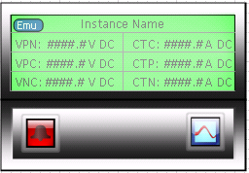

Figure : Typical Metering Point Display

#### Lab Section

|  |  |
| --- | --- |
|  |  |
|  | Example of a **lab section view** (concept / screen mockup) |

#### Lateral

|  |  |
| --- | --- |
|  | |
|  | Example of a **lateral view** (concept / screen mockup) |

#### FESB

|  |  |
| --- | --- |
|  | |
|  | **FESB Status**  Clicking the FESB status control drills down to the one-line diagram for the FESB |
| Figure : FESB One-Line Example | |

### Waveform Capturing & Viewing

#### Waveform Capture

|  |
| --- |
| Requests for data are made to the CRIO by the SCADA system. The response is captured, displayed, and logged as illustrated below: |
|  |

#### Waveform Viewing

##### Chart View & Format

|  |  |  |  |
| --- | --- | --- | --- |
|  | | The menu system provides methods to change the view, chart type, and to add additional chart area. | |
|  | | The user may configure chart formatting properties. | |
|  | | The format can be saved as a template and recalled by the user. Multiple templates may be created, saved and recalled by the user. | |
| Chart Zooming | | | |
|  |  | |  |

##### Viewing Multiple Channels

Multiple channels may be selected for viewing in the channel selection grid. The grid is populated with channel list and configuration by a database lookup for the associated CRIO.

The information below provides detail of the waveform capture and display testing that was observed during prototype. During the test, the GGS developed cRIO TCP driver and Waveform Display tool was running on a DELL LATITUDE E5510 laptop connected, via CAT-5 cable, to the switch at the prototype site.

Display time: Time from snapshot request to display on screen of the complete snapshot (5 seconds of data). Note that after this test was completed, the program was modified to display the waveform in parallel with the XML file creation. This improved the performance, shortening the display time. The time required was not measured.

Copy Time: Files for messages received are written to a common “receive location” once the message is received and written (XML File) to this location they are copied to a specified storage location. The copy time is the time that was required to copy the file from the receive location to the storage location.

|  |  |  |  |  |
| --- | --- | --- | --- | --- |
| Channels | **Samples Per Channel** | **File Size**  **(KB)** | **Approximate Display Time**  **(seconds)** | **Approximate Copy Time**  **(seconds)** |
| 1 | 250,000 | 9,133 | 0.8 | 1.8 |
| 2 | 250,000 | 18,260 | 1.8 | 5.4 |
| 3 | 250,000 | 27,412 | 2.6 | 4.5 |
| 4 | 250,000 | 36,607 | 3.5 | 6.17 |
| 5 | 250,000 | 45,845 | 4.4 | 6.64 |
| 6 | 250,000 | 55,040 | 5.2 | 7.39 |

While the data for all the channels of a cRIO may be captured and stored, attempting to view more than six channels during the capture will result in degradation of performance, including a lag in the display of the Waveform.

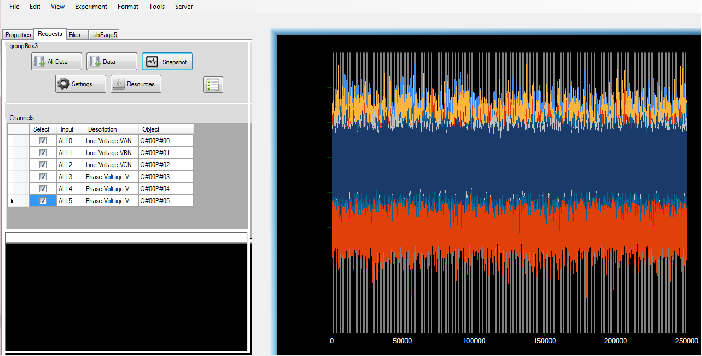

##### Waveform Alignment

|  |  |
| --- | --- |
|  |  |
|  | Waveforms may be stacked and aligned for comparison. |
|  |  |

##### Waveform Files

|  |  |
| --- | --- |
|  | |
|  | Collected waveform data is stored in an XML file format and stored in a pre-configured location. A entry is made in the database with a file location pointer and a cross reference to the experiment.  Files created for the current running experiment will be listed in the grid on the file tab. File may be filtered by message type. |
| |  |  |  | | --- | --- | --- | | Estimated File Sizes | | | | Channel Count | Samples Per Channel | File Size (KB) | | 1 | 250,000 | 9,133 KB | | 2 | 250,000 | 18,260 | | 3 | 250,000 | 27,412 | | 4 | 250,000 | 36,607 | | 5 | 250,000 | 45,845 | | 6 | 250,000 | 55,040 | |

##### Opening Stored Waveform Files

|  |  |
| --- | --- |
| Stored waveform files may be opened by using the menu commands; *File* 🡪 *Open* 🡪 *Waveform* *Snapshot.* | |
| The user is presented with a *file dialog* box navigated automatically to the user’s folder in the storage location specified in the server properties.  The user may “drill down” to any experiment specific files with which they have the privileges to view (*based on folder security*) |  |
|  |

# Process Control System (PCS)

## Common Components

### Labeling

Each major piece of process equipment, such as vessels and pumps, will have a description above the equipment symbol that includes the equipment number*, brief description (i.e., “*Chilled Water Pump*”), and control system tag number.

### Symbology

The symbols illustrated in this section are used for the representation of instruments and devices on area overview screens.

#### Pumps

Pump States indicated by color are Yellow: Alarm, Green: ON, Grey: OFF.

Constant feed pumps display KW used, Variable Speed pumps display Speed %.

A State label is located over the pump feedback display. It shows the ON/OFF state of the pump to give accompaniment to the state color changes of the pump.

The pump name is displayed over its graphical icon.

The icon will be “clickable” to display the pump controls pop-up.

|  |  |  |
| --- | --- | --- |
| **STATE** | **SYMBOL** | |
| **CONSTANT SPEED** | **VARIABLE SPEED** |
| **ALARM**  ***UnAck: Blinking***  ***Ack: Solid*** |  |  |
| **ON** |  |  |
| **OFF** |  |  |

#### Valves

Analog Valve position is shown in percent open regardless of valve position.

Failed to open and failed to close alarms are displayed (when associated I/O required for functionality is available)

Discrete and Modulating Valve states are shown and OPEN/CLOSED/ALARM.

The icon will be “clickable” to display the Valve controls pop-up.

|  |  |  |
| --- | --- | --- |
| **STATE** | **SYMBOL** | |
| **DISCRETE** | **MODULATING** |
| **ALARM**  ***UnAck: Blinking***  ***Ack: Solid*** |  |  |
| **OPEN** |  |  |
| **CLOSED** |  |  |

#### Boilers

Boiler icons will be accompanied with Voltage, Current, and Temperature Setpoint indication.

The boiler icon has a color indication to indicate Running, Stopped and Alarm States

The boiler icon will be clickable to display the Contol panel for the boiler.

|  |
| --- |
| **STATE** |
| **Color Representation** |
| **ALARM**  **“Blinking”** |  |
| **RUNNING** |  |
| **NOT RUNNING** |  |

#### Chillers

Chilller icons will be accompanied with Voltage, Current, and Temperature Setpoint indication.

The chiller icon has a color indicator to indicate Running, Stopped and Alarm states.

The chiller icon will be clickable to display the Control panel for the chiller.

|  |
| --- |
| **STATE** |
| **Color Representation** |
| **ALARM**  **“Blinking”** |  |
| **RUNNING** |  |
| **NOT RUNNING** |  |

#### Non-Animated Elements

Sensors, such as pressure or temperature, are connected to the associated process line or pipe with a solid, single pixel wide, line. Vessel probe instruments are shown protruding into vessel.

Sensors associated with PID loops will be “clickable” and will open the PID pop up for that loop. (see 3.1.3.3)

Process variables displays are shown near the sensor location and contain:

* Display tag name
* Tag number
* Engineering units
* Process Variable

|  |  |  |  |  |
| --- | --- | --- | --- | --- |
| **STATE** | **SYMBOL** | | | |
| **TEMPERATURE** | **PRESSURE** | **DIFFERENTIAL PRESSURE** | **FLOW** |
| **NORMAL** |  |  |  |  |
| **ALARM**  ***UnAck: Blinking***  ***Ack: Solid*** |  |  |  |  |

## Common Unit Graphics

Unit graphics within the Process Control System (PCS) Area of the SCADA System provide the following functionality as applicable to the related device or component:

1. Monitoring
   1. Status of control elements
   2. Process parameters for related field instruments.
   3. Current process step
   4. Interlock status.
2. Operation & Configuration
   1. Mode selection (AUTO/MANUAL)
   2. Manual Operation
   3. Setpoint Entry
   4. Navigation to sub-unit screens such as alarm details, configuration, and others as applicable.

### Pumps

Full Graphic Representation of the Pop-Up controls:

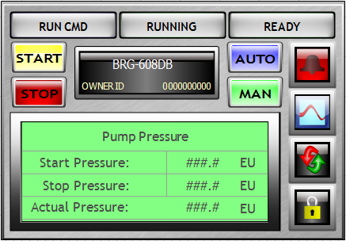

Figure: Constant Speed Pump

Figure: Variable Speed Pump

Common Buttons and functions for pumps:

|  |  |  |
| --- | --- | --- |
| **Name** | **ITEM** | |
| **SYMBOL** | **DESCTRIPTION** |
| **ALARM**  **CONTROL** |  | Pop-up Alarm controls, Set HH, HI, LO, LL alarms. View Real time Interaction of alarms with PV. (turns bright red when in alarm). |
| **START** |  | Button to start the pump, turns yellow when pump is started.  Button also provides pop-up with yes, no confirmation before command to start is sent to pump. |
| **STOP** |  | Button to stop the pump, turns red when pump is stopped.  Button also provides pop-up with yes, no confirmation before command to stop is sent to pump. |
| **AUTO** |  | Button to put the pump in Auto, turns blue when pump is in auto.  Button also provides pop-up with yes, no confirmation before pump is placed in auto |
| **MANUAL** |  | Button to put the pump in Manual, turns green when pump is in manual.  Button also provides pop-up with yes, no confirmation before pump is placed in manual |
| **RUN CMD** |  | Indicates Run Command, changes to blue in color. |
| **RUNNING** |  | Indicates pump running status, turns green when the pump is running |
| **READY** |  | Indicates pump is ready to be put in a running state. |
| **RESET** |  | Button to reset pump alarms |
| **LOCK-OUT** |  | Button used to put pump in Lock Out/Tag Out mode. |
| **NAME PLATE** |  | Display for pump name and  Owner Id (Logged in User) |
| **Pump Control**  **Indication Status** |  | Display Screen that displays indication values used in pump control. |

### Valves

Full Graphic Representation for Discrete Valves (Modulating Valves Use PID control).

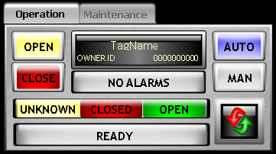

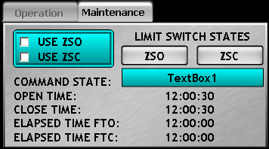

Common Buttons and Functions for Valves:

|  |  |  |
| --- | --- | --- |
| **Name** | **ITEM** | |
| **SYMBOL** | **DESCTRIPTION** |
| **ALARM**  **CONTROL** |  | Pop-up Alarm controls, Set HH, HI, LO, LL alarms. View Real time Interaction of alarms with PV. |
| **AUTO** |  | Button to put the pump in Auto, turns blue when pump is in auto.  Button also provides pop-up with yes, no confirmation before valve is placed in auto |
| **MANUAL** |  | Button to put the pump in Manual, turns green when pump is in manual.  Button also provides pop-up with yes, no confirmation before valve is placed in manual |
| **NAME PLATE** |  | Display for valve name and  Owner Id (Logged in User) |
| **ALARM BANNER** |  | Display Alarm state of valve |
| **READY** |  | Indicates valve is ready to be operated. |

1. Buttons and functions for Discrete Valves only:

|  |  |  |
| --- | --- | --- |
| **Name** | **ITEM** | |
| **SYMBOL** | **DESCTRIPTION** |
| **OPEN VALVE** |  | Open Command button for opening valve.  Button also provides pop-up with yes, no confirmation before valve is opened manually |
| **CLOSE VALVE** |  | Close Command button for Closing valve.  Button also provides pop-up with yes, no confirmation before valve is closed manually |
| **OPEN/CLOSED/**  **UNKNOWN STATE** |  | State indication for Discrete Valve |
| **ENABLE/DISABLE**  **OPEN/CLOSED FIELD INDICATION** |  | Enable/Disable field indication for troubleshooting valve problems |
| **VALVE POSITION FIELD INDICATION** |  | Field indication for valve troubleshooting |
| **COMMAND STATE INDICATION** |  | Display Current command sent to operate valve |
| **TIME COMMAND INDICATION** |  | Time indication used for troubleshooting valve operation. (FTC = Failed to Close, FTO = Failed to Open) |

Modulating valves will be controlled through the PID Loop control screens. Modulating valves will not have separate pop ups similar to the Discrete Valves.

### Boilers

Full Graphic Representation of Boiler Controls:

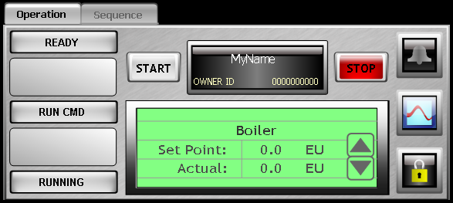

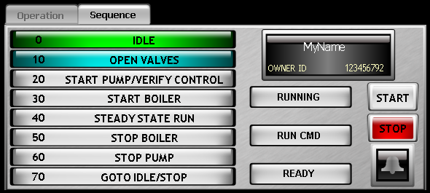

Common Buttons and Functions for Boilers:

|  |  |  |
| --- | --- | --- |
| **Name** | **ITEM** | |
| **SYMBOL** | **DESCTRIPTION** |
| **ALARM**  **CONTROL** |  | **Pop-up Alarm controls, Set HH, HI, LO, LL alarms. View Real time Interaction of alarms with PV.** |
| **START** |  | **Button to start the Boiler, turns yellow when Boiler is started.**  **Button also provides pop-up with yes, no confirmation before command to start is sent to Boiler.** |
| **STOP** |  | **Button to stop the boiler, turns red when boiler is stopped.**  **Button also provides pop-up with yes, no confirmation before command to stop is sent to Boiler.** |
| **NAME PLATE** |  | **Display for Boiler name and**  **Owner Id (Logged in User)** |
| **LOCK-OUT** |  | **Button used to put Boiler in Lock Out/Tag Out mode.** |
| **READY** |  | **Indicates Boiler is ready to be operated.** |
| **TREND** |  | **Open trends for Boiler.** |
| **Chiller Setpoint and Actual Temp display** |  | **Display Chiller Set Point and Actual Temperature Values, Set Point can be changed with proper UserAccessLevel** |
| **RUN CMD** |  | **Indicates Run Command, changes to blue in color.** |
| **RUNNING** |  | **Indicates boiler running status, turns green when the boiler is running** |
| **Sequence Indicator** |  | **Determines sequence current and finished states with color indication. Green = Step Finished, Blue = Step In Process, Grey = not currently active.** |

### Chillers

Full Graphic Representation of Chiller Controls:

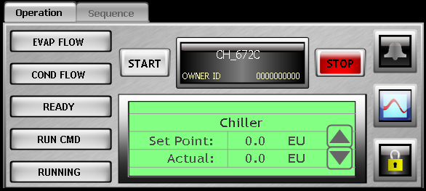

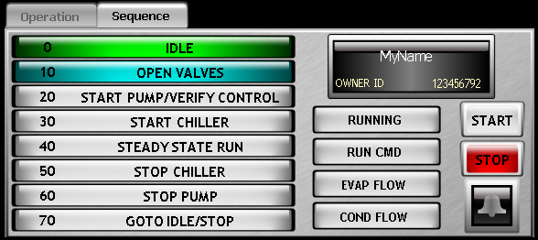

Common buttons and functions for Chillers:

|  |  |  |
| --- | --- | --- |
| **Name** | **ITEM** | |
| **SYMBOL** | **DESCTRIPTION** |
| **ALARM**  **CONTROL** |  | **Pop-up Alarm controls, Set HH, HI, LO, LL alarms. View Real time Interaction of alarms with PV.** |
| **START** |  | **Button to start the Chiller, turns yellow when Chiller is started.**  **Button also provides pop-up with yes, no confirmation before command to start is sent to Chiller.** |
| **STOP** |  | **Button to stop the chiller, turns red when chiller is stopped.**  **Button also provides pop-up with yes, no confirmation before command to stop is sent to Chiller.** |
| **NAME PLATE** |  | **Display for Chiller name and**  **Owner Id (Logged in User)** |
| **LOCK-OUT** |  | **Button used to put chiller in Lock Out/Tag Out mode.** |
| **READY** |  | **Indicates Chiller is ready to be operated.** |
| **TREND** |  | **Open trends for chiller.** |
| **Chiller Setpoint and Actual Temp display** |  | **Display Chiller Set Point and Actual Temperature Values, Set Point can be changed with proper UserAccessLevel** |
| **EVAP FLOW** |  | **Indicates Flow to the Evaporator** |
| **COND FLOW** |  | **Indicates Flow to the Condensator** |
| **RUN CMD** |  | **Indicates Run Command, changes to blue in color.** |
| **RUNNING** |  | **Indicates chiller running status, turns green when the chiller is running** |
| **Sequence Indicator** |  | **Determines sequence current and finished states with color indication. Green = Step Finished, Blue = Step In Process, Grey = not currently active.** |

### PID Control

PID Control Pop-Up:

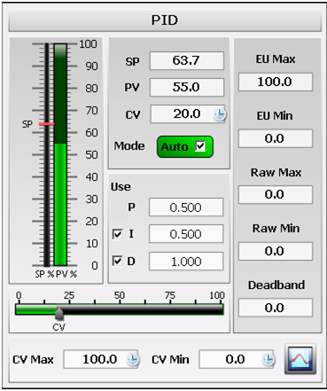

PID Control Pop up buttons and functions:

|  |  |  |
| --- | --- | --- |
| **Name** | **ITEM** | |
| **SYMBOL** | **DESCTRIPTION** |
| **Set Point needle with PV bar** |  | Set Point is adjustable by moving the SP pointer, The PV is real time feedback from the monitored process value. |
| **Mode Checkbox** |  | Check this box to put the PID loop in Auto/Man |
| **Set Point** |  | Manually enter and monitor the PID set point |
| **Process Value** |  | Monitor the PV |
| **Control Value** |  | Monitor and Control (in Manual mode) Control Value |
| **Proportional Value** |  | Proportional Gain value in the PID mathematical equation. |
| **Integral Value** |  | Integral Gain value in the PID mathematical equation. It has enable/disable checkbox and is editable with proper user access |
| **Differential Value** |  | Differential Gain value in the PID mathematical equation. It has enable/disable checkbox and is editable with proper user access |
| **CV Visual Slider** |  | Used to visually discern CV value. Slider can edit CV value when PID is in Manual Mode |
| **CV Maximum Value** |  | Edit the CV maximum Value. Requires proper user access level |
| **CV Minimum Value** |  | Edit the CV minimum Value. Requires proper user access level |
| **Trend Button** |  | Button to open PID, Alarm, Trend Overview screen |
| **Dead band Control** |  | Use this Field to edit the dead band of the PID Loop |
| **Raw Minimum Value Control** |  | Use this Field to edit the Raw Minimum Value of the PID Loop |
| **Raw Maximum Value Control** |  | Use this Field to edit the Raw Maximum Value of the PID Loop |
| **Engineering Units Maximum Value** |  | Use this Field to edit the Engineering Units Maximum Value of the PID Loop |
| **Engineering Units Minimum Value** |  | Use this Field to edit the Engineering Units Minimum Value of the PID Loop |

### Alarm Control Panel

Complete Alarm Pop-up graphic:

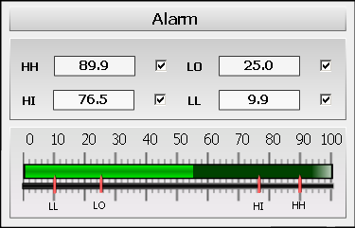

Alarm Control Panel Buttons and Functions:

|  |  |  |
| --- | --- | --- |
| **Name** | **ITEM** | |
| **SYMBOL** | **DESCTRIPTION** |
| **Alarm Set Point Visual Gauge** |  | **Visually monitor Alarm Status and change values with proper User Access Level** |
| **High, High Alarm Set Point** |  | **High, High Alarm Set point with enable/disable checkbox** |
| **High Alarm Set Point** |  | **High Alarm Set point with enable/disable checkbox** |
| **Low Alarm Set Point** |  | **Low Alarm Set point with enable/disable checkbox** |
| **Low, Low Alarm Set Point** |  | **Low, Low Alarm Set point with enable/disable checkbox** |

## Research Fuel Lines (RFL)

### System Controls (Non-Safety Functions)

#### Natural Gas

The Research Fuel Lines PLC (RFL) is responsible for the monitoring and totalization of natural gas flows to the following locations within the facility:

1. Laboratories
2. Domestic Hot Water Heater
3. Laboratory Hot Water Heater
4. Research Hot Water Boiler

Additionally, the system controls the diesel fuel supply pumps for the ESL and PSIL laboratories.

#### Diesel Fuel Pumps

In addition to monitoring the natural gas flows to the facility, the RFL PLC also controls the diesel fuel supply pumps to the Energy Systems Lab (ESL) and the Power Systems Integration Lab (PSIL). Each lab’s pump is connected to the diesel fuel storage tank in that particular lab, and each lab’s pump is manually started by the researcher when required. There is no automatic start control provided.

Pump(s) will be stopped when commanded or when a Low-Low level is detected by the RFL PLC for the associated diesel fuel storage tank.

#### Diesel Fuel Storage Tanks

The RFL PLC monitors the level in the diesel fuel tanks for the ESL and PSIL continuously. When the tanks are filled, the researcher enters the amount of fuel to be transferred into the tank at the HMI. When the researcher starts the filling process, the fill valve on the tank being filled will be commanded to open and fuel transfer will begin. Once the desired amount of fuel has been transferred or if the high level switch detects that the tank is in a high level state, the fill valve will be closed. The valve will also be closed on a high-high level alarm from the level transmitter for the tank.

## Hydrogen (H2) (Future)

### Area screens

Hydrogen systems are future and not Day 1. No area screens will be provided for hydrogen systems.

### System Controls

Hydrogen systems are future and not Day 1. No system controls will be provided for hydrogen systems.

## Research Heating and Cooling (RHC)

The Research Heating & Cooling (RHC) PLC controls three systems in the facility:

1. Primary Chilled Water
2. Secondary Chilled Water
3. Research Hot Water

Each system contains a set of two pumps which is expandable to three. The pumps operate in a “duty / standby” configuration whereby a single pump runs at a time. On the second Tuesday of the month, operators will be alerted by the SCADA system to rotate the pumps. Pumps are rotated manually. This action could take place at any time, but the SCADA rotation alert will be sent to the operators at the aforementioned interval. In the event of a pump fault or failure to start on the part of the lead pump, the pump rotation take place automatically and the next pump started.

Should rotation be requested while a pump is running, the second pump is started and allowed to accelerate to the same speed as the running pump before the rotation actually occurs. In this way, water flow through the system is maintained as is differential pressure during the rotation process.

The speed of the running pump is controlled by the differential pressure across the end of the distribution header using a PID loop. A setpoint for desired DP is entered and the pumps’ speeds are modulated by the system to maintain that DP. Thus, as demand on the system increases, DP will fall and the speed of the pumps will be increased to raise the DP to the desired level.

If the supply pump is running at minimum speed and the header differential pressure is at 110% of setpoint, the header pressure control valve will be modulated to maintain header DP at 110%.

### System Specific Controls (Non-Safety Functions)

#### Primary Chilled Water

The primary chilled water (PCW) system is started and stopped via a sequence in the PLC. The steps of that sequence are detailed below:

|  |  |  |
| --- | --- | --- |
| Step | Action | Transition Condition |
| 0 | Close all valves; stop all pumps; place pump speed PID loop into manual at minimum output | Sequence start pushbutton is pressed in HMI |
| 10 | Open FV-672B, FV-672C, FV-672E, and FV-672H | 30 second delay timer |
| 20 | Start lead pump | Lead pump running; evaporator and condenser flow established through chiller (5 minutes max.) |
| 30 | Start chiller | Chiller running |
| 40 | Steady state run; Enable system alarms | Sequence stop pushbutton is pressed in HMI |
| 50 | Stop chiller; Disable system alarms | Chiller has stopped |
| 60 | Stop lead pump | Lead pump has stopped |
| 70 | Return to step 0 (Idle Step) | N/A |

Should the chiller fail to start initially, the run command is deactivated and a reset command sent to the chiller. Start will then be attempted a second time. Should the chiller fail to start the second time, a maintenance alarm will be activated and the sequence aborted. Additionally, should both pumps fail to start, the sequence will also abort. In order to restart the sequence, all fail to start alarms MUST be acknowledged and cleared by the operator.

Should a problem be detected while the system is running (even if that problem is unrelated to the PCW system), a manual abort function is provided which will serve the same function as an emergency stop. The abort command will cause the sequence to return to the idle step immediately, without going through the normal shutdown steps.

If a problem is detected during system startup, pressing the stop pushbutton will advance the sequence to step 50 so that the shutdown section of the sequence will execute.

A glycol pump is provided to periodically inject glycol into the system. The glycol pump is a constant speed pump which runs when the glycol system pressure drops below a setpoint entered at the HMI. The pump will start and run until the pressure rises above a second configurable setpoint. Pump current is monitored and alarmed if it rises above a user-configurable threshold.

##### System I/O

The following table outlines the IO devices contained within the PCW system:

|  |  |  |
| --- | --- | --- |
| **Tag Name** | **Description** | **Type** |
| CCT_672CN | Research Chiller Current | AI |
| CVM_672CA | Research Chiller Voltage | AI |
| HBF_670BA | Research Primary Chilled Water System Lab Bypass Valve Position Indication | AI |
| HPD_670BB | Chilled Water Header Differential Pressure | AI |
| MKW_672CN | Chiller CH-672C Meter kW Reading | AI |
| PCM_672CA | Research Cooling Glycol System Pump Current | AI |
| PDT_672AC | Research Cooling Pump 672A Differential Pressure | AI |
| PDT_672BC | Research Cooling Pump 672B Differential Pressure | AI |
| PRE_672AA | Research Cooling Glycol System Pressure | AI |
| RFM_672AC | Research Chilled Water Return Flow | AI |
| RTT_672AB | Research Chilled Water Return Temperature | AI |
| STT_672AF | Research Chilled Water Supply Temperature | AI |
| VKW_672AA | Research Cooling Pump 672A VFD kW | AI |
| VKW_672BA | Research Cooling Pump 672B VFD kW | AI |
| VSF_672AA | Research Cooling Pump 672A VFD Speed Feedback | AI |
| VSF_672BA | Research Cooling Pump 672B VFD Speed Feedback | AI |
| HBV_670BA | Research Primary Chilled Water System Lab Bypass Valve Position Command | AO |
| VSP_672AA | Research Cooling Pump 672A VFD Speed Command | AO |
| VSP_672BA | Research Cooling Pump 672B VFD Speed Command | AO |
| HES_672CA | Glycol Pump ESTOP Switch | DI |
| VSR_672AA | Research Cooling Pump P-672A Running Indication | DI |
| VSR_672BA | Research Cooling Pump P-672B Running Indication | DI |
| CSV_672HA | Research Cooling Chiller Condenser Water Isolation Valve Open Command | DO |
| HBV_672BA | Research Cooling Heat Exchanger Bypass Valve Open Command | DO |
| PSS_672CA | Glycol Pump Start / Stop Command | DO |
| SBV_672FA | Research Cooling Chiller Plant Bypass from Ice House Valve Open Command | DO |
| SFV_672CA | Research Cooling Chiller Evaporator Inlet Isolation Valve open Command | DO |
| SFV_672EA | Research Cooling Chiller Evaporator Outlet Isolation Valve Open Command | DO |
| SFV_672GA | Research Cooling Chiller Plant Supply from Ice House Valve Open Command | DO |
| VSS_672AA | Research Cooling Pump P-672A Start / Stop Command | DO |
| VSS_672BA | Research Cooling Pump P-672B Start / Stop Command | DO |

##### System Alarms

The following is a summary of the available alarms in the PCW system. Alarms may be individually enabled or disabled from the HMI as needed. Additionally, alarms may be acknowledged individually or globally, depending on the need, from the HMI.

|  |  |
| --- | --- |
| **Alarm Tag** | **Alarm Description** |
| CCT_672CN.HH | Research Chiller Current High High Alarm |
| CCT_672CN.HI | Research Chiller Current High Alarm |
| CCT_672CN.LO | Research Chiller Current Low Alarm |
| CCT_672CN.LL | Research Chiller Current Low Low Alarm |
| CVM_672CA.HH | Research Chiller Voltage High High Alarm |
| CVM_672CA.HI | Research Chiller Voltage High Alarm |
| CVM_672CA.LO | Research Chiller Voltage Low Alarm |
| CVM_672CA.LL | Research Chiller Voltage Low Low Alarm |
| HBF_670BA.HH | Research Primary Chilled Water System Lab Bypass Valve Position Indication High High Alarm |
| HBF_670BA.HI | Research Primary Chilled Water System Lab Bypass Valve Position Indication High Alarm |
| HBF_670BA.LO | Research Primary Chilled Water System Lab Bypass Valve Position Indication Low Alarm |
| HBF_670BA.LL | Research Primary Chilled Water System Lab Bypass Valve Position Indication Low Low Alarm |
| HPD_670BB.HH | Chilled Water Header Differential Pressure High High Alarm |
| HPD_670BB.HI | Chilled Water Header Differential Pressure High Alarm |
| HPD_670BB.LO | Chilled Water Header Differential Pressure Low Alarm |
| HPD_670BB.LL | Chilled Water Header Differential Pressure Low Low Alarm |
| MKW_672CN.HH | Chiller CH-672C Meter kW Reading High High Alarm |
| MKW_672CN.HI | Chiller CH-672C Meter kW Reading High Alarm |
| MKW_672CN.LO | Chiller CH-672C Meter kW Reading Low Alarm |
| MKW_672CN.LL | Chiller CH-672C Meter kW Reading Low Low Alarm |
| PCM_672CA.HH | Research Cooling Glycol System Pump Current High High Alarm |
| PCM_672CA.HI | Research Cooling Glycol System Pump Current High Alarm |
| PCM_672CA.LO | Research Cooling Glycol System Pump Current Low Alarm |
| PCM_672CA.LL | Research Cooling Glycol System Pump Current Low Low Alarm |
| PDT_672AC.HH | Research Cooling Pump 672A Differential Pressure High High Alarm |
| PDT_672AC.HI | Research Cooling Pump 672A Differential Pressure High Alarm |
| PDT_672AC.LO | Research Cooling Pump 672A Differential Pressure Low Alarm |
| PDT_672AC.LL | Research Cooling Pump 672A Differential Pressure Low Low Alarm |
| PDT_672BC.HH | Research Cooling Pump 672B Differential Pressure High High Alarm |
| PDT_672BC.HI | Research Cooling Pump 672B Differential Pressure High Alarm |
| PDT_672BC.LO | Research Cooling Pump 672B Differential Pressure Low Alarm |
| PDT_672BC.LL | Research Cooling Pump 672B Differential Pressure Low Low Alarm |
| PRE_672AA.HH | Research Cooling Glycol System Pressure High High Alarm |
| PRE_672AA.HI | Research Cooling Glycol System Pressure High Alarm |
| PRE_672AA.LO | Research Cooling Glycol System Pressure Low Alarm |
| PRE_672AA.LL | Research Cooling Glycol System Pressure Low Low Alarm |
| RFM_672AC.HH | Research Chilled Water Return Flow High High Alarm |
| RFM_672AC.HI | Research Chilled Water Return Flow High Alarm |
| RFM_672AC.LO | Research Chilled Water Return Flow Low Alarm |
| RFM_672AC.LL | Research Chilled Water Return Flow Low Low Alarm |
| RTT_672AB.HH | Research Chilled Water Return Temperature High High Alarm |
| RTT_672AB.HI | Research Chilled Water Return Temperature High Alarm |
| RTT_672AB.LO | Research Chilled Water Return Temperature Low Alarm |
| RTT_672AB.LL | Research Chilled Water Return Temperature Low Low Alarm |
| STT_672AF.HH | Research Chilled Water Supply Temperature High High Alarm |
| STT_672AF.HI | Research Chilled Water Supply Temperature High Alarm |
| STT_672AF.LO | Research Chilled Water Supply Temperature Low Alarm |
| STT_672AF.LL | Research Chilled Water Supply Temperature Low Low Alarm |
| VKW_672AA.HH | Research Cooling Pump 672A VFD kW High High Alarm |
| VKW_672AA.HI | Research Cooling Pump 672A VFD kW High Alarm |
| VKW_672AA.LO | Research Cooling Pump 672A VFD kW Low Alarm |
| VKW_672AA.LL | Research Cooling Pump 672A VFD kW Low Low Alarm |
| VKW_672BA.HH | Research Cooling Pump 672B VFD kW High High Alarm |
| VKW_672BA.HI | Research Cooling Pump 672B VFD kW High Alarm |
| VKW_672BA.LO | Research Cooling Pump 672B VFD kW Low Alarm |
| VKW_672BA.LL | Research Cooling Pump 672B VFD kW Low Low Alarm |
| VSF_672AA.HH | Research Cooling Pump 672A VFD Speed Feedback High High Alarm |
| VSF_672AA.HI | Research Cooling Pump 672A VFD Speed Feedback High Alarm |
| VSF_672AA.LO | Research Cooling Pump 672A VFD Speed Feedback Low Alarm |
| VSF_672AA.LL | Research Cooling Pump 672A VFD Speed Feedback Low Low Alarm |
| VSF_672BA.HH | Research Cooling Pump 672B VFD Speed Feedback High High Alarm |
| VSF_672BA.HI | Research Cooling Pump 672B VFD Speed Feedback High Alarm |
| VSF_672BA.LO | Research Cooling Pump 672B VFD Speed Feedback Low Alarm |
| VSF_672BA.LL | Research Cooling Pump 672B VFD Speed Feedback Low Low Alarm |
| HES_672CA | Glycol Pump ESTOP Switch Pressed Alarm |
| VAL_672AA.Faulted | Research Cooling Pump P-672A Faulted |
| VAL_672BA.Faulted | Research Cooling Pump P-672B Faulted |
| VSR_672AA.FTS | Research Cooling Pump P-672A Failed to Start |
| VSR_672BA.FTS | Research Cooling Pump P-672B Failed to Start |
| FV_672H.DiscreteValve.FTO | Research Cooling Chiller Condenser Water Isolation Valve Failed to Open |
| FV_672H.DiscreteValve.FTC | Research Cooling Chiller Condenser Water Isolation Valve Failed to Close |
| FV_672C.DiscreteValve.FTO | Research Cooling Chiller Evaporator Inlet Isolation Valve Failed to Open |
| FV_672C.DiscreteValve.FTC | Research Cooling Chiller Evaporator Inlet Isolation Valve Failed to Close |
| FV_672E.DiscreteValve.FTO | Research Cooling Chiller Evaporator Outlet Isolation Valve Failed to Open |
| FV_672E.DiscreteValve.FTC | Research Cooling Chiller Evaporator Outlet Isolation Valve Failed to Close |
| FV_672A.DiscreteValve.FTO | Research Cooling Heat Exchanger Bypass Valve Failed to Open |
| FV_672A.DiscreteValve.FTC | Research Cooling Heat Exchanger Bypass Valve Failed to Close |
| FV_672F.DiscreteValve.FTO | Research Cooling Bypass from Ice House Valve Failed to Open |
| FV_672F.DiscreteValve.FTC | Research Cooling Bypass from Ice House Valve Failed to Close |
| FV_672G.DiscreteValve.FTO | Research Cooling Supply Valve from Ice House Valve Failed to Open |
| FV_672G.DiscreteValve.FTC | Research Cooling Supply Valve from Ice House Valve Failed to Close |

#### Secondary Chilled Water System

The secondary chilled water system (SCW) runs through the facility and has a supply temperature setpoint which is independent of the PCW supply temperature setpoint. SCW is supplied by mixing the primary and secondary chilled water supplies. As such, the SCW supply temperature setpoint may not be less than the PCW supply temperature setpoint.

Temperature is controlled using a mixing valve that allows enough heat exchange between the primary and secondary chilled water systems for the temperature of the secondary chilled water system to be maintained at setpoint.

The SCW pumps may be enabled from the HMI directly. Their speed is variably controlled in order to maintain a differential pressure across their distribution header.. Pump lead / lag operation is identical to the PCW pumps’ lead / lag operation as described above.

##### System I/O

|  |  |  |
| --- | --- | --- |
| **Tag Name** | **Description** | **Type** |
| HPD_670CB | Secondary Cooling Water Header Differential Pressure | AI |
| SFM_671CB | Secondary Chilled Water Supply Flow | AI |
| PDT_671AC | Secondary Chilled Water Pump 671-A Differential Pressure | AI |
| PDT_671BC | Secondary Chilled Water Pump 671-B Differential Pressure | AI |
| VSF_671AA | Secondary Cooling Water Pump P-671A Speed Feedback | AI |
| VKW_671AA | Secondary Cooling Water Pump P-671A VFD kW | AI |
| VSF_671BA | Secondary Cooling Water Pump P-671B Speed Feedback | AI |
| VKW_671BA | Secondary Cooling Water Pump P-671B VFD kW | AI |
| RTT_671CF | Secondary Cooling Water Return Temperature | AI |
| STT_671CD | Secondary Cooling Water Supply Temperature | AI |
| TMF_671CD | Primary / Secondary Chilled Water Mixing Valve Position Indication | AI |
| VSP_671AA | Secondary Cooling Water Pump P-671A Speed Reference | AO |
| VSP_671BA | Secondary Cooling Water Pump P-671B Speed Reference | AO |
| TMV_671CD | Primary / Secondary Chilled Water Mixing Valve Position Command | AO |
| VSR_671AA | Secondary Cooling Pump P-671A Running Indication | DI |
| VSR_671BA | Secondary Cooling Pump P-671B Running Indication | DI |
| VAL_671AA | Secondary Cooling Pump P-671A Faulted Indication | DI |
| VAL_671BA | Secondary Cooling Pump P-671B Faulted Indication | DI |
| VSS_671AA | Secondary Cooling Pump P-671A Start / Stop Command | DO |
| VSS_671BA | Secondary Cooling Pump P-671B Start / Stop Command | DO |

##### System Alarms

The following is a summary of the available alarms in the SCW system. Alarms may be individually enabled or disabled from the HMI as needed. Additionally, alarms may be acknowledged individually or globally, depending on the need, from the HMI.

|  |  |
| --- | --- |
| **Alarm Tag** | **Alarm Description** |
| HPD_670CB.HH | Secondary Cooling Water Header Differential Pressure High High Alarm |
| HPD_670CB.HI | Secondary Cooling Water Header Differential Pressure High Alarm |
| HPD_670CB.LO | Secondary Cooling Water Header Differential Pressure Low Alarm |
| HPD_670CB.LL | Secondary Cooling Water Header Differential Pressure Low Low Alarm |
| SFM_671CB.HH | Secondary Chilled Water Supply Flow High High Alarm |
| SFM_671CB.HI | Secondary Chilled Water Supply Flow High Alarm |
| SFM_671CB.LO | Secondary Chilled Water Supply Flow Low Alarm |
| SFM_671CB.LL | Secondary Chilled Water Supply Flow Low Low Alarm |
| PDT_671AC.HH | Secondary Chilled Water Pump 671-A Differential Pressure High High Alarm |
| PDT_671AC.HI | Secondary Chilled Water Pump 671-A Differential Pressure High Alarm |
| PDT_671AC.LO | Secondary Chilled Water Pump 671-A Differential Pressure Low Alarm |
| PDT_671AC.LL | Secondary Chilled Water Pump 671-A Differential Pressure Low Low Alarm |
| PDT_671BC.HH | Secondary Chilled Water Pump 671-B Differential Pressure High High Alarm |
| PDT_671BC.HI | Secondary Chilled Water Pump 671-B Differential Pressure High Alarm |
| PDT_671BC.LO | Secondary Chilled Water Pump 671-B Differential Pressure Low Alarm |
| PDT_671BC.LL | Secondary Chilled Water Pump 671-B Differential Pressure Low Low Alarm |
| VSF_671AA.HH | Secondary Cooling Water Pump P-671A Speed Feedback High High Alarm |
| VSF_671AA.HI | Secondary Cooling Water Pump P-671A Speed Feedback High Alarm |
| VSF_671AA.LO | Secondary Cooling Water Pump P-671A Speed Feedback Low Alarm |
| VSF_671AA.LL | Secondary Cooling Water Pump P-671A Speed Feedback Low Low Alarm |
| VKW_671AA.HH | Secondary Cooling Water Pump P-671A VFD kW High High Alarm |
| VKW_671AA.HI | Secondary Cooling Water Pump P-671A VFD kW High Alarm |
| VKW_671AA.LO | Secondary Cooling Water Pump P-671A VFD kW Low Alarm |
| VKW_671AA.LL | Secondary Cooling Water Pump P-671A VFD kW Low Low Alarm |
| VSF_671BA.HH | Secondary Cooling Water Pump P-671B Speed Feedback High High Alarm |
| VSF_671BA.HI | Secondary Cooling Water Pump P-671B Speed Feedback High Alarm |
| VSF_671BA.LO | Secondary Cooling Water Pump P-671B Speed Feedback Low Alarm |
| VSF_671BA.LL | Secondary Cooling Water Pump P-671B Speed Feedback Low Low Alarm |
| VKW_671BA.HH | Secondary Cooling Water Pump P-671B VFD kW High High Alarm |
| VKW_671BA.HI | Secondary Cooling Water Pump P-671B VFD kW High Alarm |
| VKW_671BA.LO | Secondary Cooling Water Pump P-671B VFD kW Low Alarm |
| VKW_671BA.LL | Secondary Cooling Water Pump P-671B VFD kW Low Low Alarm |
| RTT_671CF.HH | Secondary Cooling Water Return Temperature High High Alarm |
| RTT_671CF.HI | Secondary Cooling Water Return Temperature High Alarm |
| RTT_671CF.LO | Secondary Cooling Water Return Temperature Low Alarm |
| RTT_671CF.LL | Secondary Cooling Water Return Temperature Low Low Alarm |
| STT_671CD.HH | Secondary Cooling Water Supply Temperature High High Alarm |
| STT_671CD.HI | Secondary Cooling Water Supply Temperature High Alarm |
| STT_671CD.LO | Secondary Cooling Water Supply Temperature Low Alarm |
| STT_671CD.LL | Secondary Cooling Water Supply Temperature Low Low Alarm |
| TMF_671CD.HH | Primary / Secondary Chilled Water Mixing Valve Position Indication High High Alarm |
| TMF_671CD.HI | Primary / Secondary Chilled Water Mixing Valve Position Indication High Alarm |
| TMF_671CD.LO | Primary / Secondary Chilled Water Mixing Valve Position Indication Low Alarm |
| P_671A.VFD.Faulted | Secondary Cooling Pump P-671A Faulted Alarm |
| P_671B.VFD.Faulted | Secondary Cooling Pump P-671B Faulted Alarm |
| P_671A.VFD.FTS | Secondary Cooling Pump P-671A Failed to Start |
| P_671B.VFD.FTS | Secondary Cooling Pump P-671B Failed to Start |
| TMF_671CD.LL | Primary / Secondary Chilled Water Mixing Valve Position Indication Low Low Alarm |

#### Research Hot Water

The research hot water (RHW) system is started and stopped via a sequence in the PLC. The steps of that sequence are detailed below:

|  |  |  |
| --- | --- | --- |
| Step | Action | Transition Condition |
| 0 | Close TCV-674M; stop all pumps; place pump speed PID loop into manual at minimum output | Sequence start pushbutton is pressed in HMI |
| 10 | Open FV-674C, FV-674E, FV-674F, FV-674H, FV-674L and FV-674M | FV-674M > 95% open |
| 20 | Start lead pump | Lead pump running for 30 seconds |
| 30 | Start boiler | Boiler running |
| 40 | Steady state run; Enable system alarms | Sequence stop pushbutton is pressed in HMI |
| 50 | Stop boiler; Disable system alarms | Boiler has stopped |
| 60 | Stop lead pump | Lead pump has stopped |
| 70 | Return to step 0 (Idle Step) | N/A |

Should the boiler fail to start, a maintenance alarm will be activated and the sequence aborted. Additionally, should both pumps fail to start, the sequence will also abort. In order to restart the sequence, all fail to start alarms MUST be acknowledged and cleared by the operator.

Should a problem be detected while the system is running (even if that problem is unrelated to the RHW system), a manual abort function is provided which will serve the same function as an emergency stop. The abort command will cause the sequence to return to the idle step immediately, without going through the normal shutdown steps.

If a problem is detected during system startup, pressing the stop pushbutton will advance the sequence to step 50 so that the shutdown section of the sequence will execute.

##### System I/O

The following table outlines the devices contained within the RHW system:

|  |  |  |
| --- | --- | --- |
| **Tag Name** | **Description** | **Type** |
| HBF_670AA | Research Hot Water System Lab Bypass Valve Position Indication | AI |
| HPD_670AB | Hot Water Header Differential Pressure | AI |
| PDT_674AC | Research Hot Water Pump P-674A Differential Pressure | AI |
| PDT_674BC | Research Hot Water Pump P-674B Differential Pressure | AI |
| PRE_674FA | Research Hot Water System Pressure | AI |
| RCF_674MA | Research Hot Water Return Bypass Valve Position Indication | AI |
| RTT_674AD | Research Hot Water Boiler B-674A Inlet Temperature | AI |
| RTT_674AH | Research Hot Water System Return Temperature | AI |
| SFM_674AD | Research Hot Water Supply Flow | AI |
| SFM_674FC | Research Hot water System Non-Potable Water Supply Flow | AI |
| STT_674AC | Research Hot Water Boiler B-674A Outlet Temperature | AI |
| STT_674AE | Research Hot Water System Supply Temperature | AI |
| VKW_674AA | Research Hot Water Pump P-674A VFD kW | AI |
| VKW_674BA | Research Hot Water Pump P-674B VFD kW | AI |
| VSF_674AA | Research Hot Water Pump P-674A Speed Feedback | AI |
| VSF_674BA | Research Hot Water Pump P-674B Speed Feedback | AI |
| BSS_674AB | Research Hot Water Boiler B-674A Start / Stop and Setpoint Command | AO |
| HBV_670AA | Research Hot Water System Lab Bypass Valve Position Command | AO |
| RVC_674MA | Research Hot Water Boiler Bypass Valve Position Command | AO |
| VSP_674AA | Research Hot Water Pump P-674A Speed Reference | AO |
| VSP_674BA | Research Hot Water Pump P-674B Speed Reference | AO |
| BSR_674AA | Research Hot Water Boiler B-674A Running | DI |
| VAL_674AA | Research Hot Water Pump P-674A VFD Faulted | DI |
| VAL_674BA | Research Hot Water Pump P-674B VFD Faulted | DI |
| VSR_674AA | Research Hot Water Pump P-674A VFD Running | DI |
| VSR_674BA | Research Hot Water Pump P-674B VFD Running | DI |
| BBV_674FA | Research Hot Water Boiler #1 Bypass Valve Open Command | DO |
| BBV_674LA | Research Hot Water Boiler #2 Bypass Valve Open Command | DO |
| BSV_674EA | Research Hot Water Boiler #1 Supply Valve Open Command | DO |
| HBV_674CA | Research Hot Water Heat Exchanger Bypass Valve Open Command | DO |
| HBV_674HA | Research Hot Water Heat Exchanger Bypass Valve Open Command | DO |
| VSS_674AA | Research Hot Water Pump P-674A VFD Start / Stop Command | DO |
| VSS_674BA | Research Hot Water Pump P-674B VFD Start / Stop Command | DO |

##### System Alarms

The following is a summary of the available alarms in the RHW system. Alarms may be individually enabled or disabled from the HMI as needed. Additionally, alarms may be acknowledged individually or globally, depending on the need, from the HMI.

|  |  |
| --- | --- |
| **Alarm Tag** | **Alarm Description** |
| HBF_670AA.HH | Research Hot Water System Lab Bypass Valve Position Indication High High Alarm |
| HBF_670AA.HI | Research Hot Water System Lab Bypass Valve Position Indication High Alarm |
| HBF_670AA.LO | Research Hot Water System Lab Bypass Valve Position Indication Low Alarm |
| HBF_670AA.LL | Research Hot Water System Lab Bypass Valve Position Indication Low Low Alarm |
| HPD_670AB.HH | Hot Water Header Differential Pressure High High Alarm |
| HPD_670AB.HI | Hot Water Header Differential Pressure High Alarm |
| HPD_670AB.LO | Hot Water Header Differential Pressure Low Alarm |
| HPD_670AB.LL | Hot Water Header Differential Pressure Low Low Alarm |
| PDT_674AC.HH | Research Hot Water Pump P-674A Differential Pressure High High Alarm |
| PDT_674AC.HI | Research Hot Water Pump P-674A Differential Pressure High Alarm |
| PDT_674AC.LO | Research Hot Water Pump P-674A Differential Pressure Low Alarm |
| PDT_674AC.LL | Research Hot Water Pump P-674A Differential Pressure Low Low Alarm |
| PDT_674BC.HH | Research Hot Water Pump P-674B Differential Pressure High High Alarm |
| PDT_674BC.HI | Research Hot Water Pump P-674B Differential Pressure High Alarm |
| PDT_674BC.LO | Research Hot Water Pump P-674B Differential Pressure Low Alarm |
| PDT_674BC.LL | Research Hot Water Pump P-674B Differential Pressure Low Low Alarm |
| PRE_674FA.HH | Research Hot Water System Pressure High High Alarm |
| PRE_674FA.HI | Research Hot Water System Pressure High Alarm |
| PRE_674FA.LO | Research Hot Water System Pressure Low Alarm |
| PRE_674FA.LL | Research Hot Water System Pressure Low Low Alarm |
| RCF_674MA.HH | Research Hot Water Return Bypass Valve Position Indication High High Alarm |
| RCF_674MA.HI | Research Hot Water Return Bypass Valve Position Indication High Alarm |
| RCF_674MA.LO | Research Hot Water Return Bypass Valve Position Indication Low Alarm |
| RCF_674MA.LL | Research Hot Water Return Bypass Valve Position Indication Low Low Alarm |
| RTT_674AD.HH | Research Hot Water Boiler B-674A Inlet Temperature High High Alarm |
| RTT_674AD.HI | Research Hot Water Boiler B-674A Inlet Temperature High Alarm |
| RTT_674AD.LO | Research Hot Water Boiler B-674A Inlet Temperature Low Alarm |
| RTT_674AD.LL | Research Hot Water Boiler B-674A Inlet Temperature Low Low Alarm |
| RTT_674AH.HH | Research Hot Water System Return Temperature High High Alarm |
| RTT_674AH.HI | Research Hot Water System Return Temperature High Alarm |
| RTT_674AH.LO | Research Hot Water System Return Temperature Low Alarm |
| RTT_674AH.LL | Research Hot Water System Return Temperature Low Low Alarm |
| SFM_674AD.HH | Research Hot Water Supply Flow High High Alarm |
| SFM_674AD.HI | Research Hot Water Supply Flow High Alarm |
| SFM_674AD.LO | Research Hot Water Supply Flow Low Alarm |
| SFM_674AD.LL | Research Hot Water Supply Flow Low Low Alarm |
| SFM_674FC.HH | Research Hot water System Non-Potable Water Supply Flow High High Alarm |
| SFM_674FC.HI | Research Hot water System Non-Potable Water Supply Flow High Alarm |
| SFM_674FC.LO | Research Hot water System Non-Potable Water Supply Flow Low Alarm |
| SFM_674FC.LL | Research Hot water System Non-Potable Water Supply Flow Low Low Alarm |
| STT_674AC.HH | Research Hot Water Boiler B-674A Outlet Temperature High High Alarm |
| STT_674AC.HI | Research Hot Water Boiler B-674A Outlet Temperature High Alarm |
| STT_674AC.LO | Research Hot Water Boiler B-674A Outlet Temperature Low Alarm |
| STT_674AC.LL | Research Hot Water Boiler B-674A Outlet Temperature Low Low Alarm |
| STT_674AE.HH | Research Hot Water System Supply Temperature High High Alarm |
| STT_674AE.HI | Research Hot Water System Supply Temperature High Alarm |
| STT_674AE.LO | Research Hot Water System Supply Temperature Low Alarm |
| STT_674AE.LL | Research Hot Water System Supply Temperature Low Low Alarm |
| VKW_674AA.HH | Research Hot Water Pump P-674A VFD kW High High Alarm |
| VKW_674AA.HI | Research Hot Water Pump P-674A VFD kW High Alarm |
| VKW_674AA.LO | Research Hot Water Pump P-674A VFD kW Low Alarm |
| VKW_674AA.LL | Research Hot Water Pump P-674A VFD kW Low Low Alarm |
| VKW_674BA.HH | Research Hot Water Pump P-674B VFD kW High High Alarm |
| VKW_674BA.HI | Research Hot Water Pump P-674B VFD kW High Alarm |
| VKW_674BA.LO | Research Hot Water Pump P-674B VFD kW Low Alarm |
| VKW_674BA.LL | Research Hot Water Pump P-674B VFD kW Low Low Alarm |
| VSF_674AA.HH | Research Hot Water Pump P-674A Speed Feedback High High Alarm |
| VSF_674AA.HI | Research Hot Water Pump P-674A Speed Feedback High Alarm |
| VSF_674AA.LO | Research Hot Water Pump P-674A Speed Feedback Low Alarm |
| VSF_674AA.LL | Research Hot Water Pump P-674A Speed Feedback Low Low Alarm |
| VSF_674BA.HH | Research Hot Water Pump P-674B Speed Feedback High High Alarm |
| VSF_674BA.HI | Research Hot Water Pump P-674B Speed Feedback High Alarm |
| VSF_674BA.LO | Research Hot Water Pump P-674B Speed Feedback Low Alarm |
| VSF_674BA.LL | Research Hot Water Pump P-674B Speed Feedback Low Low Alarm |
| P_674A.VFD.Faulted | Research Hot Water Pump P-674A VFD Faulted Alarm |
| P_674B.VFD.Faulted | Research Hot Water Pump P-674B VFD Faulted Alarm |
| P_674A.VFD.FTS | Research Hot Water Pump P-674A Failed to Start Alarm |
| P_674B.VFD.FTS | Research Hot Water Pump P-674B Failed to Start Alarm |
| FV_674C.DiscreteValve.FTO | Research Hot Water Heat Exchanger Bypass Valve Failed to Open Alarm |
| FV_674C.DiscreteValve.FTC | Research Hot Water Heat Exchanger Bypass Valve Failed to Close Alarm |
| FV_674L.DiscreteValve.FTO | Research Hot Water Boiler Bypass Valve Failed to Open Alarm |
| FV_674L.DiscreteValve.FTC | Research Hot Water Boiler Bypass Valve Failed to Close Alarm |
| FV_674E.DiscreteValve.FTO | Research Hot Water Boiler Outlet Valve Failed to Open Alarm |
| FV_674E.DiscreteValve.FTC | Research Hot Water Boiler Outlet Valve Failed to Close Alarm |
| FV_674F.DiscreteValve.FTO | Research Hot Water Boiler Bypass Valve Failed to Open Alarm |
| FV_674F.DiscreteValve.FTC | Research Hot Water Boiler Bypass Valve Failed to Close Alarm |
| FV_674H.DiscreteValve.FTO | Research Hot Water Heat Exchanger Bypass Valve Failed to Open Alarm |
| FV_674H.DiscreteValve.FTC | Research Hot Water Heat Exchanger Bypass Valve Failed to Close Alarm |

### Heat Exchanger Carts

Each heat exchanger cart (HXC) provides monitoring and control of both the process and utility flow and temperature. In each case, a control loop is provided for each available process value. Researchers will have the ability to use the HXC in any of the following control configurations:

1. Control process temperature
2. Control process flow through the HXC
3. Control utility temperature change through the HXC
4. Control utility flow through the HXC

Selections for each of the above operational modes is provided through the HMI. Additionally, the researcher will have the ability to place any or all operating loops into manual and drive the flow control valve to any position. During an experiment, the flows through each side of the HXC (process and utility) may be totalized and that data retrieved later for analysis.

Entering and leaving temperatures for both the process and utility sides are monitored and logged. Additionally, the entering and leaving process pressures are monitored and logged.

Logic Flow Chart:



### Pump Carts

Each pump cart includes a VFD-driven pump, a flow meter, suction side and discharge side temperature sensors, a pressure sensor on the suction and discharge sides of the pump, and a modulating control valve. The pump cart can be used in two ways:

1. The cart can be used to control temperature by acting as a bridge between the utility and process sides. In this configuration, utility connections are ports “A” and “B.” Port “A” is the supply port and port “B” is the return port. The cross pipe acts as the mixing point. In this configuration, the TCV is used to vary the amount of utility flow through the cart, while the pump is run in order to maintain a process flow rate. Ports “C” and “D” are the process supply and return ports, respectively.
2. The cart can be used to control flow on the process side by closing the isolation valves on the “A” and “B” ports. In this control scenario, the flow meter is used to close the control loop and a setpoint is entered into a PID loop which will modulate pump drive speed in order to maintain the flow through the pump cart at setpoint.

Logic Flow Chart:



### System Controls (Safety Instrumented Functions)

The safety system PLC constantly communicates with the non-safety control system. Should the activation of any EPO switch by detected by the safety system, the associated system shall be stopped immediately.

## Master Safety System

### Overview

The safety PLC system comprises a master PLC and sixteen lab safety PLC’s, located in each of the labs. The system is designed so that the lab safety PLC’s can execute logic and respond locally to gas alarms, EPO buttons, and C-stop buttons without the presence of the master PLC. The master PLC is used to collect and distribute EPO and C-stop signals with other peer PLC’s such as the REDB, RHC, and RFL PLC’s. The master PLC is also the point of entrance for software-generated EPO and C-stop signals, which originate at SCADA level 3.

### System I/O

See Attachment B for a list of lab safety IO points and “Cause and Effect” charts for each lab.

#### Process Stop Buttons and Controlled Stop Active Relay

Certain labs have a yellow process stop button. The lab PLC locally controls a signaling relay which can be used to trigger an action. The signaling relay closes when the yellow button is pressed or when a C-stop flag has been set from SCADA level 3. The relay opens when the button and/or flag is released and the alarm has been reset from SCADA.

#### Controlled Stop

The controlled stop (C-stop) is an experiment-specific collection of SCADA level 3 alarms that trigger a common reaction. During experiment configuration, the user must select which alarms are to be included in the collection. By default the process stop button (yellow button) alarms for all labs included in the experiment are added to the collection, but they can be removed and any readable alarm can be added. The experiment’s single C-stop can be configured to open or close any rated switches that are owned by the experiment and set the C-stop flags in the lab PLC’s, but by default does nothing. If any of the selected alarms becomes active, the AOS commands the configured switches to open or close and sets lab PLC C-stop flags as configured. C-Stops must be manually reset via SCADA once the triggering alarms have been cleared. The C-stop is for equipment protection only. Note that the process stop buttons will not function if the redundant pair of AOS servers is not functioning, with the exception of the locally controlled contact.

#### EPO Buttons

Each lab is equipped with an EPO button (red button). The functionality of these buttons is hard-programmed into the safety system. Pressing the EPO button generates an EPO action. Generally, an EPO action consists of:

* The red light and alarm horn turn on
* Any gasses present in the lab are isolated
* If the lab has REDB connections, an EPO signal is sent to the REDB system
* Security is notified

#### Software EPO Alarms

The software emergency power off (SEPO) is an experiment-specific collection of SCADA level 3 alarms that trigger a configured set of EPO actions, effectively remotely pressing a selected set of EPO buttons. During experiment configuration, the user must select which alarms are to be included in the collection and which EPOs are to be activated. If a SEPO becomes active, SCADA level 3 logic sets a flag bit in the SAFETY PLC for each EPO to be activated. The SAFETY PLC logically ORs the switch state with the software flag and forwards the combined EPO signal to all other Siemens safety PLCs in the system. SEPOs must be reset via SCADA once the triggering alarms have been cleared.

By default, all EPO switches included in the experiment are configured to be activated by the SEPO, and the controlled stop alarm is selected as a triggering alarm, so that by default the C-stop pushbuttons in a given experiment have the same functionality as the EPO buttons. SEPOs are for equipment protection only.

#### Gas Detection

Gas detectors have an analog output that signals the gas level, an alarm contact, and a trouble contact.

##### Gas Detector Alarms

When a gas detector goes into alarm (generated in the detector unit), an EPO action is triggered. In addition:

* The fire system interface contact is activated
* The blue alarm light turns on. If there is no blue light in the lab the red light is used.
* If the gas is a flammable gas, the red light is used in addition to the blue light.
* A BAS interface contact is closed to signal the BAS system to increase ventilation to the lab

##### Analog Warning Level Alarms

Analog alarms are processed in the local lab PLC. If any of the gas detectors exhibits a warning level alarm (less gas than a detector-based alarm), the yellow warning light turns on and BAS is requested to increase ventilation.

##### Trouble Alarms

If any of the trouble alarm contacts in the gas detectors becomes active, the yellow warning light turns on. If the BAS system detects trouble with a VESDA pump (which services the smoke detectors as well as the gas detectors), the SCADA system displays an alarm and the yellow warning light turns on.

#### Alarms & Messages

* EPO Active Alarm
* Process Stop Button Active Alarm
* Gas Detector Alarms
* Gas Detector Trouble Alarms
* Gas Detector Analog Alarms (Warning and Action Level)
* EPO Switch Redundant Signal Mismatch
* EPO Active Relay Signal Mismatch

### Safety Instrumented Functions

#### EPO Switch Monitoring

EPO switch strings utilize redundant sets of contacts. The safety program of the lab PLC’s verifies that these two signals agree. If they do not agree, the EPO is assumed to be activated and an alarm is generated.

#### EPO Active Relay

When an EPO is active as a result of an EPO button being pressed, a SEPO, or a gas detector alarm, the lab PLC safety program energizes the EPO active relay. The EPO active relay energizes the shunt trip to the house power supply breaker for the area. The relay contacts are monitored, and if the contact state does not match the commanded state, an alarm is generated.

# Building Automation System (BAS)

## Overview

* The Building Automation System (BAS) is a commercial control system (Delta – provided by others) to provide sequence control of the building and laboratory environmental systems to maintain appropriate space conditions as outlined in the mechanical basis of design.
* A Laboratory has hardwired safety connections to it’s remote Safety PLC rack for critical sequence operations as required by the laboratory.
* Safety-critical action signals are hardwired between the safety PLC and the BAS.
* Non-safety critical signals will be conveyed between the BAS and the SCADA system via network digital communication (BacNET/MODBUS)
* Setpoint signals between the SCADA system and the BAS will be conveyed via network digital communication.
* The BAS communicates to the Master SCADA System to provide information required for research purposes and to retrieve information required by the building energy models. BAS set points for room temperature and room humidity can be modified via the SCADA system.

## System I/O interfaced to SCADA/PLC

|  |  |  |  |  |  |
| --- | --- | --- | --- | --- | --- |
| **Area(DP5)** | **Description** | **Data Path** |  | **Connection** |  |
| **Electrochemical Char. Lab (from DP-601)** | Hood Status | BAS to SCADA |  | BACNET/MODBUS |  |
|  | Hood Alarm | BAS to SCADA |  | BACNET/MODBUS |  |
|  | Room DP | BAS to SCADA |  | BACNET/MODBUS |  |
|  | AIT-H2 Action | SAFETY PLC |  | HARDWIRED |  |
|  | AIT-CO Action | SAFETY PLC |  | HARDWIRED |  |
|  | Lab Temperature | BAS to SCADA |  | BACNET/MODBUS |  |
|  | Lab Humidity | BAS to SCADA |  | BACNET/MODBUS |  |
| **Energy Sys Fabrication Lab (from DP-602)** | Hood Status | BAS to SCADA |  | BACNET/MODBUS |  |
|  | Hood Alarm | BAS to SCADA |  | BACNET/MODBUS |  |
|  | Room DP | BAS to SCADA |  | BACNET/MODBUS |  |
|  | AIT-H2 Action | SAFETY PLC |  | HARDWIRED |  |
|  | Lab Humidity | BAS to SCADA |  | BACNET/MODBUS |  |
| **Fuel Cell Dev. And Test Lab (from DP-603)** | Hood Status | BAS to SCADA |  | BACNET/MODBUS |  |
|  | Hood Alarm | BAS to SCADA |  | BACNET/MODBUS |  |
|  | Room DP | BAS to SCADA |  | BACNET/MODBUS |  |
|  | AIT-H2 Action | SAFETY PLC |  | HARDWIRED |  |
|  | AIT-CO Action | SAFETY PLC |  | HARDWIRED |  |
|  | AIT-NH3 Action | SAFETY PLC |  | HARDWIRED |  |
|  | AIT-H25 Action | SAFETY PLC |  | HARDWIRED |  |
|  | AIT-O2 Action | SAFETY PLC |  | HARDWIRED |  |
|  | Lab Temperature | BAS to SCADA |  | BACNET/MODBUS |  |
|  | Lab Humidity | BAS to SCADA |  | BACNET/MODBUS |  |
| **Manufacturing Lab (from drawing DP-604)** | Hood Status | BAS to SCADA |  | BACNET/MODBUS |  |
|  | Hood Alarm | BAS to SCADA |  | BACNET/MODBUS |  |
|  | Room DP | BAS to SCADA |  | BACNET/MODBUS |  |
|  | AIT-H2 Action | SAFETY PLC |  | HARDWIRED |  |
|  | Lab Temperature | BAS to SCADA |  | BACNET/MODBUS |  |
|  | Lab Humidity | BAS to SCADA |  | BACNET/MODBUS |  |
| **High Pressure Testing Bay Lab (from drawing DP-605)** | AIT-H2 Action | SAFETY PLC |  | HARDWIRED |  |
|  | AIT-O2 Action | SAFETY PLC |  | HARDWIRED |  |
|  | Lab Temperature | BAS to SCADA |  | BACNET/MODBUS |  |
|  | Lab Humidity | BAS to SCADA |  | BACNET/MODBUS |  |
| **Sensor Lab (from drawing (DP-606)** | Hood Status | BAS to SCADA |  | BACNET/MODBUS |  |
|  | Hood Alarm | BAS to SCADA |  | BACNET/MODBUS |  |
|  | Room DP | BAS to SCADA |  | BACNET/MODBUS |  |
|  | AIT-H2 Action | SAFETY PLC |  | HARDWIRED |  |
|  | Lab Room Pressure | BAS to SCADA |  | BACNET/MODBUS |  |
|  | Lab Temperature | BAS to SCADA |  | BACNET/MODBUS |  |
|  | Lab Humidity | BAS to SCADA |  | BACNET/MODBUS |  |
| **Materials Characterization Lab (from drawing DP-607)** | Hood Status | BAS to SCADA |  | BACNET/MODBUS |  |
|  | Hood Alarm | BAS to SCADA |  | BACNET/MODBUS |  |
|  | Room DP | BAS to SCADA |  | BACNET/MODBUS |  |
|  | AIT-H2 Action | SAFETY PLC |  | HARDWIRED |  |
|  | Lab Humidity | BAS to SCADA |  | BACNET/MODBUS |  |
| **Energy Systems Integration Lab (from drawing DP-608)** | Hood Status | BAS to SCADA |  | BACNET/MODBUS |  |
|  | Hood Alarm | BAS to SCADA |  | BACNET/MODBUS |  |
|  | Room DP | BAS to SCADA |  | BACNET/MODBUS |  |
|  | AIT-H2 Action | SAFETY PLC |  | HARDWIRED |  |
|  | AIT-UV/IR Action | SAFETY PLC |  | HARDWIRED |  |
|  | AIT Heat Action | SAFETY PLC |  | HARDWIRED |  |
|  | Ventilation Fan Status | BAS to SCADA |  | BACNET/MODBUS |  |
|  | Lab Temperature | BAS to SCADA |  | BACNET/MODBUS |  |
|  | Lab Humidity | BAS to SCADA |  | BACNET/MODBUS |  |
| **Electrical Characterization Lab (from drawing DP-609)** | Room DP | BAS to SCADA |  | BACNET/MODBUS |  |
|  | AIT-H2 Action | SAFETY PLC |  | HARDWIRED |  |
|  | Lab Temperature | BAS to SCADA |  | BACNET/MODBUS |  |
|  | Lab Humidity | BAS to SCADA |  | BACNET/MODBUS |  |
| **Machine Shop Lab (from drawing DP-610)** | Hood Status | BAS to SCADA |  | BACNET/MODBUS |  |
|  | Hood Alarm | BAS to SCADA |  | BACNET/MODBUS |  |
|  | Room DP | BAS to SCADA |  | BACNET/MODBUS |  |
|  | Lab Temperature | BAS to SCADA |  | BACNET/MODBUS |  |
| **Optical Characterization Lab (from drawing DP-611)** | Room DP | BAS to SCADA |  | BACNET/MODBUS |  |
|  | Lab Temperature | BAS to SCADA |  | BACNET/MODBUS |  |
| **Smart Power Lab (from drawing DP-612)** | Room DP | BAS to SCADA |  | BACNET/MODBUS |  |
|  | Lab Temperature | BAS to SCADA |  | BACNET/MODBUS |  |
| **Power Systems Integration Lab (from drawing DP-613)** | AIT-O2 Action | SAFETY PLC |  | HARDWIRED |  |
|  | AIT-NOX Action | SAFETY PLC |  | HARDWIRED |  |
|  | AIT-CO Action | SAFETY PLC |  | HARDWIRED |  |
|  | Lab Temperature | BAS to SCADA |  | BACNET/MODBUS |  |
| **Energy Storage Lab (from drawing DP-615)** | AIT-O2 Action | SAFETY PLC |  | HARDWIRED |  |
|  | AIT-H2 Action | SAFETY PLC |  | HARDWIRED |  |
|  | AIT-CO Action | SAFETY PLC |  | HARDWIRED |  |
|  | Lab Temperature | BAS to SCADA |  | BACNET/MODBUS |  |
|  | Lab Dewpoint | BAS to SCADA |  | BACNET/MODBUS |  |
|  | Lab Humidity | BAS to SCADA |  | BACNET/MODBUS |  |
| **Thermal Storage Process Lab (from drawing DP-617)** | Hood Status | BAS to SCADA |  | BACNET/MODBUS |  |
|  | Hood Alarm | BAS to SCADA |  | BACNET/MODBUS |  |
|  | Room DP | BAS to SCADA |  | BACNET/MODBUS |  |
|  | AIT-H2 Action | SAFETY PLC |  | HARDWIRED |  |
|  | Lab Temperature | BAS to SCADA |  | BACNET/MODBUS |  |
|  | Lab Humidity | BAS to SCADA |  | BACNET/MODBUS |  |
| **Energy Storage OTA Lab (from drawing DP-619)** | AIT-H2 Action | SAFETY PLC |  | HARDWIRED |  |
|  | AIT-UV/IR Action | SAFETY PLC |  | HARDWIRED |  |

## Graphical User Interface (GUI)

User interface to the BAS from the Master SCADA takes place at the “Laboratory” level. A User has access to a pop-up menu from the individual Laboratory overview screens to manipulate setpoints for laboratory temperature and humidity (where available). Laboratory temperature and humidity (from the BAS), as well as other parameters (where required) such as dewpoint, etc., are displayed on the individual Laboratory overview screens. A BAS overview/summary screen is available from the navigation 'tree' menu that allows total visualization of the information passed between SCADA and the BAS.

### System Overview Screen

There is a single BAS overview screen, designed primarily as an aid to Maintenance, which provides an overview of the status or data associated with each of the I/O points in the IO table (Section 7.2) and information available over the BAS-SCADA BacNet/MODBUS interface (status and alarms).

### Alarms & Messages

Alarms and messages generated from the BAS data by the Master SCADA are displayed in the SCADA alarm banner and summary. Alarms generated from instrumentation connected to SCADA (through the safety PLC) are also displayed on the lab screens, and are sent to the BAS by means of a single hardwired dry contact. The single contact (in most instances) does not communicate to the BAS the specific device causing contact closure, but serves mainly to alert BAS to a life-safety of unsecure condition so that BAS may respond appropriately. Alarms generated in SCADA by instrumentation or devices connected to the PLC-interface can be acknowledged and cleared from SCADA (once the alarming condition is remedied).

# Fire & Security System

## Overview

The Fire and Security Systems receive status information with the Master SCADA system by means of hardwired contacts from the individual safety PLC remote racks. These hardwired connections serve to communicate to the Fire and Security systems a general "alarm" state within the monitored area.

## Graphical User Interface (GUI)

There is no direct SCADA visualization into either the Fire or Security systems. The laboratory area screens display the status of the contacts from their local PLCs that are inputs to the Fire and Security systems.

### Overview Screen

A single overview screen in the Master SCADA serves to display the status of all inputs to the Fire and Security systems through the hardwired connections to the remote safety PLC racks. This browser-type screen is intended to allow security personnel to quickly ‘drill down’ into the area of interest to identify specifically which device or devices may have initiated the 'alarm' event.

### Alarms & Messages

Alarm conditions are hard coded in the respective area's PLC and linked to the state of a single dry contact (output) from the PLC to the Fire and Security systems. In a laboratory with multiple fuel sources or types of gasses, any one or combination of instruments may initiate an alarm condition within the PLC. This means that the Fire system or Security system is only 'aware' that an alarm condition exists within an area, and not which specific device is generating the alarm. All ESTOPs (EPO actions) initiate contact closure (indication) to the Security system. Security personnel, upon receiving notification from the Security system that an event has occurred, will be able to navigate (by using the Overview screen) to the specific laboratory or area where the alarm originated, and thereby be able to identify the specific reason for the alarm. The Fire System contact is closed by SCADA for the same conditions that initiate contact closure to the Security System, with the exception of an ESTOP (EPO): this is true in all areas except for the LVOTA and MVOTA, which do not have conditional attachment to the Fire system. A contact from the Fire System is hardwired to the Safety PLC to give an indication of a fire alarm in the High Bay, which generates a SCADA-displayed alarm.

# Laboratories

## Overview

The MASTER SCADA monitors individual lab use of each of the following:

* Electricity
* Water
* Gasses
* Fuels

Unit (Lab) Graphics provide an operator access to Lab monitoring and manual control. The Unit Graphic is designed for operator access to necessary information to determine state of process without having to leave that Unit Graphic. Monitoring functions include the following:

* Status of control elements
* Process parameters for each field instrument
* Interlock status and description(s)
* Access to specific control and monitoring sub-graphics from unit graphics

## Graphical User Interface (GUI)

The Area Overview screens provide navigation to the Unit Graphics screens for each laboratory. The Unit Graphics can also be accessed directly from the navigation 'tree' menu.

### Lab Screen (Typical Unit graphics)

Each laboratory HMI has access to the complete Master SCADA system. The purpose of a laboratory is to conduct experiments. The Master SCADA treats each individual laboratory as a ‘Unit’, and will by default display the HMI graphics locally that are pertinent to that laboratory.

The general laboratory screen schema involves four (template) screens:

1. The REDB View Screen – an overview of the entire REDB bus utilized by a laboratory;
2. The Lateral View Screen – a view of the ‘lateral’ branch of the REDB bus that serves the lab
3. The Test View Screen – an overview screen that allows an experimenter to set-up, control, and view experiment-specific parameters (see Section 10 - Experiments).
4. The Room View Screen – an overview screen that supports the operator’s visualization of laboratory-specific equipment, alarms, configurations, and data capture and transfer. All Room View screens provide a visualization of monitored lab utilities and of REDB lateral status.

Each of the above-referenced screens are provided with pop-up screens that allow the experimenter to ‘drill-down’ to access control and visualization aspects of specific devices or equipment. Each screen also includes the ability to navigate quickly to each of the other screens, or to SCADA functions external to a specific laboratory.

## Laboratory Details

### ****Electrochemical Characterization Laboratory****

#### Area Screens

The Electrochemical Characterization Laboratory has the base laboratory template screens. This lab has a local display monitor. The screens specific to this lab are generally accessed from the Area Overview screen of 'Area A - Level 3'.

##### Lab Overview Screen (from drawing DP-601)

The Electrochemical Characterization lab Room View screen has indication of the status of:

* H2 AITs indication (pressure, flow, & temperature)
* H2, H2S, and CO detector status
* Status of H2 block and bleed valves
* Gas Bottle Manifold status (O2 and CO, Hi Purity N2 and H2)
* Lab room temperature
* Lab room humidity
* Hood status
* REDB lateral status

From this screen, the operator can shut down the individual gas manifolds (CO & Hi Purity H2), send setpoints to the BAS for room temperature and humidity, and control the state of the H2 block and bleed valves. The screen is designed to accommodate the (future) addition of multiple NI workstations and laboratory equipment (reference DP-601).

##### Alarms & Messages

Alarms configured:

* Gas Bottle Manifold alarms (N2, H2, O2, CO)
* Hood Alarm
* Alert alarm for H2
* Action alarm for H2
* Alert alarm for CO
* Action alarm for CO
* Action alarm for H2S
* Trouble alarms - H2, CO, H2S detectors
* EPO action alarm

##### Security Interface

The Security System dry contact interface is activated whenever any of the following occur:

* H2 detector alarm
* CO detector alarm
* H2S detector alarm
* EPO action

##### BAS Interface

The BAS system dry-contact interface is activated whenever any of the following occur:

* H2, H2S, or CO detector warning alarm; or
* H2, H2S, or CO detector alarm

Through the Master SCADA HMI, temperature and humidity setpoints for the lab can be sent to the BAS. The BAS sends Hood Status and Alarms to SCADA.

### ****Energy Systems Fabrication Laboratory****

#### Area Screens

The **Energy Systems Fabrication** Laboratory has the base laboratory template screens. This lab has a local display monitor. These lab screens are usually accessed from the 'Area A - Level 3' Area screen.

##### Lab Overview (from drawing DP-602)

The **Energy Systems Fabrication** Laboratory Room View screen has indication of the following:

* Warning and Trouble alarm of H2 detector
* Action level alarm of H2 detector
* H2 AITs indication (pressure, flow, temperature)
* Status of H2 block and bleed valves and pressure switch
* CO Gas Manifold alarm
* Lab Room temperature
* Lab Room humidity
* EPO Status
* REDB lateral status

From this screen, the operator can send setpoints to the BAS for room temperature and humidity, and control the state of the H2 block and bleed valves.

##### Alarms & Messages

Configured alarms/messages in this lab:

* H2 detector Warning
* H2 detector Trouble
* H2 detector alarm
* CO Gas Manifold alarm
* Hood alarm
* EPO action

##### Security Interface

The Security System dry contact interface is activated whenever any of the following occur:

* H2 detector alarm, or
* EPO action

##### BAS Interface

The BAS system dry-contact interface is activated whenever any of the following occur:

* H2 detector warning
* H2 detector alarm

Through the Master SCADA HMI, temperature and humidity setpoints for the lab can be sent to the BAS. The BAS sends Hood Alarms to SCADA.

### ****Fuel Cell Development & Testing Laboratory****

#### Area Screens

The **Fuel Cell Development & Testing** Laboratory has the base laboratory template screens. This lab has a local display monitor. These screens reside below the 'Area A - Level 3' area screen.

##### Lab Overview (from drawing DP-603)

The **Fuel Cell Development & Testing** Laboratory Room View screen has indication of the following:

* Status of the DI Water system
* H2 Bottle S flow
* Gas Manifold Alarms - CH4, NH3, CO/H2, He, Ar, O2, HiPurity H2
* Detector Trouble - H2, H2S, NH3, CO/O2
* Detector Warning - H2, H2S, NH3, CO, O2
* Detector Alarm - H2, H2S, NH3, CO, O2
* H2 AITs indication (pressure, flow, temperature)
* Status of H2 block and bleed valves and pressure switch
* Lab Room temperature
* Lab Room humidity
* Dew Point
* EPO status
* REDB lateral status

From this screen, the operator can shut down the individual gas manifolds (CH4, NH3, CO/H2, Hi Purity H2), send setpoints to the BAS for room temperature and humidity, and control the state of the H2 block and bleed valves. The Room View screen is able to accommodate future expansion to include NI test stations and other (future) lab equipment.

##### Alarms & Messages

Configured alarms/messages:

* DI Water system Trim alarm
* DI Water system alarm
* Warning alarm for H2, NH3, CO, O2, and H2S
* Action alarm for H2, NH3, CO, O2, and H2S
* Trouble alert for gas detectors for H2, H2S, NH3, & CO/O2
* Gas Manifold alarms for CH4, NH3, CO/H2, He, Ar, O2, & HiPurity H2
* EPO action

##### Security Interface

The Security System dry contact interface is activated whenever any of the following occur:

* H2 detector alarm
* CO detector alarm
* O2 detector alarm
* NH3 detector alarm
* H2S detector alarm
* EPO action

##### BAS Interface

The BAS system dry-contact interface is activated whenever any of the following occur:

* H2 detector alarm
* CO detector alarm
* O2 detector alarm
* NH3 detector alarm
* H2S detector alarm
* H2 detector warning alarm
* CO detector warning alarm
* O2 detector warning alarm
* NH3 detector warning alarm
* H2S detector warning alarm

Through the Master SCADA HMI, temperature and humidity setpoints for the lab can be sent to the BAS. BAS sends Hood status and alarms to SCADA.

### Manufacturing Laboratory

#### Area Screens

The **Manufacturing Laboratory** has the base laboratory template screens.. This lab has a local display monitor. This lab's Room View screen is typically accessed from the 'Area A -Level 3' overview screen.

##### Lab Overview (from drawing DP-604)

The **Manufacturing Laboratory** Room View screen has indication of the following:

* Status of H2 block and bleed valves and pressure switch
* Trouble, Warning, and Action alarms of H2 detectors
* Lab Room temperature
* Lab Room humidity
* Dew Point

From this screen, the operator can send setpoints to the BAS for room temperature and humidity, and control the state of the H2 block and bleed valves.

##### Alarms & Messages

Configured alarms for this Laboratory:

* Trouble alarm for H2 detector
* Alert alarm for H2 detector
* Action alarm for H2 detector
* EPO action

##### Security Interface

The Security System dry contact interface is activated whenever any of the following occur:

* H2 detector alarm, or
* EPO action

##### BAS Interface

The BAS system dry-contact interface is activated whenever any of the following occur:

* H2 detector warning alarm, or
* H2 detector alarm

Through the Master SCADA HMI, temperature and humidity setpoints for the lab can be sent to the BAS. BAS sends Hood status and alarms and dewpoint to SCADA.

### ****Energy Systems High Pressure Testing Bay Laboratory****

#### Area Screens

The **Energy Systems High Pressure Testing Bay** Laboratory graphic are part of the Energy Systems Integration Laboratory (see 9.3.8)

### ****Energy Systems Sensor Laboratory****

#### Area Screens

The **Energy Systems Sensor** Laboratory has the base laboratory template screens, modified to include laboratory-specific utilities and equipment. This lab has a local display monitor.

##### Lab Overview (from drawing DP-606)

The **Energy Systems Sensor** Laboratory overview screen has indication of the following:

* Gas Manifold Alarms - CH4, CO2, Ar, HiPurity H2
* Detector Trouble - H2
* Detector Alarm - H2
* H2 AITs indication (pressure, flow, temperature)
* Status of H2 block and bleed valves and pressure switch
* Lab Room temperature
* Lab Room humidity
* Dew Point
* Hood status
* EPO status
* REDB lateral status

From this screen, the operator can shut down the individual gas manifolds (Silane, Hi Purity H2), send setpoints to the BAS for room temperature and humidity, and control the state of the H2 block and bleed valves.

##### Alarms & Messages

Configured alarms for this Laboratory:

* Alert alarm for H2 detector
* Action alarm for H2 detector
* Trouble alarm for H2 detector
* Individual Gas Manifold Alarms - (CH4, CO2, Ar, HiPurity H2)
* H2 flow alarm
* H2 pressure alarm
* H2 temperature alarm
* Hood alarm
* EPO action

##### Security Interface

The Security System dry contact interface is activated whenever any of the following occur:

* H2 detector alarm, or
* EPO action

##### BAS Interface

The BAS system dry-contact interface is activated whenever any of the following occur:

* H2 detector warning alarm, or
* H2 detector alarm

Through the Master SCADA HMI, temperature and humidity setpoints for the lab can be sent to the BAS. BAS sends Hood status and alarms to SCADA.

### ****Materials Characterization Laboratory****

#### Area Screens

The **Materials Characterization** Laboratory has the base laboratory template screens.. This lab has a local display monitor. This lab's Room View screen is typically accessed from the 'Area A -Level 3' overview screen.

#### Lab Overview (from drawing DP-607)

The **Materials Characterization** Laboratory Room View screen has indication of the following:

* Gas Manifold Alarms - CH4, CO2, Ar, HiPurity H2
* Detector Trouble - H2, H2S
* Detector Alarm - H2, H2S
* H2 AITs indication (pressure, flow, temperature)
* Status of H2 block and bleed valves and pressure switch
* Lab Room temperature
* Lab Room humidity
* Hood status
* EPO status
* REDB lateral status

From this screen, the operator can shut down the individual gas manifolds (CH4, Hi Purity H2), send setpoints to the BAS for room temperature and humidity, and control the state of the H2 block and bleed valves.

##### Alarms & Messages

Configured alarms for this Laboratory:

* Gas Manifold Alarms - CH4, CO2, Ar, HiPurity H2
* Detector Trouble alarm- H2, H2S
* Alert alarm for H2, H2S detectors
* Action alarm for H2, H2S detectors
* Hood alarms
* H2 Flow, Temperature, and Pressure Alarms
* EPO action

##### Security Interface

The Security System dry contact interface is activated whenever any of the following occur:

* H2 detector alarm
* H2S detector alarm
* EPO action

##### BAS Interface

The BAS system dry-contact interface is activated whenever any of the following occur:

* H2 detector warning alarm
* H2 detector alarm
* H2S detector warning alarm
* H2S detector alarm

Through the Master SCADA HMI, temperature and humidity setpoints for the lab can be sent to the BAS. BAS sends Hood status and alarms to SCADA.

### ****Energy Systems Integration Lab****

#### Area Screens

The **Energy Systems Integration** Laboratory has the base laboratory template screens.. This lab's Room View screen is typically accessed from the 'Area A -Level 3' overview screen. This lab has a local display monitor located in the Control Room, and two desktop pc/monitor combinations in the Control Room. ESIL includes the two High Pressure Test Bay (HPTB) laboratories. The **Energy Systems Integration** Laboratory Room View screen is typically accessed from the 'Area A - Level 3' area graphic screen.

##### Lab Overview (from drawing DP-608, 605)

The **Energy Systems Integration** Laboratory Room View screen has indication of the following:

* HPTB 1 H2 detector alarm
* HPTB 1 O2 detector alarm
* HPTB 2 H2 detector alarm
* HPTB 2 O2 detector alarm
* H2 detector trouble alarm (6)
* H2 detector action alarm (6)
* HPTB 1&2 Door switch status
* NG shutoff valve state
* H2 Vent Heat trace status
* H2 block and bleed valve states
* O2 vent temperature
* Lab Room temperature
* Lab Room humidity
* Hood status
* REDB lateral status

From this screen, the operator can control the state of the H2 block and bleed valves, control the NG shut off valve, and send setpoints to the BAS for room temperature and humidity..

##### Alarms & Messages

Alarms configured for this Lab area:

* HPTB 1 H2 detector alarm
* HPTB 1 O2 detector alarm
* HPTB 2 H2 detector alarm
* HPTB 2 O2 detector alarm
* H2 detector trouble alarm (6)
* H2 detector action alarm (6)
* HPTB 1&2 Door switch alarm
* Hood alarms
* O2 vent temperature warning alarm
* O2 vent temperature alarm

##### Security Interface

The Security System dry contact interface is activated whenever any of the following occur in ESIL:

* H2 detector alarm
* EPO action
* Electrolyzer #3 ESTOP

In addition, each of the two HPTBs include a separate contact closure to the Security system to indicate:

* Test active (one in each Bay), and
* Electrolyzer ESTOP (one in each Bay)

##### BAS Interface

The BAS system dry-contact interface is activated whenever any of the following occur:

* HPTB1 H2 detector warning
* HPTB2 H2 detector warning
* HPTB1 O2 detector warning
* HPTB2 O2 detector warning
* H2 detector warning (6 separate)

Through the Master SCADA HMI, temperature and humidity setpoints for the lab can be sent to the BAS. BAS sends Hood status and alarms to SCADA.

### ****Electrical Characterization Laboratory****

#### Area Screens

The **Electrical Characterization** Laboratory has the base laboratory template screens. This lab has a local display monitor. These screens are typically accessed from the 'Area A - Level 3' area screen.

##### Lab Overview (from drawing DP-609)

The **Electrical Characterization** Laboratory Room View screen has indication of the following:

* H2 level
* H2 block and bleed valve states
* H2 BB pressure switch status
* NG shutoff valve state
* Lab Room temperature
* Lab Room humidity
* Room Dewpoint
* EPO status
* REDB lateral status

##### Alarms & Messages

* H2 detector trouble alarm
* H2 detector alarm
* H2 detector High alarm
* EPO action

##### Security Interface

The Security System dry contact interface is activated whenever the following occurs:

* H2 detector alarm

##### BAS Interface

The BAS system dry-contact interface is activated whenever the following occurs:

* H2 detector alarm

Through the Master SCADA HMI, temperature and humidity setpoints for the lab can be sent to the BAS. The BAS sends temperature, humidity, and dewpoint information to the SCADA.

### ****Machine Shop Laboratory****

#### Area Screens

The **Machine Shop** Laboratory has no visual interface to SCADA.

##### Security Interface

The **Machine Shop** Laboratory has no Security interface to SCADA.

##### BAS Interface

The Master SCADA is able to display the following Machine Shop information on the BAS overview screen (see Section 7.1):

* Room Dew Point
* Lab temperature
* Hood status and alarms

### ****Optical Characterization Laboratory****

#### Area Screens

The **Optical Characterization** Laboratory has a local display monitor. There is no SCADA-interfaced equipment for this laboratory (reference drawing DP-611). The Optical Characterization Lab Room View screen is typically accessed from the 'Area B - Level 3' overview screen.

##### Security Interface

There is no SCADA interface to the Security system for this lab..

##### BAS Interface

The BAS sends the following information for this lab to SCADA:

* Room Dew Point
* Lab temperature

Through the Master SCADA HMI, temperature setpoint for the lab can be sent to the BAS.

### ****Smart Power Laboratory****

#### Area Screens

The **Smart Power** Laboratory has the base laboratory template screens.. This lab has a local display monitor. This lab's Room View screen is typically accessed from the 'Area B -Level 3' overview screen.

##### Lab Overview (from drawing DP-612)

The **Smart Power** Laboratory overview screen has indication of the following:

* EPO action
* NG shutoff valve status
* Temperature
* Room Dewpoint

The main function of the overview screen will be to configure NI (Labview) interfaces to the Master SCADA system for (future) analytical devices. From this screen, an operator can control the NG valve.

##### Alarms & Messages

* EPO action

##### Security Interface

The Security System dry contact interface is activated whenever any of the following occur:

* EPO action

##### BAS Interface

The BAS sends the following information for this lab to SCADA:

* Lab temperature
* Room Dewpoint

Through the Master SCADA HMI, temperature setpoint for the lab can be sent to the BAS.

### ****Power Systems Integration Laboratory****

#### Area Screens

The **Power Systems Integration** Laboratory has the base laboratory template screens. This lab has a local display monitor. This lab's Room View screen is typically accessed from the 'Area B -Level 3' overview screen.

##### Lab Overview (from drawing DP-613)

The **Power Systems Integration** Laboratory overview screen has indication of the following:

* CO detector level
* O2 detector level
* NO2 detector level
* SG3 Gas Manifold status
* EPO status
* Lab Room temperature
* Lab Room humidity
* NG shutoff valve status

From this screen, the operator can control the NG shutoff valve. In the future, this room view screen will provide a RDC to the 250kW DC station in this lab, and navigation to a screen devoted to the Drive-in Environmental Test chamber PLC.

##### Alarms & Messages

Configured alarms:

* Warning alarm for CO detector
* Action level alarm for CO detector
* Trouble alarm of CO/O2 detector
* Warning alarm of room O2 detector
* Action level alarm of room O2 detector
* Warning alarm of room NO2 detector
* Action level alarm of room NO2 detector
* Trouble alarm of NO2 detector
* SG3 gas manifold alarm
* EPO action

##### Security Interface

The Security System dry contact interface is activated whenever any of the following occur:

* CO2 detector alarm
* O2 detector alarm
* NO2 detector alarm
* EPO action

##### BAS Interface

The BAS system dry-contact interface is activated whenever any of the following occur:

* CO2 detector warning alarm
* CO2 detector alarm
* O2 detector warning alarm
* O2 detector alarm
* NO2 detector warning alarm
* NO2 detector alarm

Through the Master SCADA HMI, temperature setpoint for the lab can be sent to the BAS.

### ****Energy Storage Laboratory****

#### Area Screens

The Energy Storage Laboratory has the base laboratory template screens.. This lab has a local display monitor. This lab's Room View screen is typically accessed from the 'Area A -Level 3' overview screen.

##### Lab Overview (from drawing DP-615)

The **Energy Storage** Laboratory room view screen has indication of the following:

* H2 detector level (2)
* O2 detector level (2)
* CO detector level (2)
* NG shutoff valve status
* Lab Dewpoint
* Lab temperature
* Lab humidity

From this screen, the operator can send temperature and humidity setpoints to the BAS system, and can control the NG shutoff valve.

##### Alarms & Messages

Configured alarms:

* H2 detector Warning Alarm (2)
* O2 detector Warning Alarm (2)
* CO detector Warning Alarm (2)
* H2 detector Trouble alarm (2)
* O2 detector Trouble alarm
* CO/O2 detector Trouble alarm (2)
* H2 detector alarm (2)
* CO detector alarm (2)
* O2 detector alarm
* EPO action

##### Security Interface

The Security System dry contact interface is activated whenever any of the following occur:

* H2 detector alarm (2)
* CO detector alarm (2)
* O2 detector alarm
* EPO action

##### BAS Interface

The BAS system dry-contact interface is activated whenever any of the following occur:

* H2 detector Warning Alarm (2)
* O2 detector Warning Alarm (2)
* CO detector Warning Alarm (2)
* H2 detector alarm (2)
* CO detector alarm (2)
* O2 detector alarm

SCADA receives laboratory temperature, humidity, and dewpoint from the BAS, and can send temperature and humidity setpoints for the lab to BAS.

### ****Thermal Storage Materials Laboratory****

#### Area Screens

The **Thermal Storage Materials** Laboratory has the base laboratory template screens. This lab has a local display monitor. These screens are typically accessed from the 'Area A - Level 3' area screen.

##### Lab Overview (from drawing DP-616)

The **Thermal Storage Materials** Laboratory room view screen has indication of the following:

* H2 detector level
* SG1 gas manifold status
* SG2 gas manifold status
* Lab Room temperature
* Lab Room humidity
* Status of Hoods (3)

##### Alarms & Messages

Configured alarms:

* H2 detector Trouble alarm
* H2 detector Warning alarm
* H2 detector alarm
* SG1 gas manifold alarm
* SG2 gas manifold alarm
* Hood Alarm (3)
* EPO action

##### Security Interface

The Security System dry contact interface is activated whenever any of the following occur:

* H2 detector alarm
* EPO action

##### BAS Interface

The BAS system dry-contact interface is activated whenever any of the following occur:

* H2 detector Warning alarm
* H2 detector alarm

Temperature and humidity setpoints for this laboratory can be sent from SCADA to the BAS.

### ****Thermal Storage Process Laboratory****

#### Area Screens

The **Thermal Storage Process** Laboratory has the base laboratory template screens. This lab has a local display monitor. These screens are typically accessed from the 'Area A - Level 3' area screen.

##### Lab Overview (from drawing DP-617)

The **Thermal Storage Process** Laboratory room view screen has indication of the following:

* H2 detector level
* Lab Room temperature
* Lab Room humidity
* Lab Dewpoint
* Status of Hood

##### Alarms & Messages

Configured alarms:

* H2 detector Trouble alarm
* H2 detector Warning alarm
* H2 detector alarm
* Hood Alarm
* EPO action

##### Security Interface

The Security System dry contact interface is activated whenever either of the following occur:

* H2 detector alarm
* EPO action

##### BAS Interface

The BAS system dry-contact interface is activated whenever either of the following occur:

* H2 detector Warning alarm
* H2 detector alarm

Temperature and humidity setpoints for this laboratory can be sent from SCADA to the BAS.

### ****Energy Storage Outdoor Test Area (FUTURE work)****

#### Area Graphics (future)

The **Energy Storage Outdoor Test Area** Laboratory has the base laboratory template screens. The lab has a local display monitor.

##### Lab Overview (from drawing DP-619, future)

The **Energy Storage Outdoor Test Area** Laboratory Room View screen will have indication of the following:

* Alert level of area H2 AIT
* Action level of area H2 AIT
* Action level of area UV/IR AIT

The overview screen will provide navigation to a separate screen which provides visualization and control of a remote tank farm/compressor application.

##### Alarms & Messages (future)

* Alert alarm for H2 AIT
* Action alarm for H2 AIT
* Action Alarm for UV/IR AIT
* EPO action

##### Security Interface (future)

A hardwired dry contact through a remote Safety PLC rack to the security system will engage when any of the following occurs:

* AIT-H2 action
* AIT –UV/IR action
* EPO action

##### BAS Interface (future)

The BAS system dry-contact interface is activated whenever any of the following occur:

* H2 AIT action
* UV/IR AIT action

### ****Low Voltage Outdoor Test Area****

#### Area Screens

The **Low Voltage Outdoor Test Area** Laboratory has a basic laboratory template screen, accessible from the Building Overview screen or from the navigation 'tree' menu. This area has a local display monitor.

##### Lab Overview (from drawing DP-620)

The **Low Voltage Outdoor Test Area** Laboratory overview screen has indication of the following:

* location of EPO (5)
* EPO status
* NG shutoff valve status (2)

##### Alarms & Messages

Configured alarms:

* EPO action (5)

##### Security Interface

The Security System dry contact interface is activated whenever any of the following occur

* EPO action (any)

##### BAS Interface

There is no interface with BAS.

### ****Medium Voltage Outdoor Test Area****

#### Area Screens

The **Medium Voltage Outdoor Test Area** Laboratory has a basic laboratory template screen, accessible from the Building Overview screen or from the navigation 'tree' menu. This area has a local display monitor.

##### Lab Overview (from drawing DP-621)

Laboratory Room View screen has indication of the following:

* location of EPOs
* EPO status
* NG utility diagram
* Status of Gas Turbine NG shutoff valves (2)
* Status of Gen Set NG shutoff valve
* Status of NG shutoff valve

##### Alarms & Messages

Configured alarms:

* EPO action (8)

##### Security Interface

The Security System dry contact interface is activated whenever any of the following occur

* EPO action (8)

##### BAS Interface

There is no interface with BAS.

# Experiments

## Experiment Configurations

### Overview

**Experiment configurations** are made up of **Stages**, **Operations**, and **Process** **Actions**.

**Stages** provide a method of organizing operations into segments that can be “staged” and loaded at different times through the course of an experiment.

**Operations** are made up of one or more process actions. A **Process Action** is the lowest level of the experiment configuration in which an I**tem** (single setting or parameter) is loaded to the system.

|  |  |
| --- | --- |
|  | |
|  | An experiment configuration must contain at least one (1) stage, the example configuration shown here includes three (3) stages.  **Stages**  To illustrate the potential use of stages, in this example the stages are initialize, energize, and de-energize. The first stage would setup the components in the experiment, the second would energize them, and later the third stage could be used to de-energize the experiment.  **Operations**  The operations for stage 1 are expanded and show how they can be used to group process actions. This is most useful for ordering operations (or actions) that are sequence critical.  **Process Actions**  Each operation must contain at least one (1) process action, but may contain many. In the example of operation 1 – REDB Setup, the process actions close the switches in an ordered sequence.  **Items**  Refer to the item within the system that is being affected by the process action. For example; in closing a breaker the item being affected would be the request close tag. |

### Creating Experiment Configurations

|  |  |
| --- | --- |
|  | |
|  | A new experiment configuration is created from the Experiment Configuration Management (*Area Overview*) Screen. The user may **navigate** to the screen using the “***My Experiments***” button on the header menu or through the **Explorer Menu**. |
|  | **“My Experiments”**  May filter configurations to display by group level (**Include Group**) or private (**Private Only** - default).  All configurations, based on filter selection will be displayed and the selected configuration, if any, will be indicated.  Click the **Create New** button, or use **ALT-N** one the keyboard, to create a new Experiment configuration  Click the **Edit** button, or use **ALT-E** one the keyboard, to edit the selected Experiment configuration.  Click the **Delete** button, or use **ALT-D** one the keyboard, to delete* the selected Experiment configuration. (***Must be confirmed***) |
|  | The **New Experiment Configuration** dialog box will be displayed when a request is made to create a new configuration.  Select the **access level** of the experiment to **Include Group** or to be a **Private Only,** or personal, configuration  Enter the configuration name and description.  The user’s information will be displayed, but cannot be modified.  Save the configuration or Cancel to back out without saving. Saving at this point created the configuration record in the master configuration list with an ID, name, and description. The configuration will not be valid until stage(s), operation(s), and process action(s) are added. | |
| The next steps of adding/creating stage(s), operation(s), and process action(s) can be done from a “blank” configuration by selecting each item for configuration manually **OR** by using configuration templates, described in the following sections. | | |

### Saving

Experiment Configurations are saved a master list of experiments configurations. This master list is maintained in the database with related records for **stages**, **operations** and **process actions**. The master experiment configuration list is associated with the user.

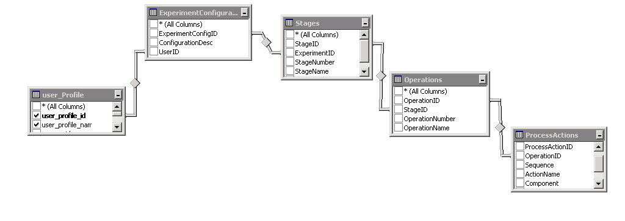

Only the user that created the configuration, or a user with a supervisor access level, may modify the configuration.

Modifications, or edits, to the configuration are tracked and logged in the database with the date-time, user ID, and a record of the modification *(old value / new value*).

The database schema facilitates the ability to export configurations or configuration sub-sections. This will allow the configuration information to be used by the researcher outside the system or to share the configuration with other users

### Templates

|  |  |
| --- | --- |
| The Experiment Configuration Management includes Base Templates (for major system components) to aid in the creation on experiment configurations. User Defined Templates may also be created new or based on existing templates. | |
|  | Templates are organized by **System**, **Component**, and **Sub-Component** .  A template for the REDB System would include the individual REDBs as components, breakers and metering points as sub-components.  The user may select for any or all of the items included in the template at any level. |
| **Example of Template Function** | |
| Figure 16: Configuration Template Illustration | The REDB, RBD21, contains laterals which contains breakers and metering points. Selecting from a REDB List, the user may select one or more of the laterals.  After selecting the lateral, the use may select all the configurable **items** (to become a process action) within the lateral or select specific items. Examples of items would be switch open/close request, alarm setpoints and enables. The selected items are presented to the user in a “spreadsheet” style grid for configuration |

## Creating ExperimentS

|  |  |
| --- | --- |
|  | |
|  | A new experiment is created from the Experiment Configuration Management (*Area Overview*) Screen. The user may **navigate** to the screen using the “***My Experiments***” button on the header menu or through the **Explorer Menu**. |
|  | **“My Experiments”**  May filter experiments to display by group level (**Include Group**) or private (**Private Only** - default).  All non-archived experiments, based on filter selection will be displayed and the selected experiment, if any, will be indicated.  Click the **Create New** button, or use **ALT-N** one the keyboard, to create a new Experiment.  Click the **Edit** button, or use **ALT-E** one the keyboard, to edit the selected Experiment configuration.  Experiments cannot be **deleted** |
|  | The **New Experiment** dialog box will be displayed when a request is made to create a new experiment.  Select the **access level** of the experiment to **Include Group** or to be a **Private Only,** or personal, experiment  Enter the **Experiment** **Name** and **Description**.  The user’s information will be displayed, but cannot be modified.  Save the experiment or Cancel to back out without saving. Saving at this point creates the experiment record in the master experiment list with an ID, name, and description. The configuration will not be valid until stage(s), operation(s), and process action(s) are added. |
|  | After saving the initial experiment information the user will be prompted to select or enter the associated **Client** information. This information is not required, but if entered will be associated with the experiment. |

### Selecting Equipment

#### Overview

A database record exists for all equipment or devices (system, components, sub-components) within the system. For those items that are capable of being owned, a record of checked in/out is maintained; along with the check in/out date-time and the user.

This information can be viewed in the system in a data grid (spreadsheet like format). In addition, the devices can be checked in or out using the grid.

Devices that are checked out will appear in the “Owned-Devices” list for the user, as shown below.

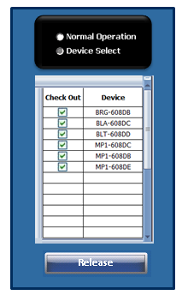

Equipment or devices (system, components, sub-components) appearing on a one-line diagrams* and having a “pick point”, used for normal operations, may be selected for ownership in the manner described in the REDB example.

Items such a such as REDB components, FESBs, and Fixed equipment appear on one-line diagrams. Components such as DAQ Carts, Pump Carts, and Hx Carts do not always appear on one-lines. They can be selected through the equipment list or their associated configuration screens.

\**In area overview screen or unit screen*

#### REDB Components Selection

|  |
| --- |
| In the example below, devices are selected from a lab lateral. The functionality is the same on the racetrack screens.  When in experiment “**Device Select**” mode, operation pick points become selection points.  After clicking an item it will be added to the owned devices list in the **Experiment Select** popup; if not currently owned.  To release a item uncheck the box beside the device in the list. Or, to release all items, use the Release button at the bottom of the window. |
|  |

### 

### Setup & Configure Experiment Parameters

|  |  |
| --- | --- |
| **Item** | **Description** |
| 1 | Breaker operation, or state change, will not be permitted on a live bus |
| 2 | To close a breaker in the context of an experiment, not already saved as a configuration, the following steps will be required to select and ready breakers for operation.   1. The user must have the proper credentials. If not already logged into the system they will be required to do so before continuing. 2. Using the GUI the user will select the breakers required to form the desired REDB path. As each breaker is selected, the system will confirm the validity of the selection based on previously selected breakers and the state of surrounding breakers. A valid selection, for each breaker will be indicated graphically on the screen. In the case of an invalid selection the user will notified with a popup screen and corresponding message. 3. The user will indicate to the system when breaker selection (and other devices / components) is complete. At this time, if the configuration is valid, the user will be prompted to save the configuration as a recipe. At the time of saving the recipe, the user will have the option of “**Save Only**” or “**Save and Engage**” (Default Selection). *Note that once saved as a recipe, the configuration can be recalled at anytime. However, the configuration may not be valid at a later time due to the state of surrounding breakers and other equipment. In such case, the “activation” of the recipe / configuration will not be permitted. Other options will be presented – see details in Experiment Configuration and Loading* 4. If “**Save and Engage**” was selected when saving the recipe configuration, once the save is complete, the system will prompt the user to “**Acknowledge and Engage**” the setup. Upon confirmation the system will activate the settings according to the recipe configuration, including closing the breakers. For details regarding this functionality can be found in *Experiment Configuration and Loading* |
| 3 | Upon completion of the experiment the user will select to have the resources released to available. The sequence and logic for opening the breakers will be as follows:   1. The system will OPEN any source breakers that have not already been placed in an OPEN position. 2. After verification that the voltage and current is below dead bus threshold setpoint, the system will prompt the user to acknowledge the opening of the REDB breakers. Confirmation will cause the system to open all racetrack, finger isolation and finger tie breakers associated with the REDB configuration. |
| 4 | Breakers located within the REDB may not be configured in such a way as to create an “S” Shaped Configuration as shown below: |
| 5 | Each lab lateral of the REDB will be comprised of two bus ring breakers (BRG 1 & 2), two isolation breakers (BLA & BLB), and a tie breaker (BLT). |
| 6 | When a set of breakers (or individual breaker if applicable) are included in the context of an experiment (or other process) the resultant bus configuration must be isolated from the remainder of the bus by its adjacent or lateral breakers in the OPEN state. This is demonstrated below graphically. |
| 7 | Further, to manage this requirement, each configuration must include CLOSED and OPENED breakers. As illustrated in the figure below, Experiment 1 owns breakers A - D. Where open breakers A and D are “Configuration Isolation” breakers and breakers B and D are closed breakers. A configuration will not be allowed where ALL breakers are closed. |
| 8 | The figure below illustrates one configuration (experiment 1) proximate to another (experiment 2). As in the previous example, Experiment 1 owns breakers A - D. In addition, Experiment 2 owns breakers D – H, where breakers D and H are “Configuration Isolation” breakers and breakers E, F, and G are closed breakers. Breaker D is owned by both configurations. Only in the capacity of a “Configuration Isolation” breaker may a breaker be owned by more than one configuration or process. |
| 9 | DAQ Carts will be the only method in which to connect a source to the REDB. Through preventing the closure of a DAQ Cart breaker, the system will not allow the connection of an improperly sized source or the connection of multiple sources that would result in the summation of an amperage rating greater than that of the REDB. |
| 10 | The system will required the user to enter the current rating of the load/source being connected to the bus prior to being permitted to close the DAQ Cart breaker. If the value entered, summed with any additional load(s)/source(s) present, exceeds the bus rating the breaker will not be permitted to close. |
| 11 | Through the DAQ Cart (via cRIO), the system will monitor all sources connected to a REDB configuration. The system will open the DAQ Cart breaker, in the event that an over current is detected, in order to remove the source from the REDB. |
| 12 | Pushing the Emergency Stop Button (RED Button) will cause the breaker on the DAQ Cart to open. |

#### Alarm and Event Messaging

* Ownership-related messages are generated by SCADA.
* Interlock-related messages are generated by the PLC
* The base functionality of E-Stop level alarms is not user-programmable in any way.
* E-Stops generate an automatic, pre-programmed reaction and are not considered safety-related, but rather for equipment protection only. However, they are handled in the safety-rated PLC in the same manner as an actual E-stop signal that comes via network from the SAFETY PLC.
* E-Stop level alarms, in addition to the pre-programmed reaction, will trigger any associated C-Stop Level alarm
* Three severities of over voltage and over current alarms are defined: Warning Level, C-Stop Level, and E-Stop Level.
* The Warning Level Alarm has user-programmable limits within equipment-determined values via SCADA. The warning level alarms are intended for operator warning only, and not intended to generate any automatic reaction. A user-programmed automatic reaction would be possible.
* The C-Stop Level Alarms have user-programmable limits within equipment-defined values. They are intended to generate an automatic soft-stop reaction, such as reduce the load level in a load bank. C-stop level alarms are not considered safety-related and are for equipment protection only.

## Experiment Validation

Experiment Validation is the process of checking configuration parameters and settings against the system operating rules.

Validation is carried out using the current conditions of all components included in the configuration and any adjacent components that could be impacted by the loading of the configuration to the system. For example; adjacent breakers. The process will also verify the ownership status of any components included in the configuration.

An experiment configuration can be created and saved without being validated however, the configuration must be validated prior to loading, or activation, into the current system settings.

The validation process will be executed, automatically, with every **experiment activation** request. The user may also execute this process manually at anytime.

The results of the validation process will be displayed to the user along with messages indicating the reason for any failed validation. A log file is generated for each validation process and contains details about each validation step; including Date/Ti are logged in a Validation steps are logged

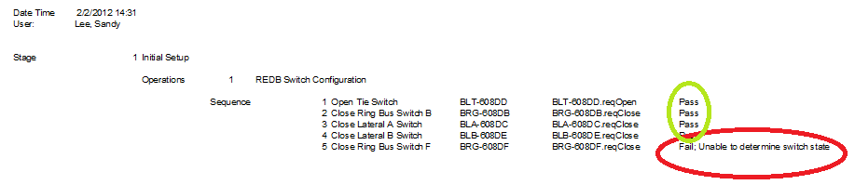

Figure : Validation Log

## Experiment ACtivation (loading)

A validated experiment configuration may be loaded to the system and activated after creation or by recalling a saved configuration.

When an experiment is activated, all configuration parameters and settings, for the selected **Stage** and **Operation**, will be written to the applicable PLC, cRIO, or other device in accordance with the **sequence number** assigned during configuration.

The activation of the experiment will be recorded in the database.

* Equipment that is not owned cannot be operated or energized. Ownership of equipment must be established prior to operation. Before ownership, of equipment, may be released the equipment must be de-energized or returned to its “non-owned” stated. Any attempt to release ownership before this occurs will be refused by the system.
* Equipment that is owned can only be controlled by the owner. The exceptions to this are the C-Stop and E-stop reactions, since anyone can press a button.
* Only the equipment owner can program its C-stop level reactions.

The equipment owner must release ownership before another entity can assume ownership.

## Equipment Control and Monitoring

### Display of process value

* Meter data
* Breaker status
* Bus live/dead status
* Fixed equipment status

### Equipment Control

* If equipment is owned by an experiment, and the actively logged in user is the owner of the experiment, equipment can be manually operated.
* Pre-programmed interlocks are still in effect

## Experiment Deactivation

* All sources and loads are disconnected. If a controlled shutdown is desired, it must be performed manually or programmed in the user-programmed experiment automation script.
* Ownership of all equipment is released.

## Experiment Data

|  |  |
| --- | --- |
|  | **Master Experiment List**  Each experiment is assigned, by the system a unique **ExperimentID.** A master Experiment is maintained containing the ExperimentID, UserID (creator), experiment name, experiment descriptions, and create date time. |
|  | **User & Client**  A relationship exists between the experiment list, the user and the client (if applicable).  This allows for securing and segregating any confidential data. |
|  | **Waveform Data**  Waveform data is captured, per the configuration, and stored with the experiment data.  (*See* ***Section 2.1.4 Waveform Capture*** *for details*) |
|  | **History**  Most “non-waveform” data collected for an experiment will be stored in the Wonderware Historian in private groups.  (*See* ***Database******Historian*** *Section for details*) |

### Waveform Snapshots

#### Overview

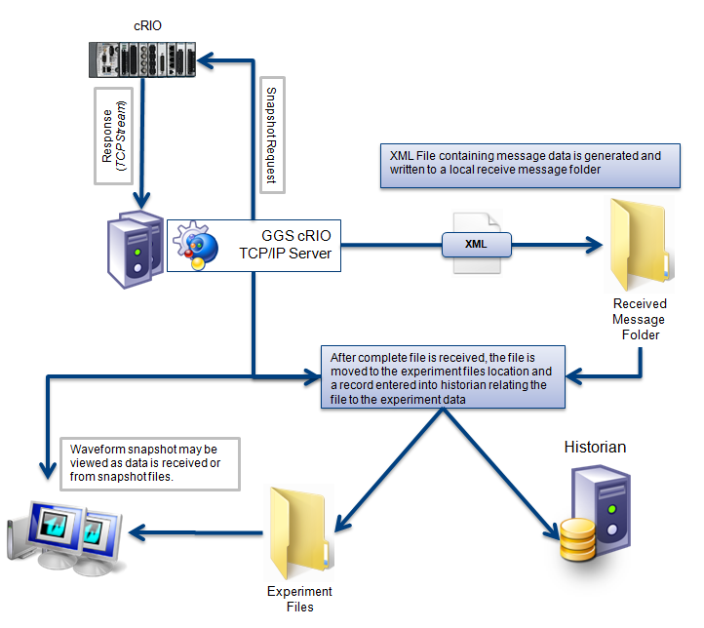

#### XML Files

|  |  |
| --- | --- |
|  | |
|  | Example of **Snapshot XML** file containing a **snapshot** of three (3) channels. (*Snapshot data collapsed*) |
|  | Example **Snapshot:**  Each snapshot contains **header** information & channel **data**.  The **header** provides information regarding the specific channel, sample rate, scaling gain, scaling offset, engineering units for the channel values, start time of snapshot, and data count (*number of samples*).  Channel values are under the **<Data>** element of the XML with a point count per the **<DataCount>** element of the header. A truncated list of **<Values>** is shown in the example. |
| **Database Entries** | |
|  | **Snapshot XML** files, as well as other types of files containing experiment data, are saved in an experiment specific folder and a record of the file including location and file information is recorded in the database by experiment and user. |
|  | |

## Experiment Screens

### DAQ Cart

|  |  |
| --- | --- |
|  |  |
|  | Selecting the DAQ Cart **type** (AC/DC) will populate the **Cart ID** drop down list with the appropriate list of carts and indicate the **status** (i.e., available, in-use, etc.) and **owner** information.  The user may **take ownership** and select the related process.  Configuration of Channels & Experiment Specific Parameters for purposes of logging data for experiment purposes the user may configure a name, engineering unit and scaling for analog & digital channels. |
|  |  |

# Attachments

## Attachmen t A – Requirement Traceability Matrix

## Attachmen t B – Master Safety I/O Listing